Automation Suite Help Document

1. About Planit 2

2. Pre-requisite Software List 2

3. Steps to Download and Install Python and Robot Framework on Windows 2

4. Business Perspective 3

5. Technology Used 3

6. Technical Implementation 3

7. Group Asia Process Steps Automated 4

7.1 Excel Consolidation 4

7.2 Run Macro 12

7.3 Uploading Macro Generated txt files 13

7.4 Login in to Group Asia Application 15

7.5 Batch Run (Deletions, Additions, Revisions) 15

7.6 Verify created Batch (Deletions, Additions, Revisions) 18

7.7 Issue Trial Balance (Additions, Revisions) 20

7.8 Verify Trial Balance premium amount (Additions, Revisions) 23

7.9 Verify Trial Balance premium amount with float amount (Additions, Revisions) 27

7.10 Issue the Policy (Deletions, Additions, Revisions) 30

7.11 Verify Policy Status (Deletions, Additions, Revisions) 33

7.12 Generate Bill Data from Bill Data dtf (Deletions, Additions, Revisions) 35

7.13 Submitted Bill No Batch Processing (Deletions, Additions, Revisions) 39

7.14 Export bill though dtf file downloader (Deletions, Additions, Revisions) 42

8. Check List for Execution of the Utility 46

9. Execution Process 48

10. To Verify the Log Reports After Execution 58

# About Planit

Planit is a leader in Quality Assurance, providing organizations around the world with best-in-class consultancy and training to ensure project success. Planit has the expertise in test automation using open source and COTS tools. Our test automation framework and tools are designed for maintainability and reuse.

Planit has taken up automation for FG Endorsement using Python and Robot Framework, to automate their transaction process for the present scope of the project.

# Pre-requisite Software List

* Python: 2.6.7
* Robot Framework

# Steps to Download and Install Python and Robot Framework on Windows

* Below is the document to install the Python and Robot Framework on windows



# Business Perspective

The client will send the details of the resources and policy number through mail. FG will collect the data from the mail and will update the data into excel sheet. After updating the data, the user will run the macro. Macro will check the errors and will convert the excel file data to a text file. That text file is uploaded through life Asia uploader. User log into the Life Asia Legacy System and will run Batch job then data get updated in the system and Spool file gets generated. Spool file shows the number of members got uploaded in policy and if members are uploaded successfully then policy should be issued. Once the policy is issued then bills get generated for the uploaded members and operation team extract the bills from group Asia in excel & the same gets converted in PDF format. The PDF generated should be sent to the company.

# Technology Used

* Python: 2.6.7
* Robot Framework
* IBM Personal Communications(pcomm) for Main Frames Applications

# Technical Implementation

**Group Asia process steps automated as part of the Automation:**

1. Read the Excel Files from client folder
2. Map the Headers of client excel file with the macro file
3. Configuration excel file is created and header fields are mapped with constant values
4. Master data excel file is created for internal mapping fields like Subsidiary, Designation, salary, plan etc.
5. Write client data in Marco excel file, based on Configuration and Master excel file
6. Based on excel sheets present in client file, the utility should populate data in Marco excel file for every transaction.
7. Run macro excel file and get total number of records are processed, verify text file is generated by macro excel file
8. Any record fails in Marco excel file that record should be saved in Failed_Logs folder with policy number
9. Text file should be uploaded in Group Asia by “Data Transfer to IBM I (. DTT) “uploader
10. Verify number of records are processed in to Group Asia, if any failures occur in uploader file error records should be saved in Failed_Logs folder with Policy number
11. Submitted the batch job “G5MBRDATA” and verified whether batch is created or not in spool file screen
12. Run the Trail bill for Addition and Revision transactions
13. Verify the premium amount for given Subsidiary for Addition and Revision transactions
14. Verify float amount is sufficient for premium amount
15. If float amount is sufficient for premium amount than Issue policy for Addition and Revision transactions. For Deletion we can directly issue the policy.
16. Verify Policy Status for all Transactions (Deletions, Additions, Revisions)
17. Bill Numbers are extracted by Bill data Transfer from IBM i (. dtf) file uploader
18. Run bill batch job as batch name “G5GBILEXT’’ and export bill though dtf file downloader

# Group Asia Process Steps Automated

## Excel Consolidation

**Requirement:**

1. Read the Excel Files from client folder

**Implementation:**

1. ‘Client data Excel files which will be named as policy number and placed **in ‘. \FG\TestData\client_data’** folder 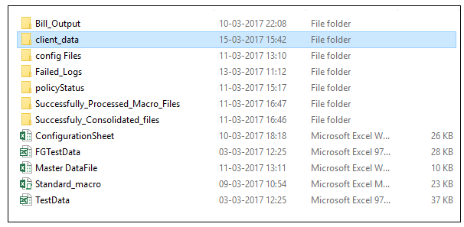
2. Utility will automatically read client data files, which are present in ‘.\FG\TestData\client_data’ folder



**Requirement:**

1. Map the Headers of client excel file with the macro file

**Implementation:**

1. Mapping will be done in configuration sheet

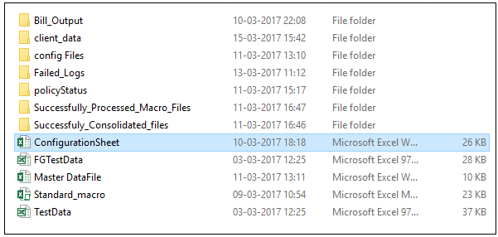

1. One mapping client file sheet should be present in configuration file in the path ‘..\FG\TestData\ConfigurationSheet.xlsx’

**Requirement:**

1. Configuration excel file is created and header fields are mapped with constant values

**Implementation:**

1. Below are the sheet names for configuration sheet file:





1. **SheetNames:**
   1. In this sheet expected sheet names from the client file should be given in the ‘Expected Different Sheet Names’ column separated with comma (‘,’) and related default sheet name should provide in the next column ‘Default Sheet To Save’

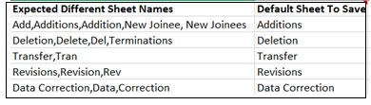

* 1. Expected column name to identify the row/Header of the client sheet should be provided in the ‘ColumnNameToGetRowNumber’ column separated with comma (‘,’)



* 1. Based on the name provided in the ‘ColumnNameToGetRowNumber’ header will be identified from the client file from the respective sheet and will get the data below to that header
  2. Sheet names provided in the ‘Default Sheet To Save’ column and sheet names for other transactions should be same (ex: if ‘Additions’ is the sheet name in Default Sheet To Save column then sheet for Addition related transaction in client should also be ‘Additions’. This names should be case sensitive)

1. **Additions:** This sheet name should be same as the name provided in the ‘Default Sheet to Save’ column in the ‘SheetNames’ sheet
   1. Expected columns from the client file in Additions related sheet should provide in the ‘Expected Different Column Names’ column separated with comma (‘,’) and related macro file column name should be provided in the ‘Default Column Name in Macro’

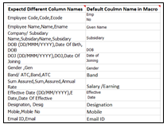

* 1. Band is not available in macro file but it is required field to identify the ‘Plan’ and ‘Occp’ from the master data file only in case of Graded policy
  2. If no macro file column name is available for the client column, then provide the same name
  3. Data should be case-insensitive and space-insensitive for ‘Expected Different Column Names’ column

1. **Revisions: Same as Addition sheet**
2. **Deletion:** 
   1. Same as the Additions sheet but in case of Effective date we need to add +1 in the macro file, for that ‘Rule’ column is provided. Provide the number of days to add / remove from the effective date in the rule column. To decrease the date please provide the number with negative sign (ex: -2)

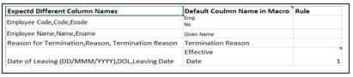

1. **Static Data:** Static data for all transactions should be provided in the “static data” sheet which is available in “Configuration excel” file.

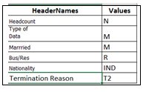

**Requirement:**

1. Master excel file is created for internal mapping fields like Subsidiary, Designation, salary, plan etc.

**Implementation:**

1. Master data file should be placed in ‘..\FG\TestData\Master DataFile.xlsx’.

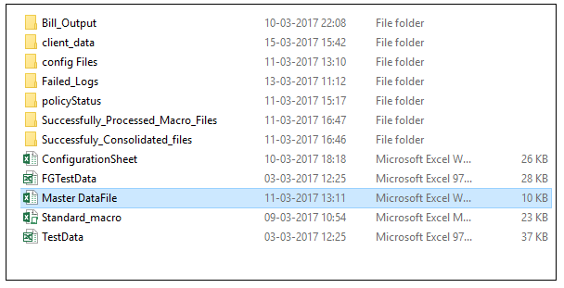

1. Master data should be in the below format in Master Data excel file

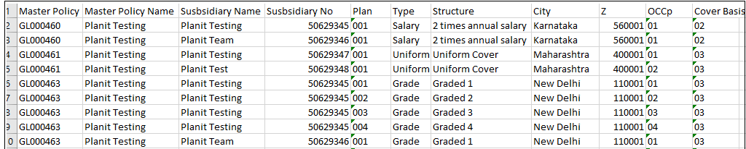

1. ‘Type’ column should be available in the Master data file to identify the Structure Type of the policy based on cover basis whether it is Uniform or Grade
2. Below is the Master Data excel file



**Requirement:**

1. Write client data in Marco excel file, based on Configuration and Master excel file

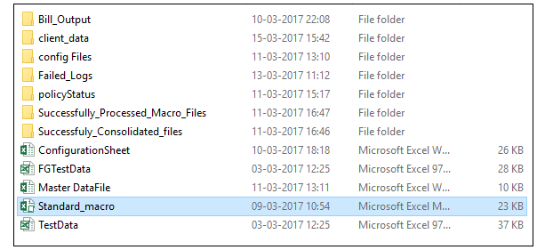

1. Standard macro file should be placed in ‘..\FG\TestData\Standard_macro.xlsm’. Data in the client file written in the provided standard macro file to upload it to the application
2. Below is the standard macro file



1. Client data files are successfully consolidated, and files will move to ‘..\FG\TestData\ \Successfuly_Consolidated _files\11-03-2017-16-46-53\GL000460.xlsx folder

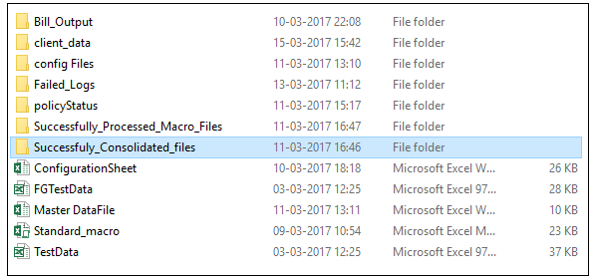

1. Client data file will be saved in “Time Stamp” folder with in “Successfuly_Consolidated _files” folder

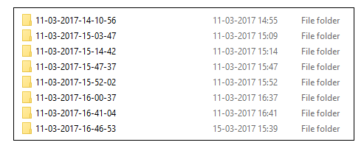



**Requirement:**

1. Based on excel sheets present in client file, the utility should populate data in Marco excel file for every transaction.

**Implementation:**

1. Macro excel file will be created with reference of “Client data”, “ConfigurationSheet”, “Master DataFile”, and “Standard_macro” excel files.
2. Macro Excel file will be saved in “FG\TestData\Successfully_Processed_Macro_Files\11-03-2017-13-16-05\GL000461” floder



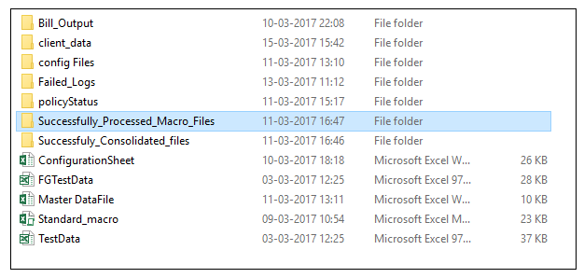

1. Folders should be created with the Timestamp

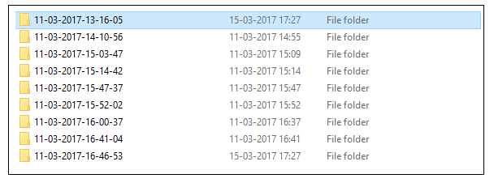

1. Folders should be created with the Policy numbers

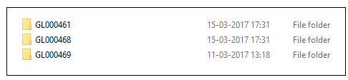

1. Excel Macro file should be created based on Transaction

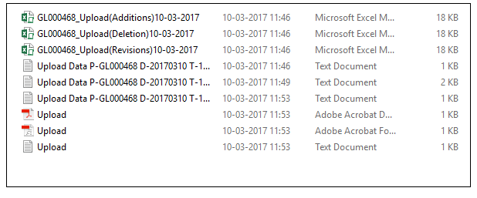

1. Below is macro excel File



## Run Macro

**Requirement:**

1. Run macro excel file and get total number of records are processed, verify text file is generated by macro excel file

**Implementation:**

a) Run macro excel file

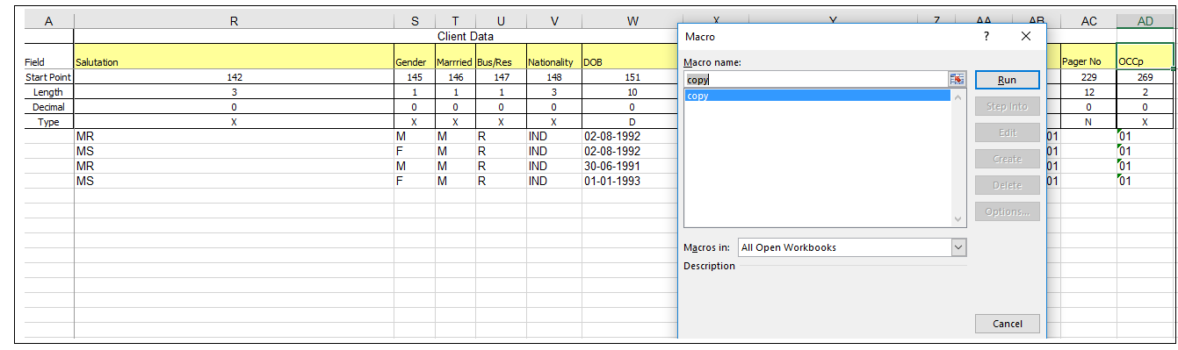

1. It should display a pop up window with total number of records processed

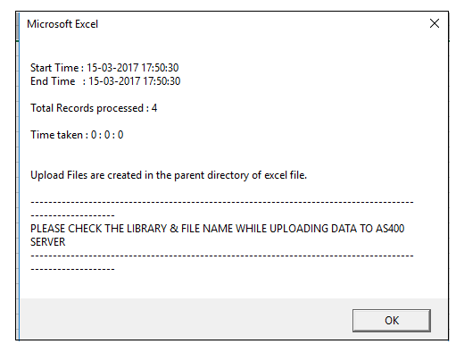

**Requirement:**

1. Any record fails in Marco excel file that record should be saved in failed_Logs folder with policy number

**Implementation:**

* 1. Failure log will be saved in ‘‘..\FG\TestData\Failed_Logs\11-03-2017-16-46-53\Error_Log_For_GL000460.xlsx”

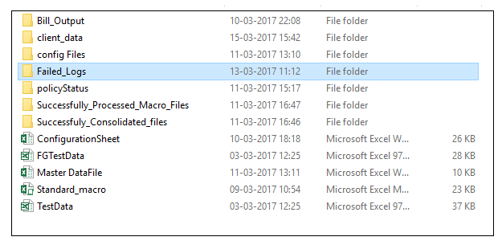

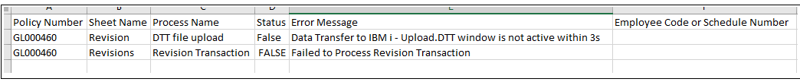

## Uploading Macro Generated txt files

**Requirement:**

1. Text file should be uploaded in Group Asia by “Data Transfer to IBM I (. DTT) “uploader

**Implementation:**

1. Click on Browse button and Browse the “Upload.txt file”
2. Enter the text **FGGACTDTA/MICDPF** in Library/File(Member) field
3. Click on “Transfer data to IBM I” button

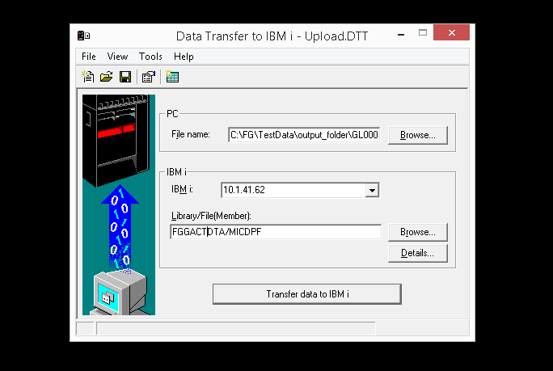

**Requirement:**

1. Verify number of records are processed in to Group Asia, if any failures occur in uploader file error records should be saved in Failed_Logs folder with Policy number

**Implementation:**

a) Verify number of records are processed in to Group Asia, if any failures occur in uploader file error records should be saved in Failed_Logs folder with Policy number

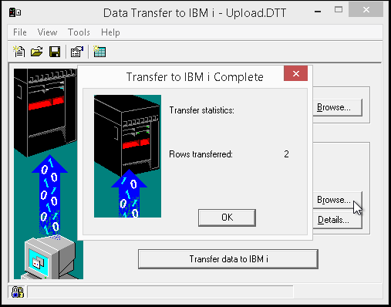

## Login in to Group Asia Application

**Requirement:**

1. Submitted the batch job “G5MBRDATA” and verified whether batch is created or not in spool file screen

**Implementation:**

1. Logging into Group Asia with valid credentials

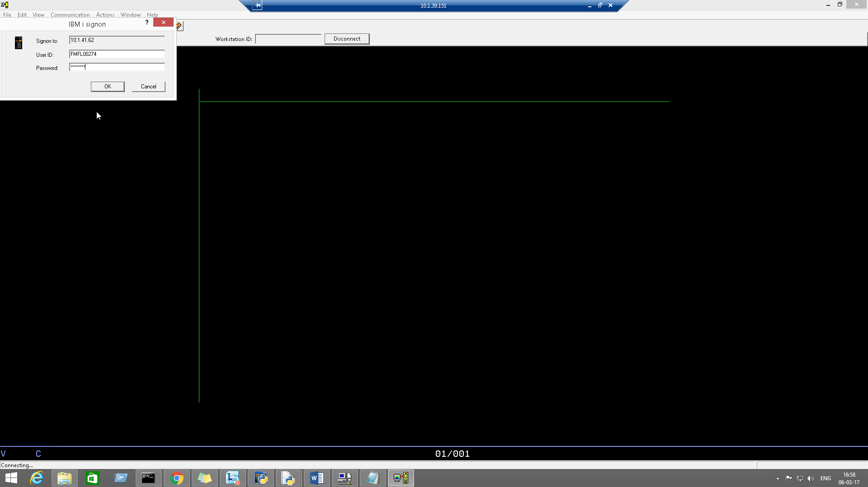

## Batch Run (Deletions, Additions, Revisions)

1. Select the “**Batch Processing** “in System Master Menu screen
2. Select the ‘**Schedule Submission**” in the Batch processing screen

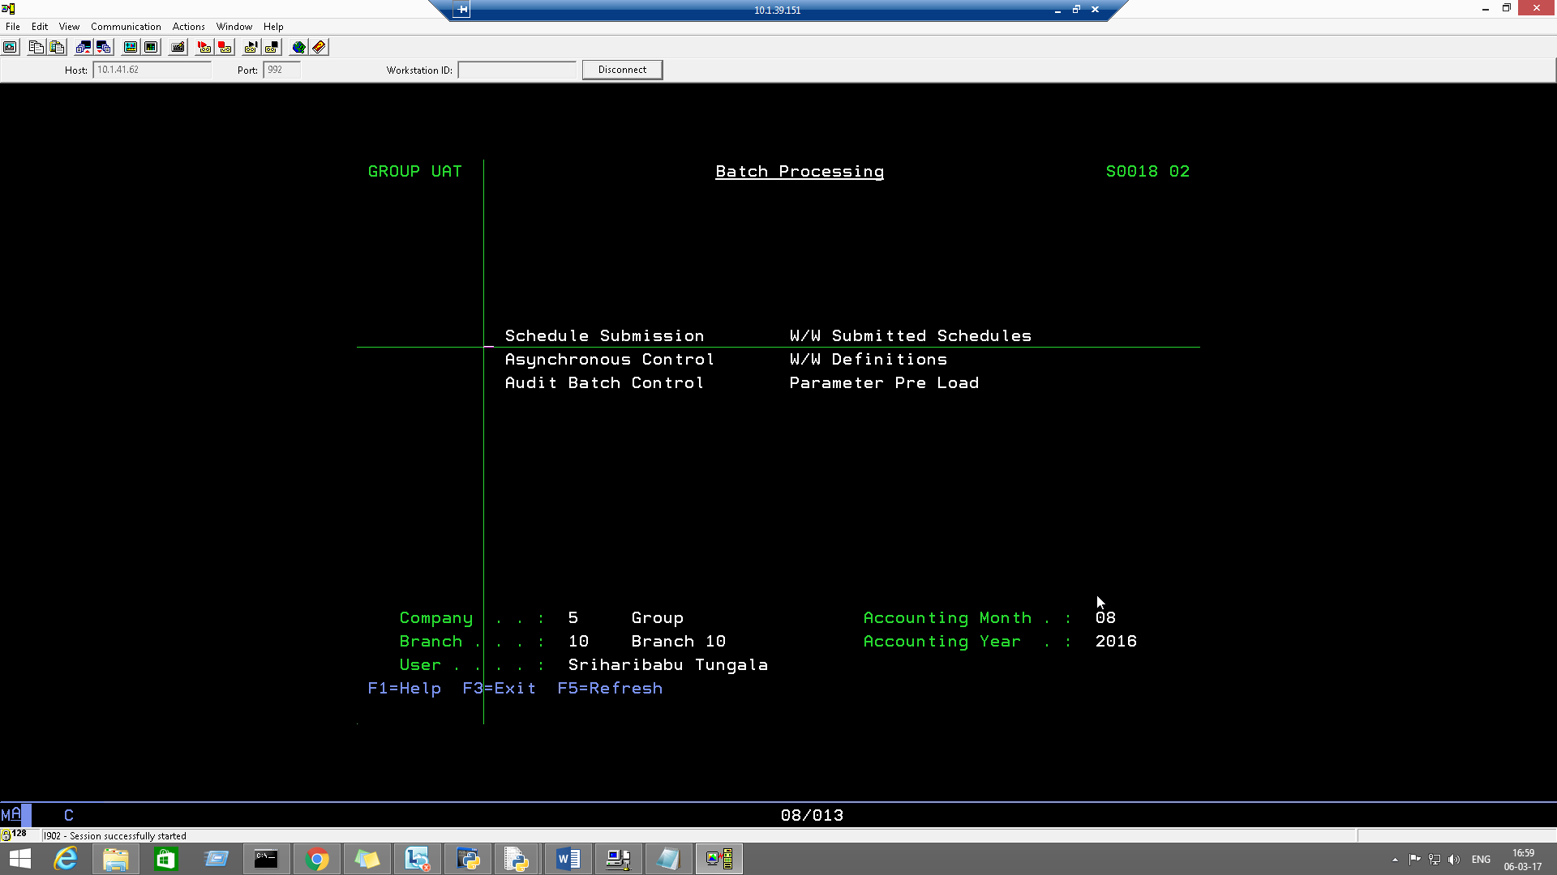

1. Enter the batch number as G**5MBRIDATA** in the Select text in“**Schedule Submission System**” screen and click on enter

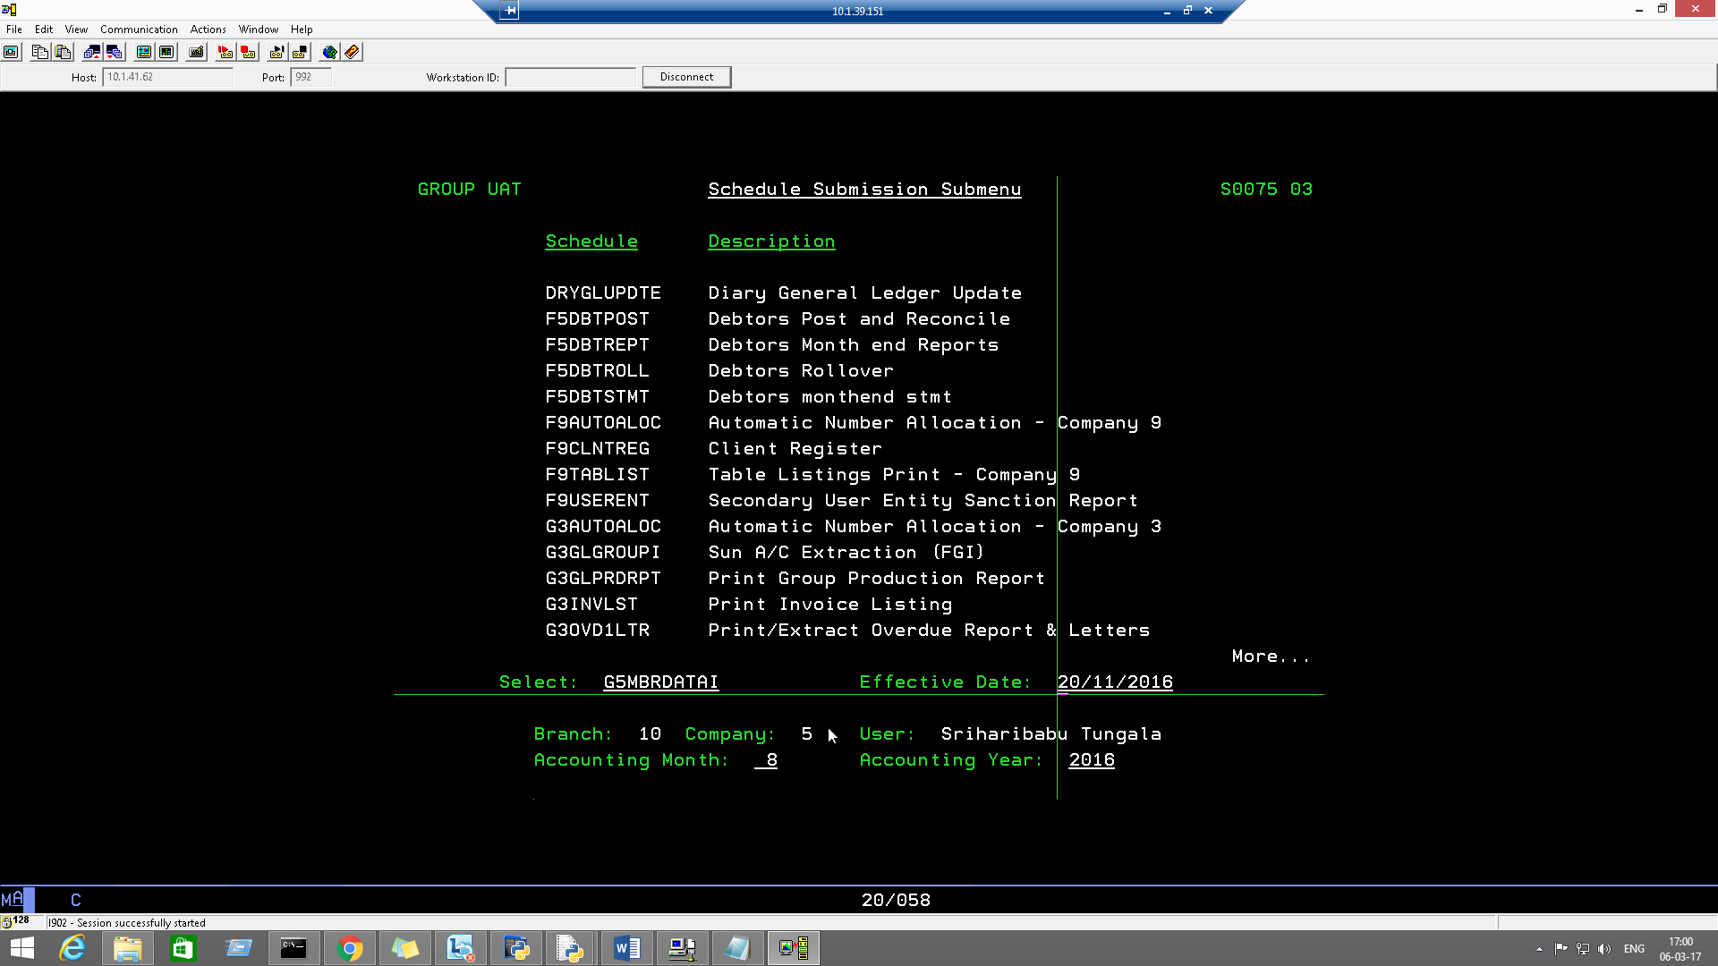

1. Enter the validations “N, Y, N, N” under Steps to run option in “**Batch member enrollment”** screen and click enter

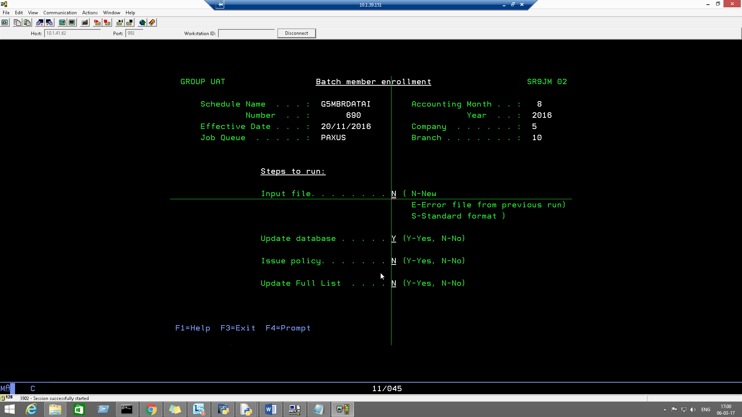

1. Verify the ‘**completed normally’** message in the “**Display Messages”** screen

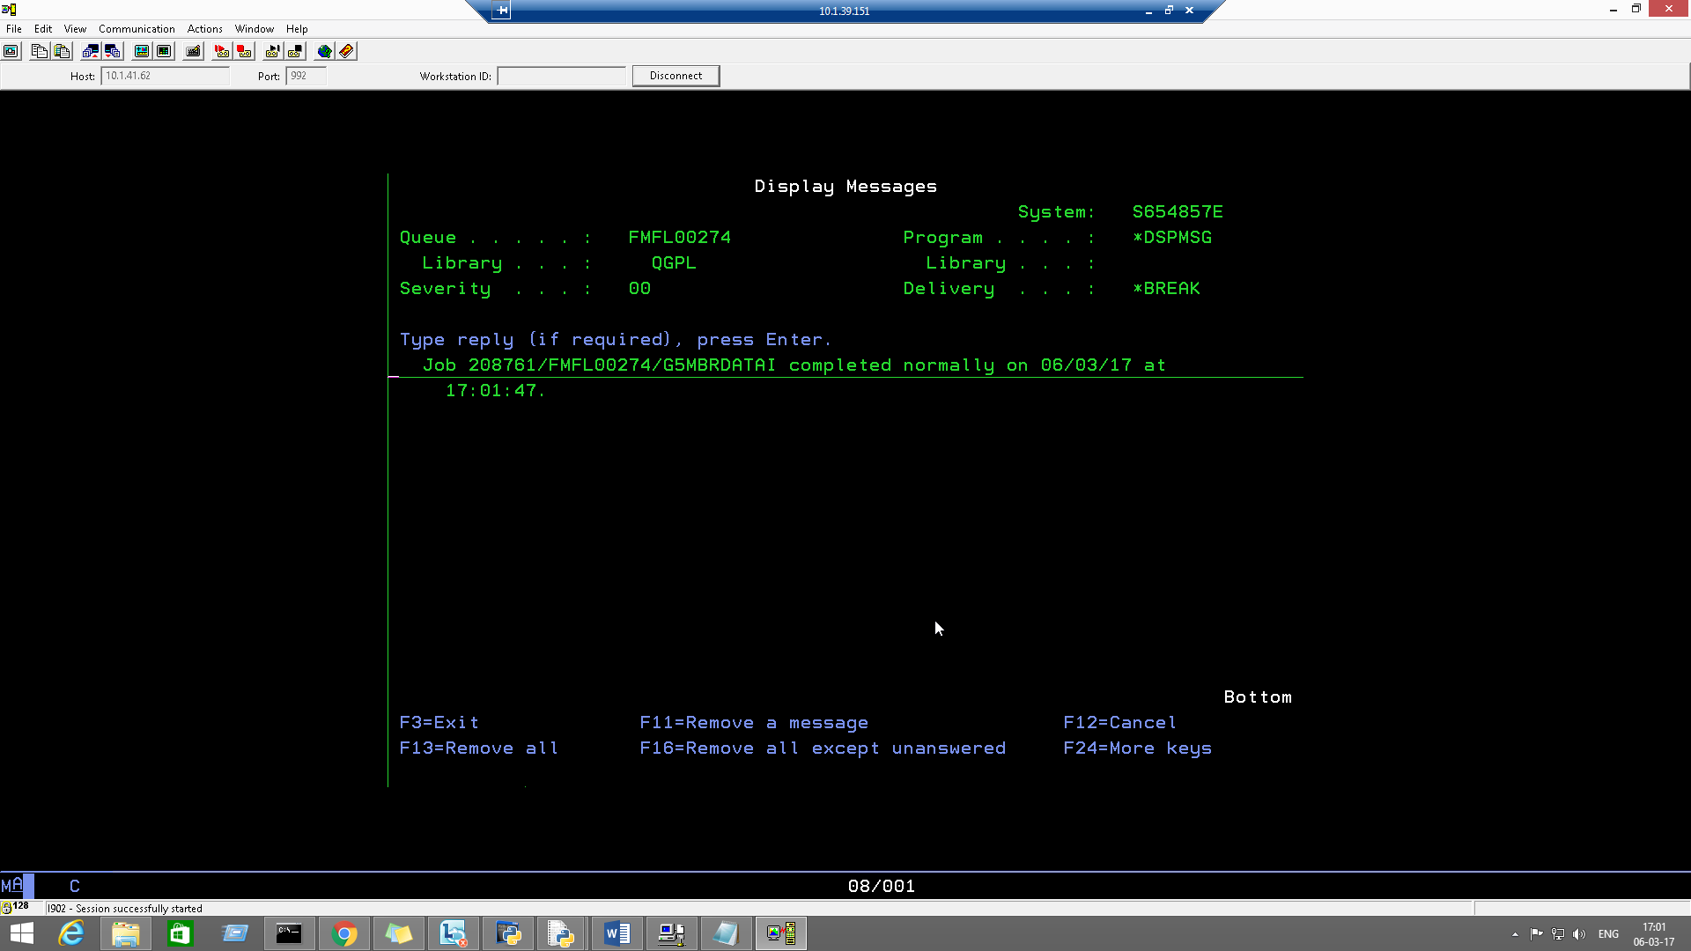

1. Validate the **Schedule submitted** message in the “**Schedule Submission Submenu** “screen

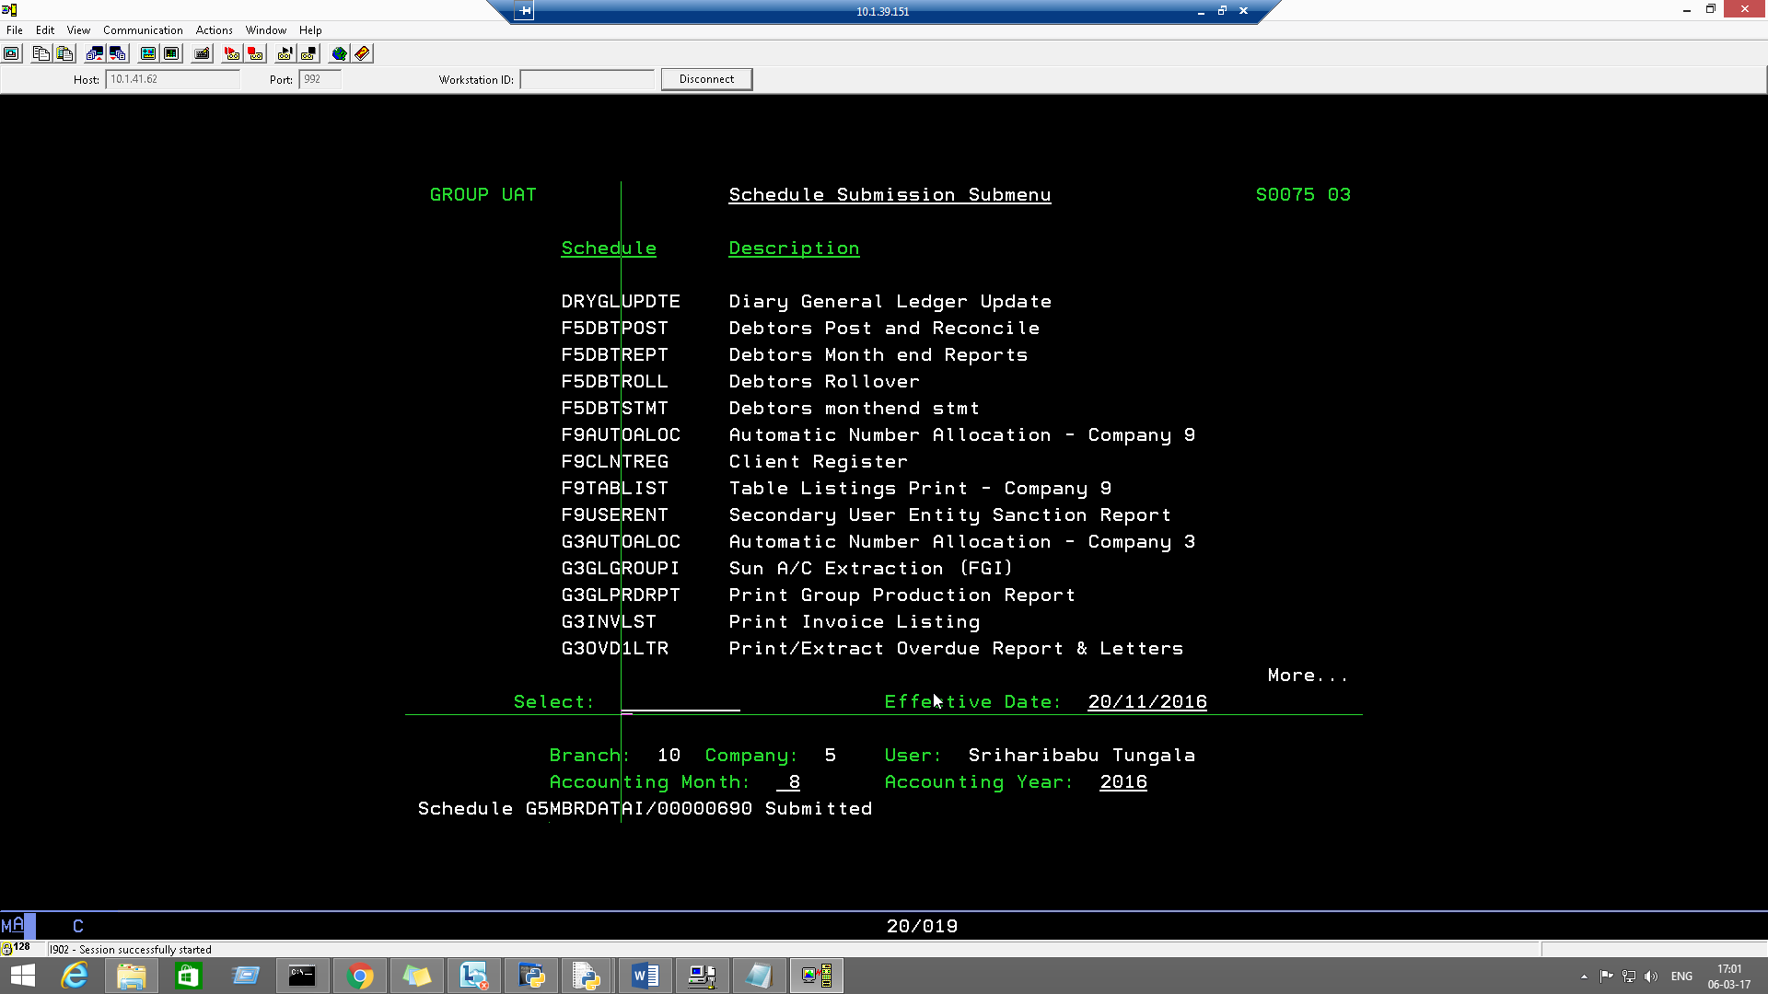

## Verify created Batch (Deletions, Additions, Revisions)

1. Select sub menu as W**/W Submitted Schedules** in the **“Batch Processing” screen**

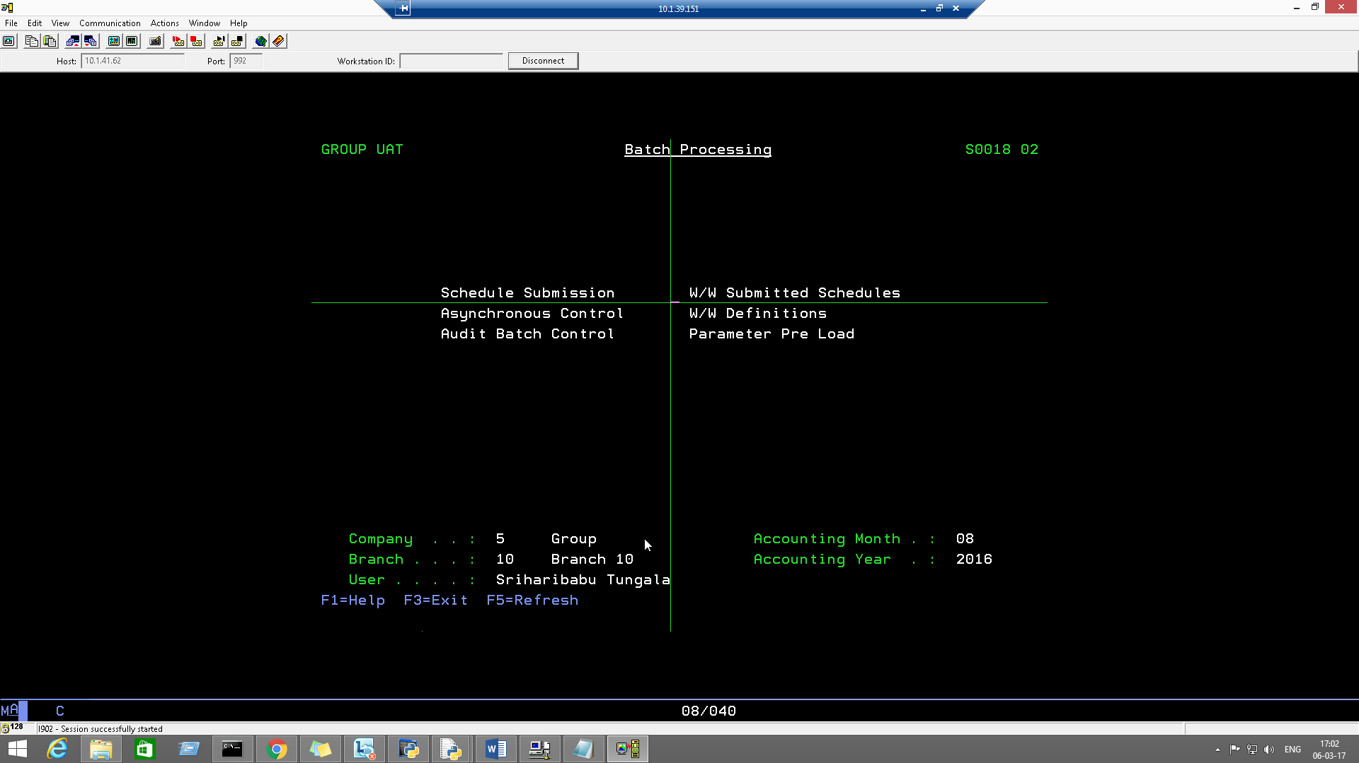

1. Click on enter in the “ **Schedule Maintenance Processing”** screen

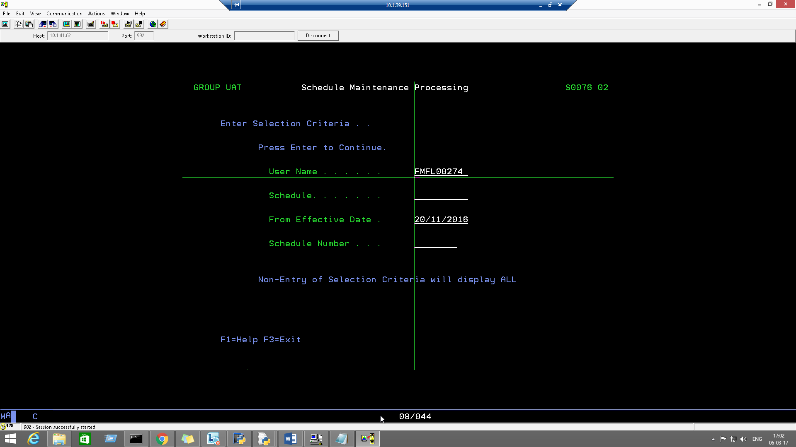

1. Enter text as 8 in Spool Files field in the recently completed schedule **G5MBRDATAI** andclick enter in **“Work with Submitted Schedules”** screen

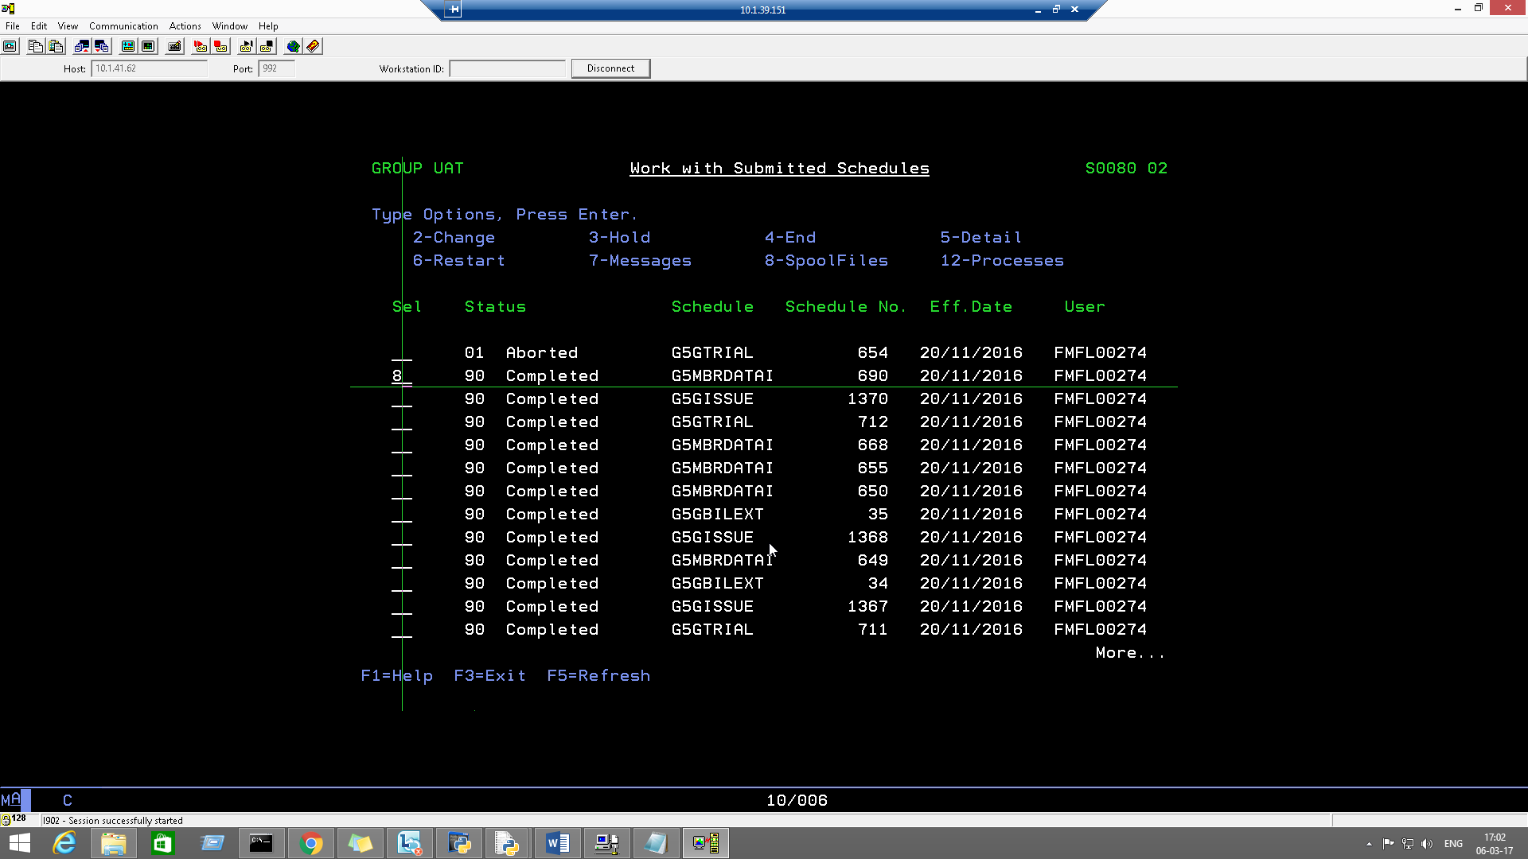

1. Enter text as **5** in ‘Display’ field in the row contains the **RR9JP** and click enter in “**Work with Spooled Files”** screen

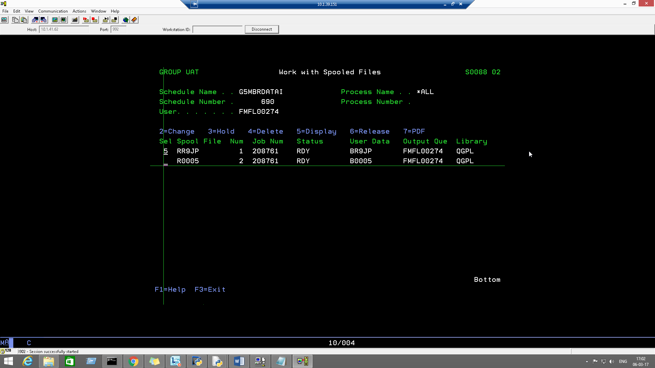

1. Verify below steps in “**Display Spooled File Screen** “
2. List of members should be successfully Terminated/Added/Changed message
3. Total number of members should be Terminated/Added/Changed
4. Log the failed error records to Failed log excel file with the schedule number

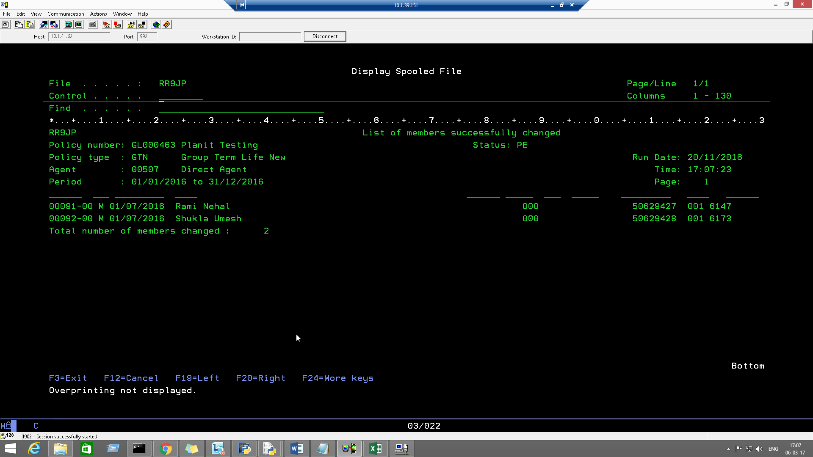

## Issue Trial Balance (Additions, Revisions)

**Requirement:**

1. Run the Trail bill and Trail Bill Batch processing for Addition and Revision transactions

**Implementation:**

1. Navigate back to “**System Master Menu**” screen and select the sub menu as **Group Policy Admin** and click enter

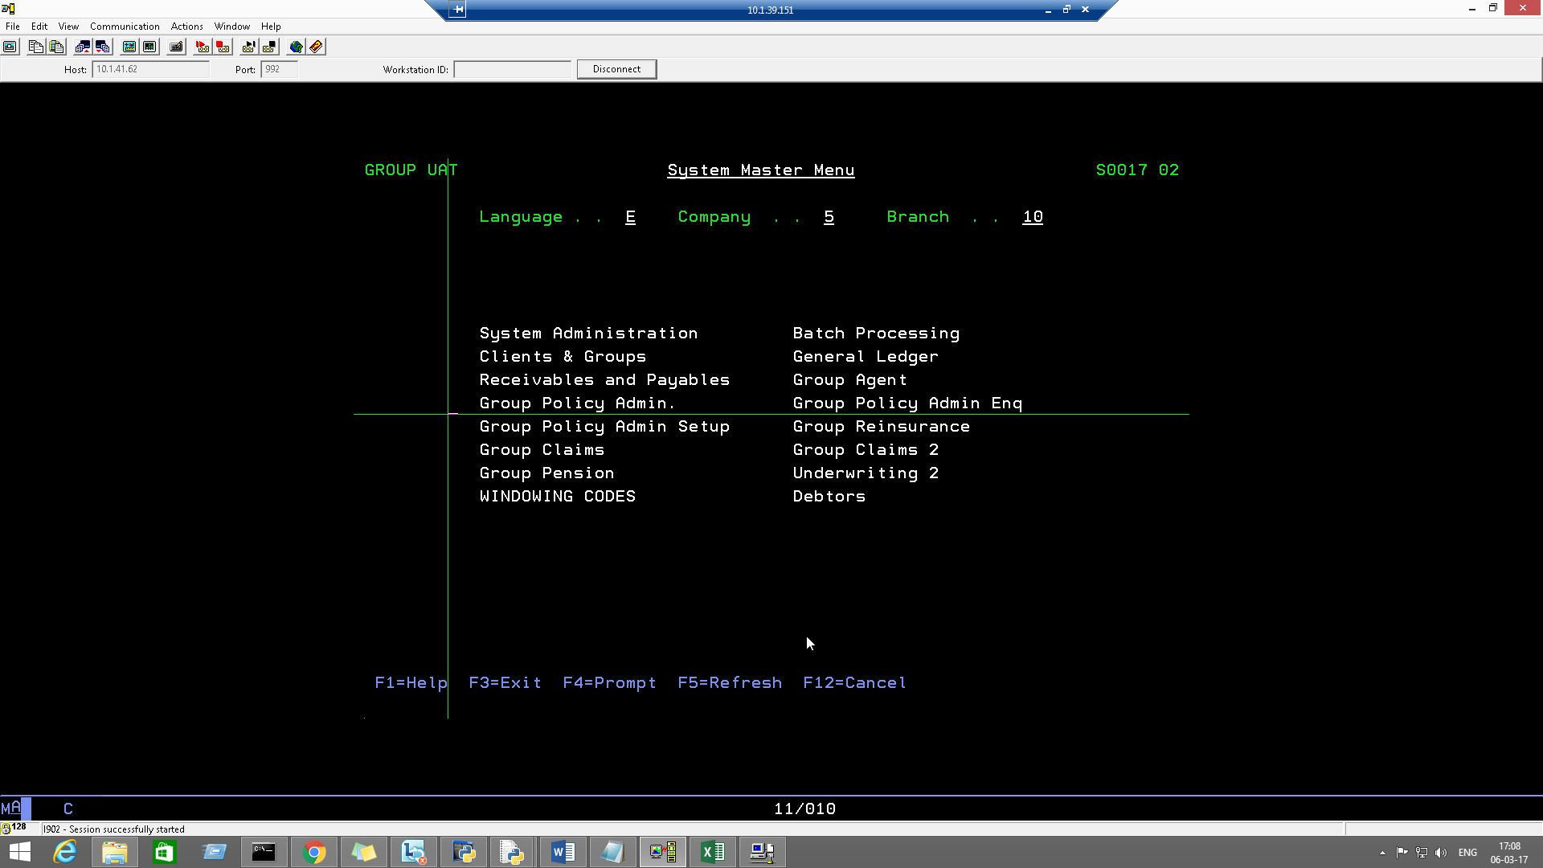

1. Select the Major Alterations in the “**Policy Administration contd** “screen and click enter

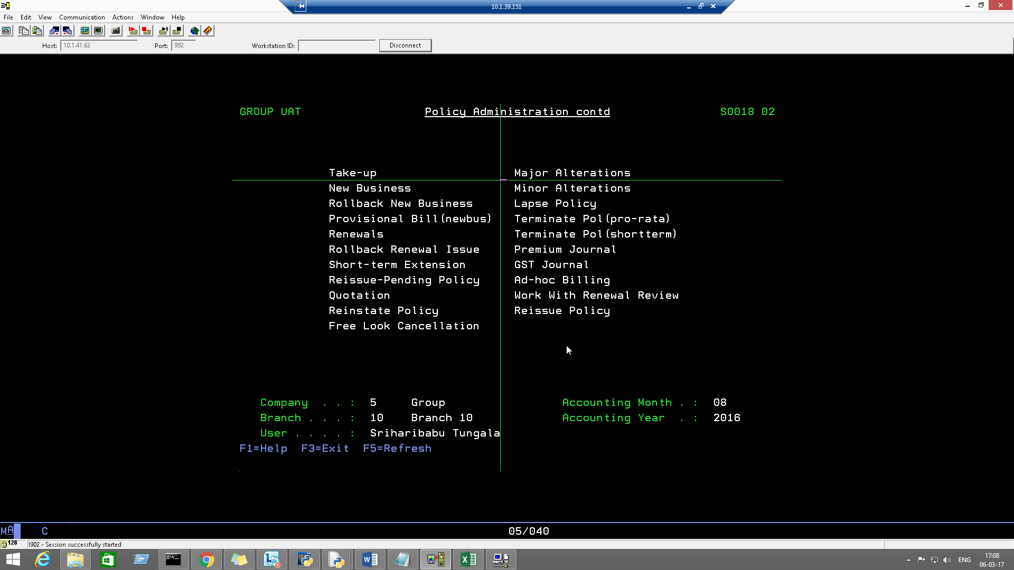

1. Enter **Y** in the **Pre-validate (Y/N)** field and Option **G** – **Issue Trial Bill** in the **Action** field in the “**Major Alterations –Sub Menu”** screen

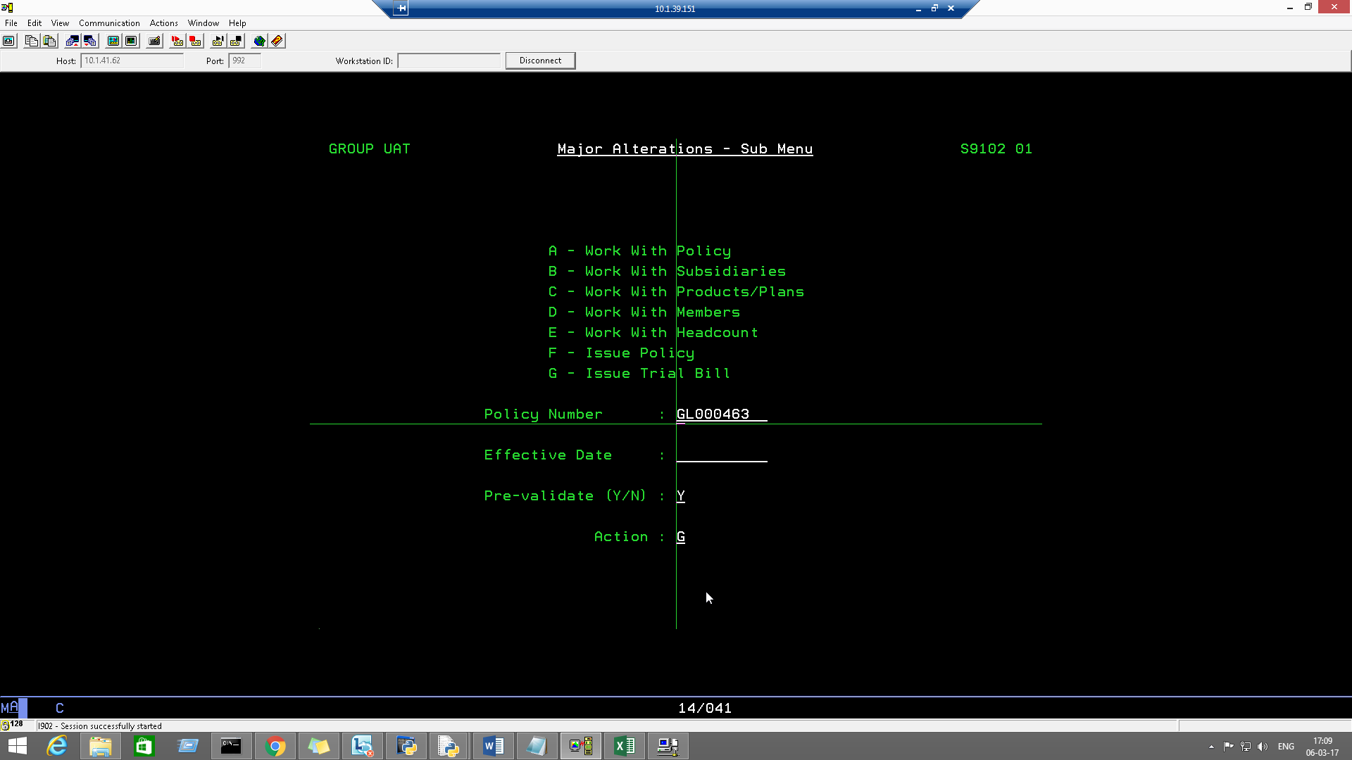

1. Click on enter in the “**Pre-Issue Product Count”** screen

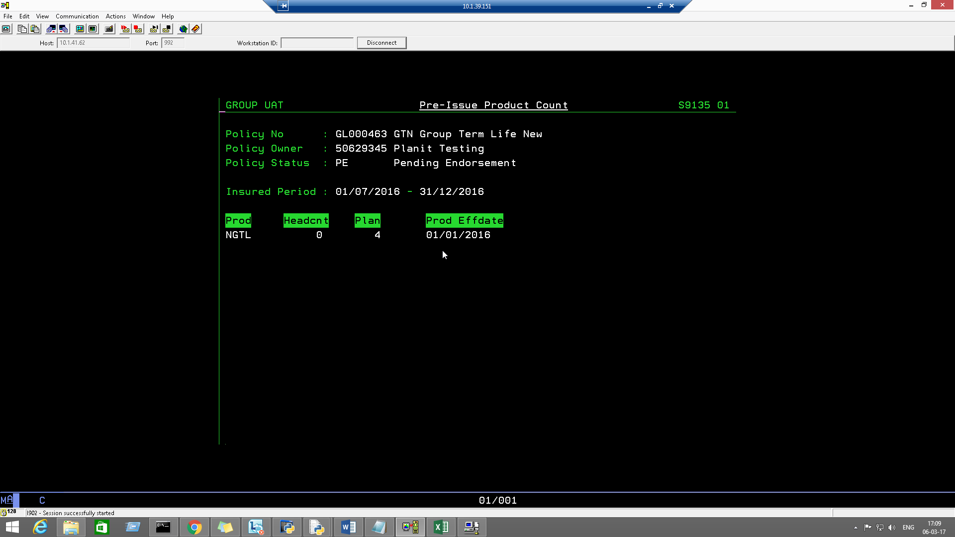

1. Click on enter in the “ **Pre-issue Validation”** screen

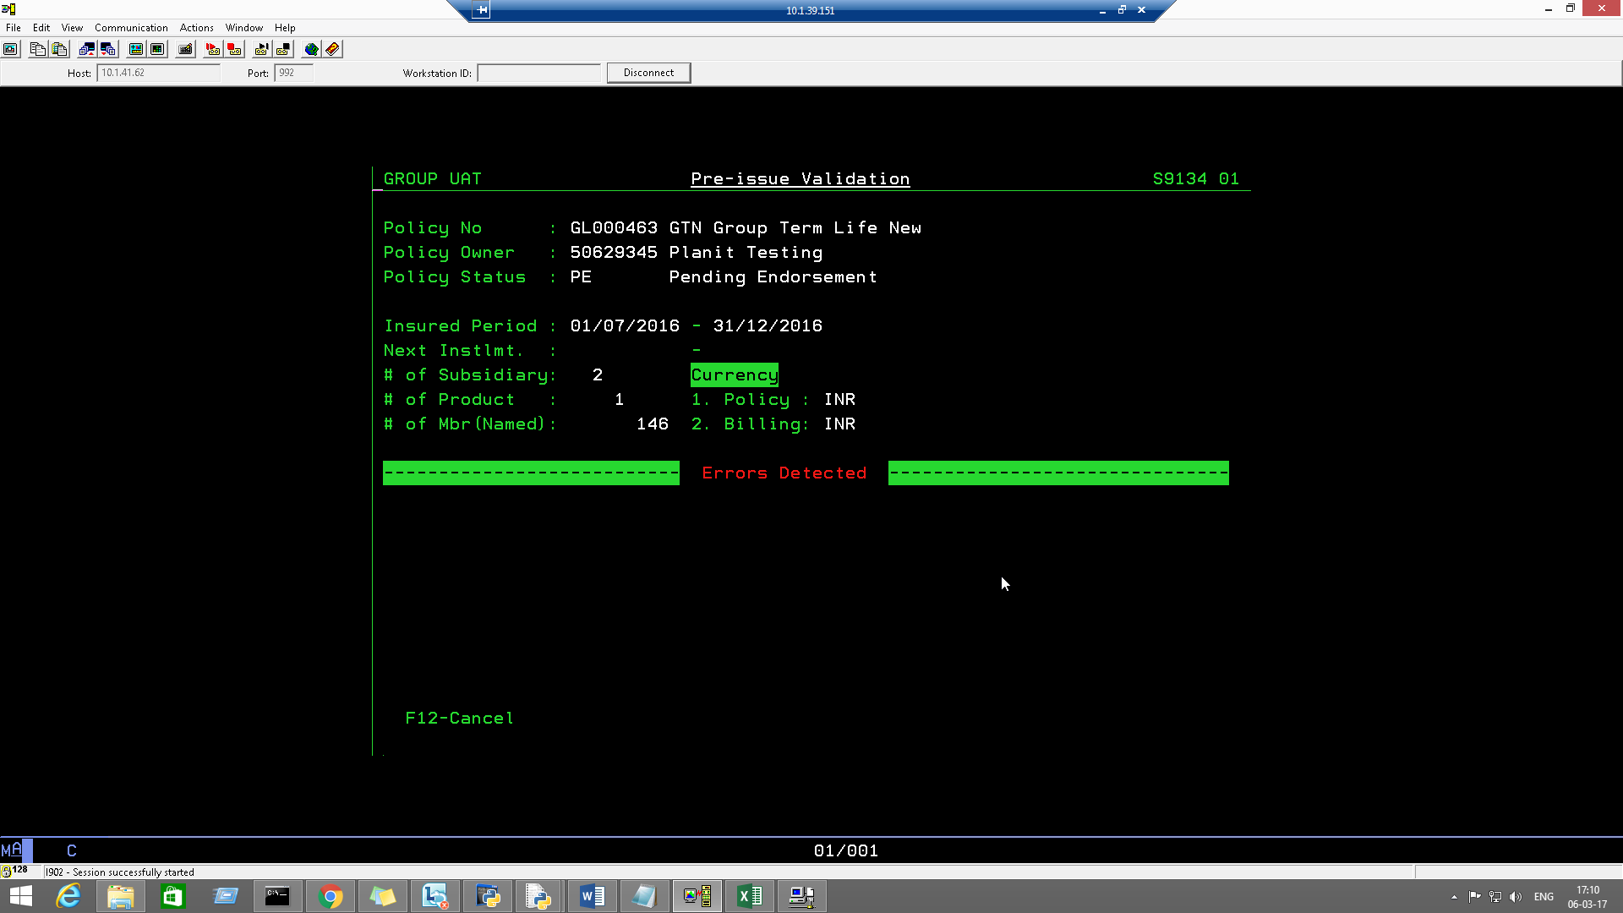

1. Click on enter in the “ **Issue Confirmation”** Screen

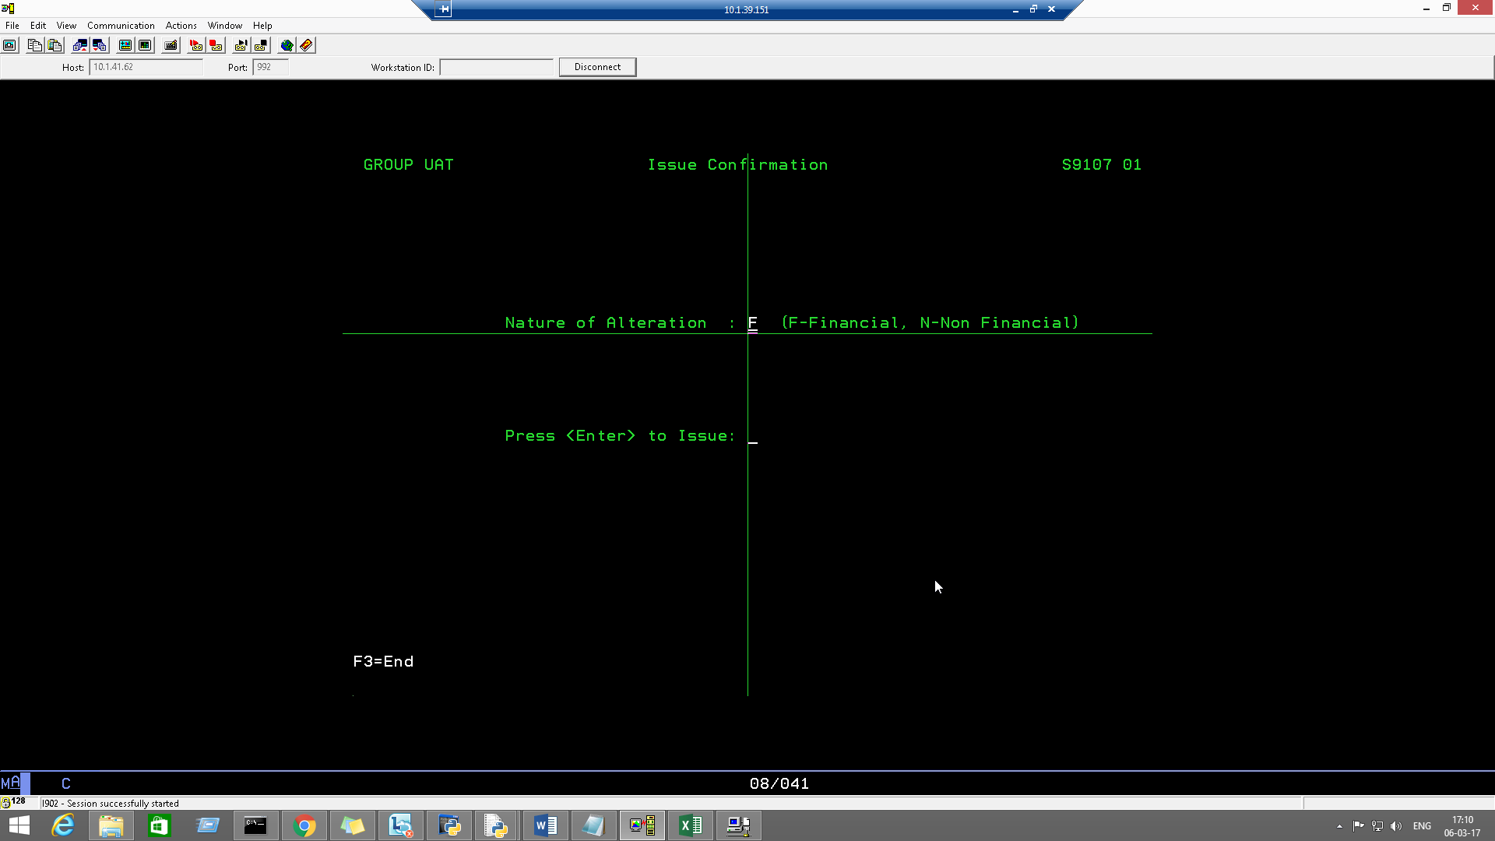

1. Verify the **completed normally** message in the “**Display Messages”** screen

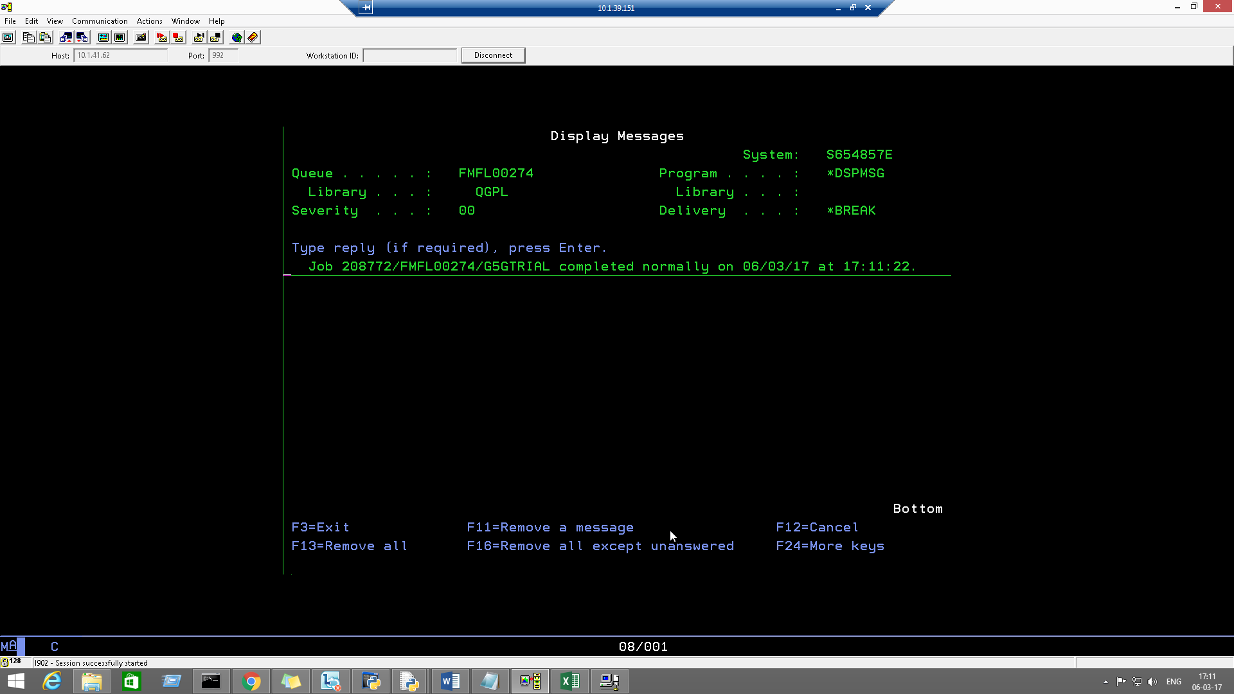

## Verify Trial Balance premium amount (Additions, Revisions)

**Requirement:**

1. Verify the premium amount for given Subsidiary for Addition and Revision transactions

**Implementation:**

1. Select the Batch Processing sub menu in “**System Master Menu screen”**

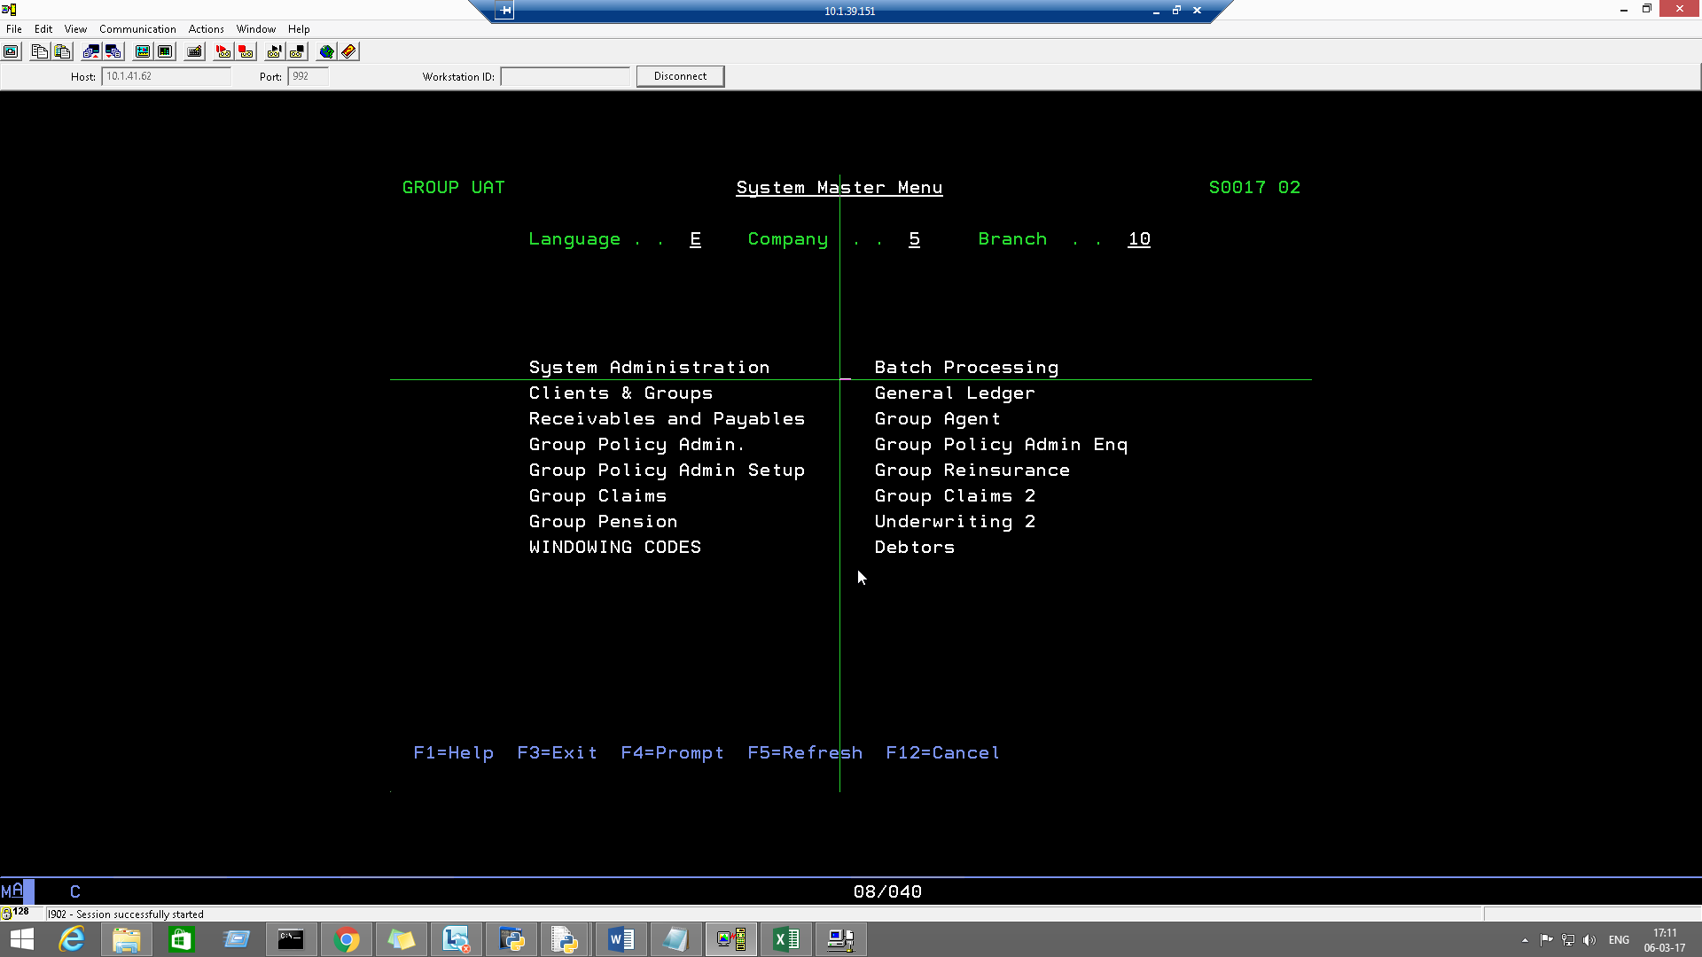

1. Navigate to “**Batch Processing screen** “and select sub menu as W/W Submitted Schedules and click on enter

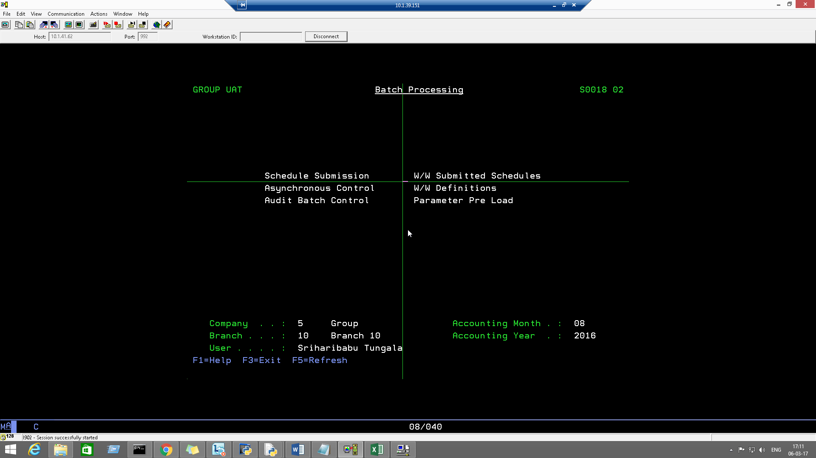

1. Click on enter in the “**Schedule Maintenance Processing”** screen

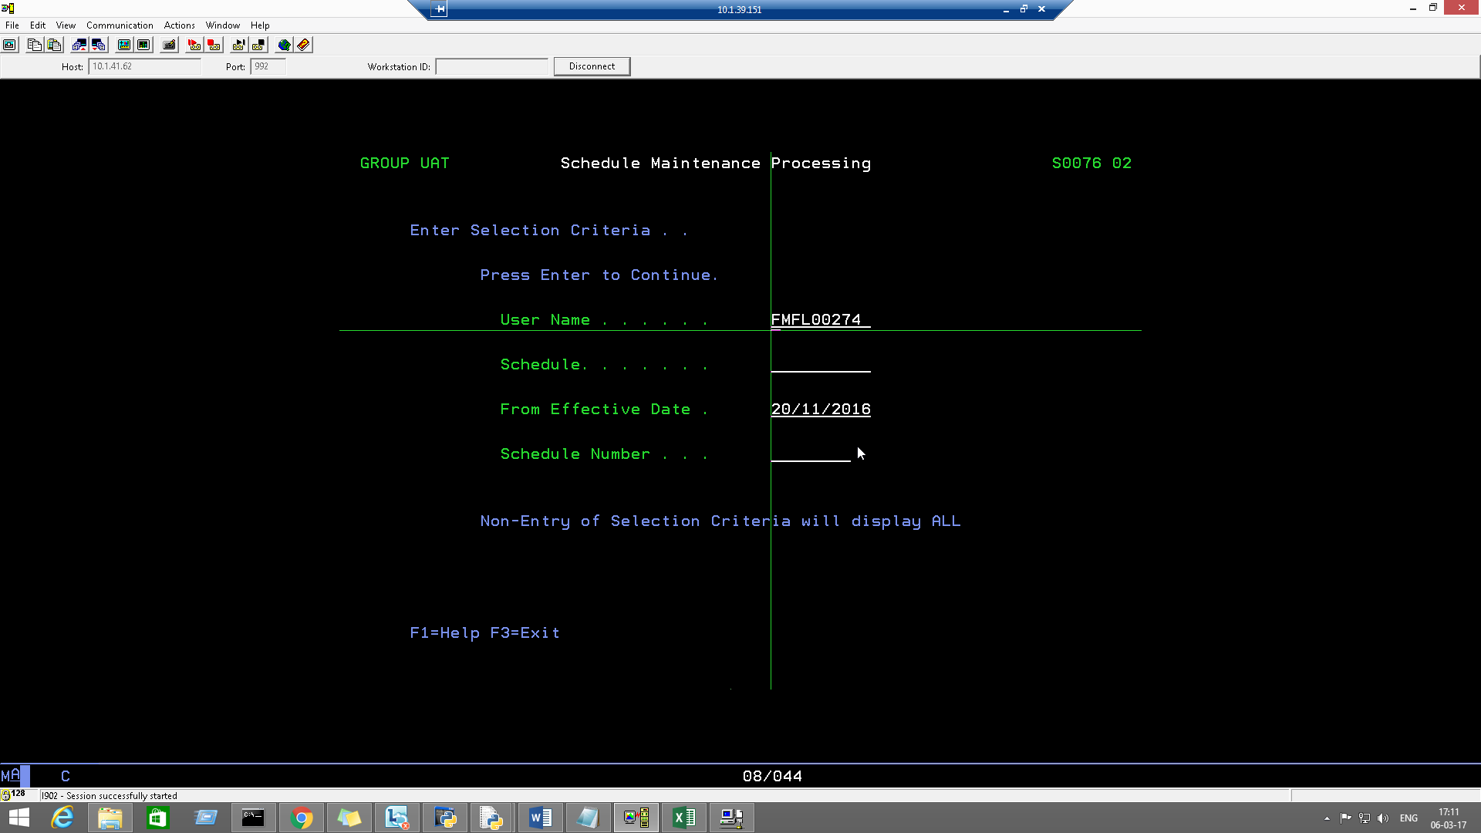

1. Enter option as 8 in ‘Sel ‘ in the row which having the schedule **G5GTRIAL** with status having **completed** in **“Work with Submitted Schedules”** screen

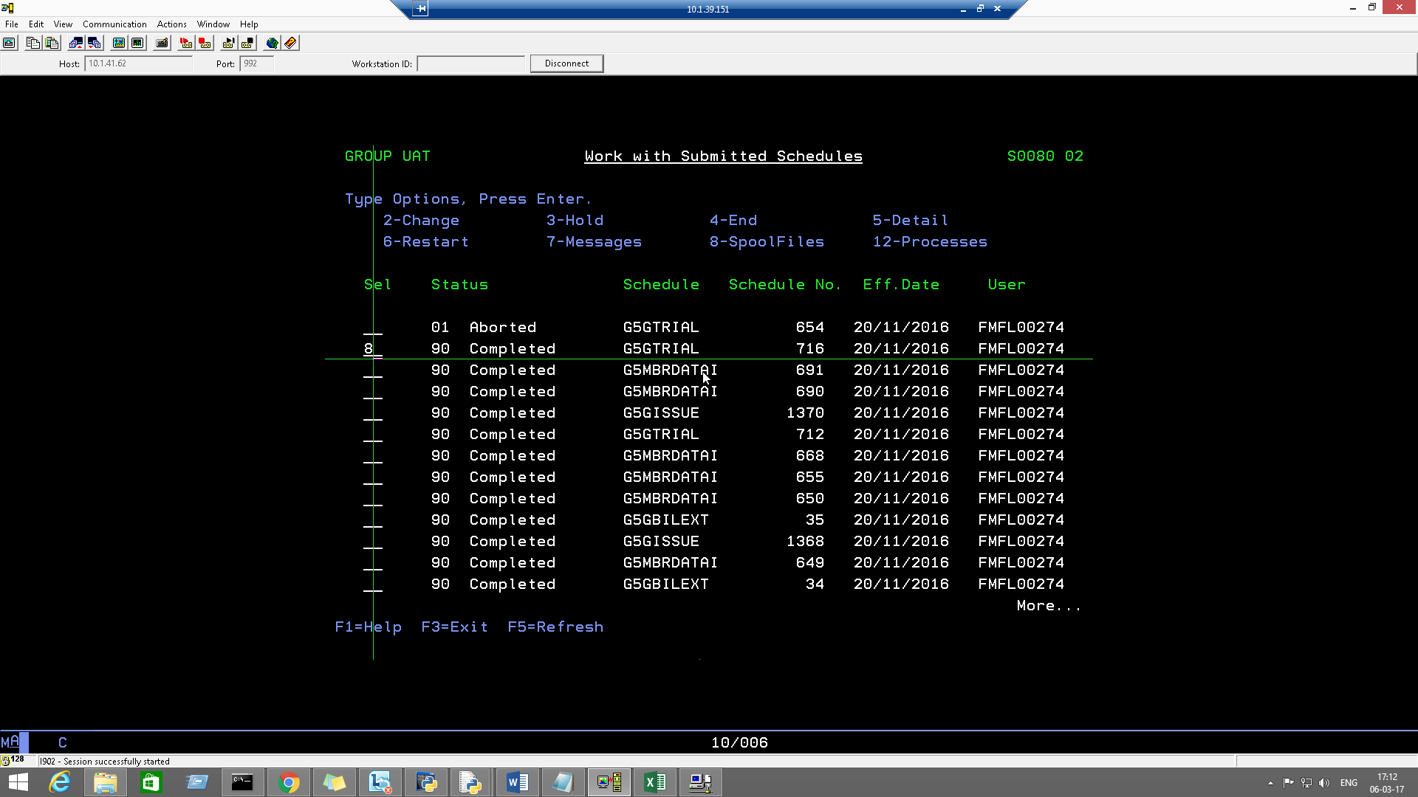

1. Enter option **5 – Display** in the row having **RG01403** in the **Spool File** column and click on enter

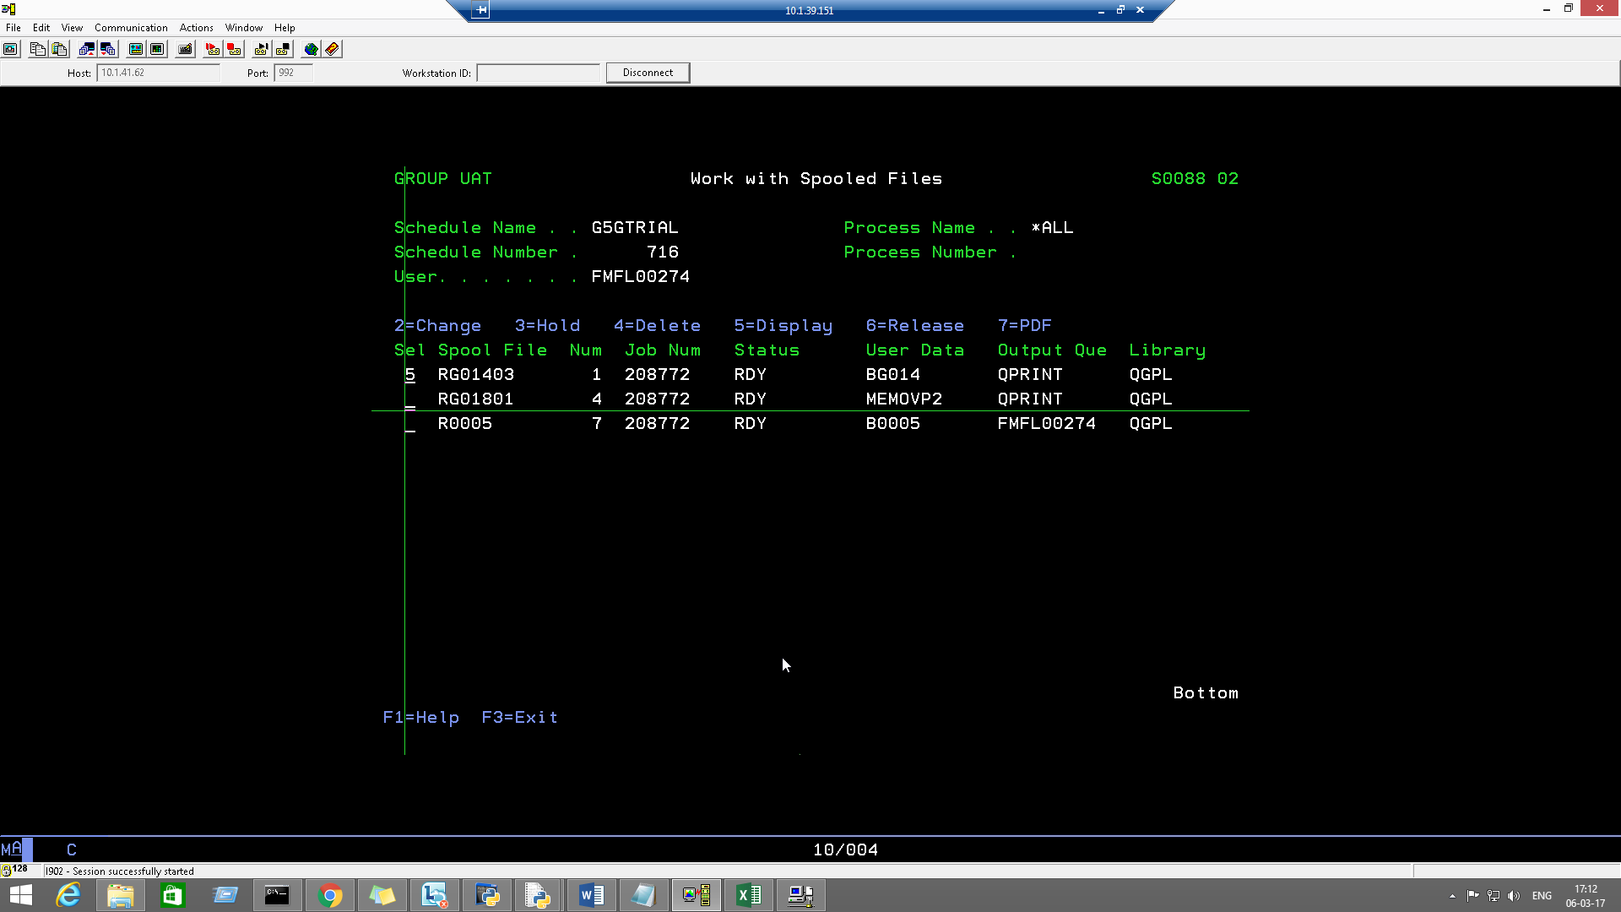

1. In the” **Display Spooled File screen”**, we should verify all the Subsidiary number premium amount related to that policy number

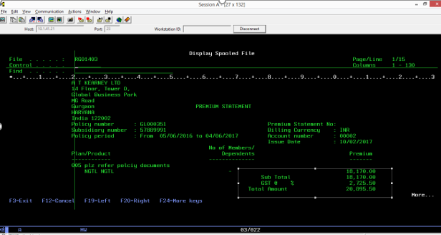

## Verify Trial Balance premium amount with float amount (Additions, Revisions)

**Requirement:**

1. Verify float amount is sufficient for premium amount

**Implementation:**

1. Navigate back to “**System Master Menu** “screen and select sub menu as “Group **Policy Admin Enq** “and click on enter

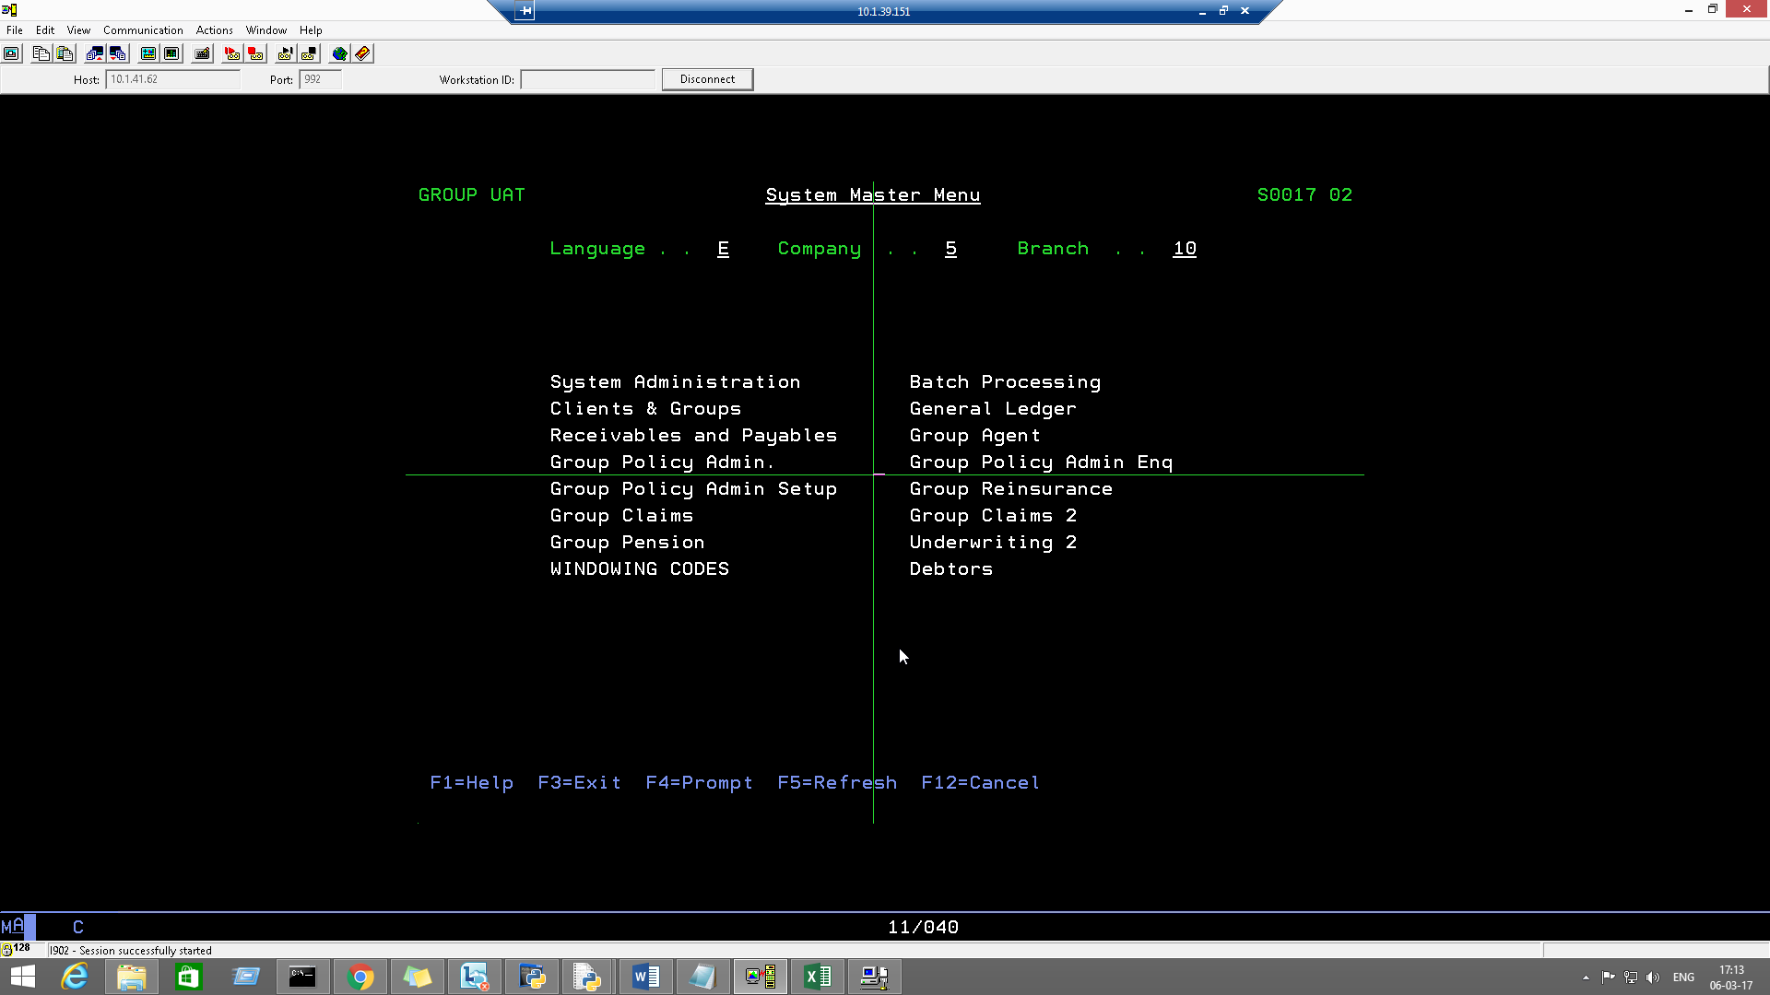

1. In the “**Policy Administration Enquiry**” screen select “**Policy Enquiry/3” sub menu screen** and click on enter

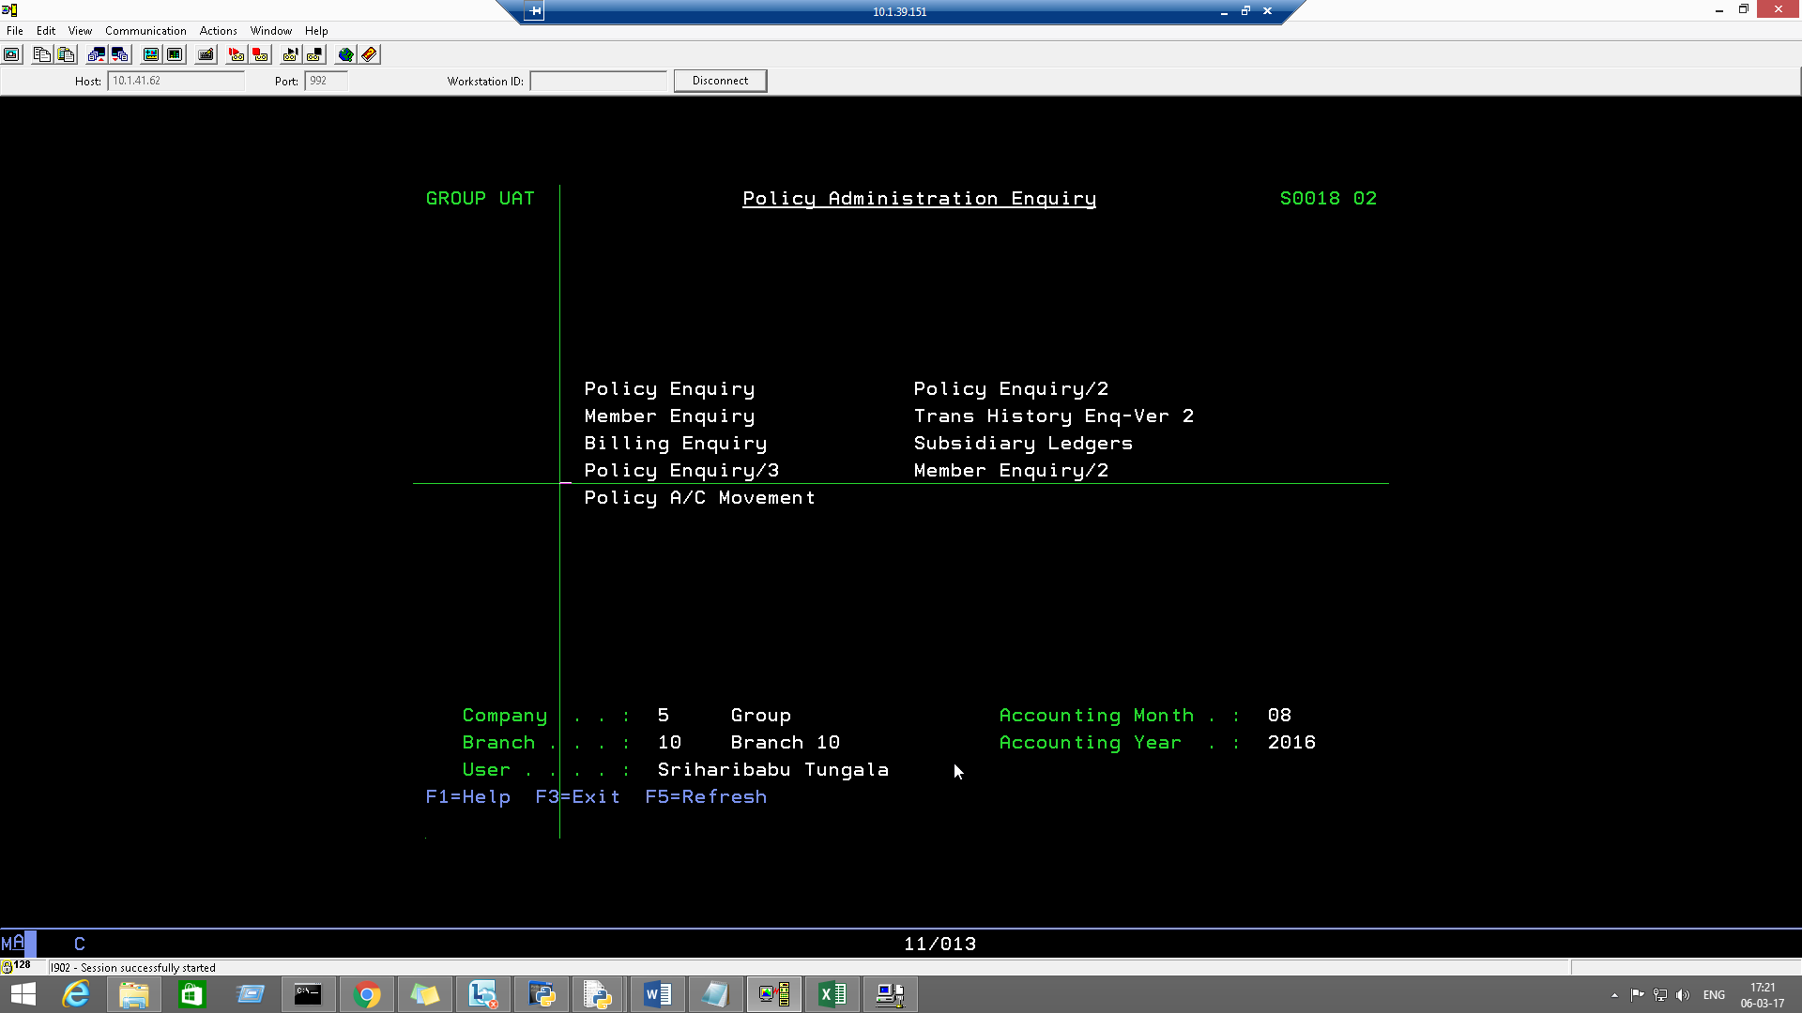

1. Click on enter in the “**Policy Enquiry/3”** Sub Menu screen

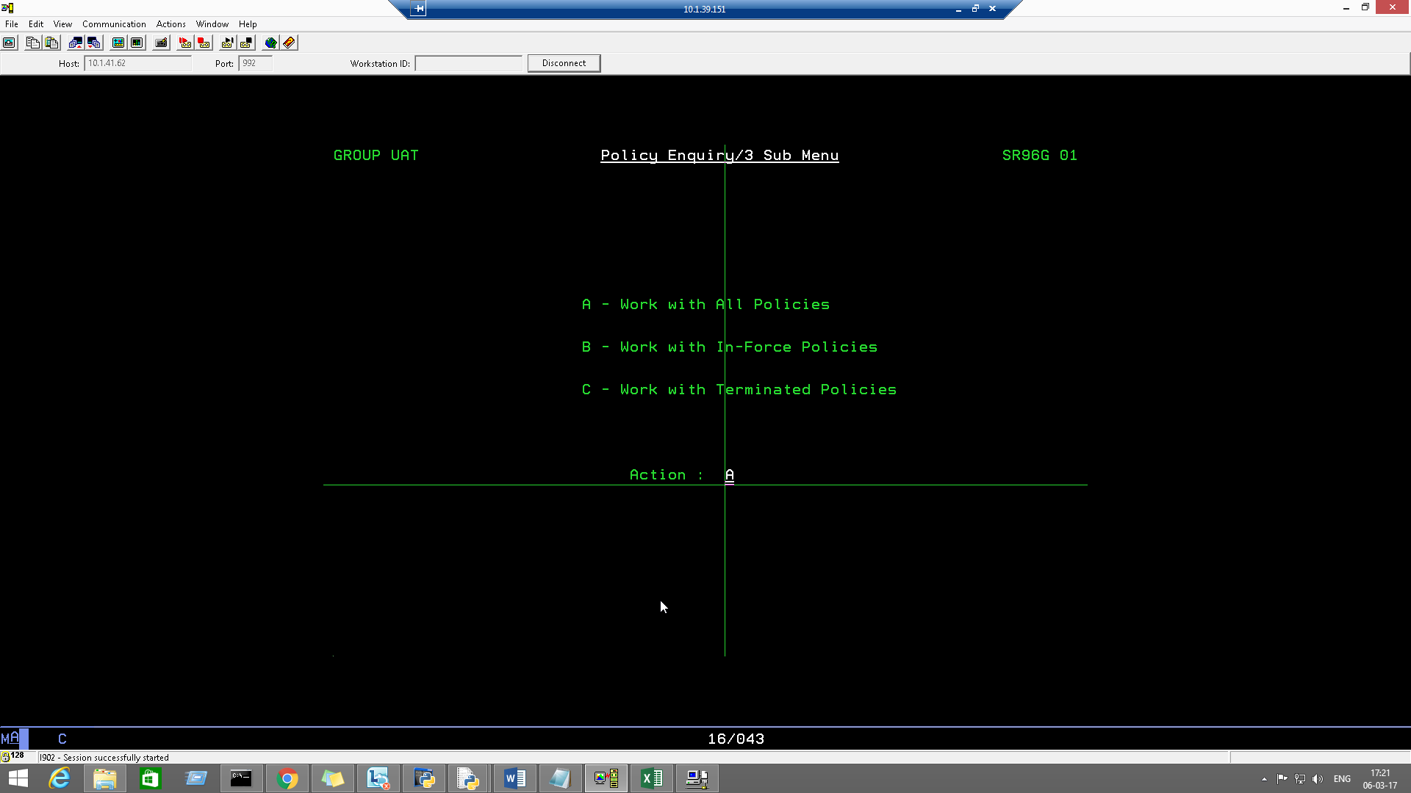

1. In the “**Work With All Polices”** screen, enter the required policy number in the policy field and click on enter.

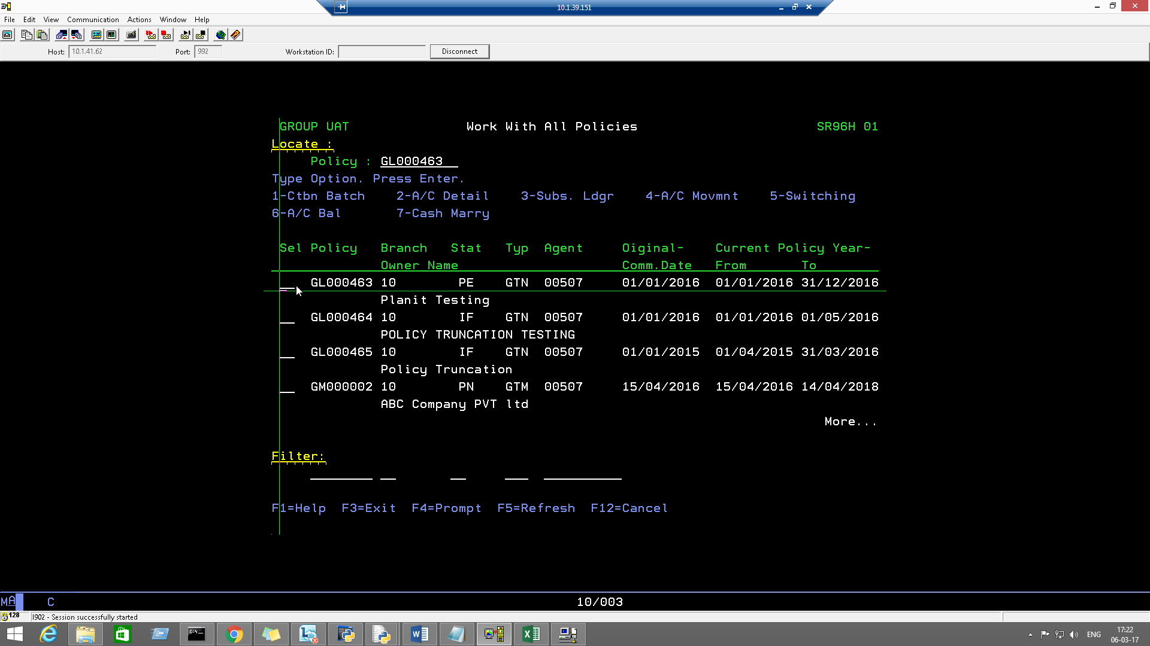

1. Enter the option “**3 – Subs. Ldgr” field** in the first row with the given policy.

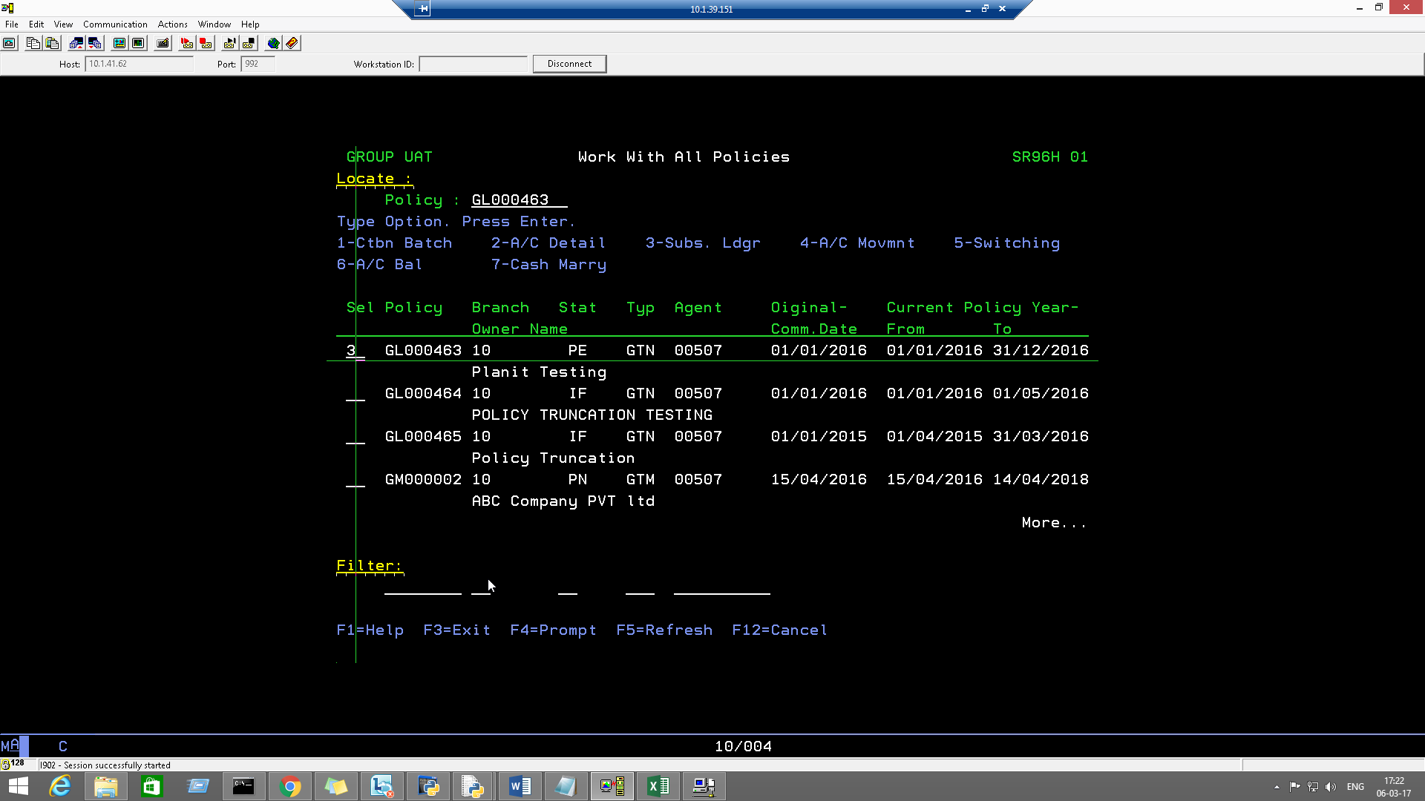

1. Verify sufficient FL balance is available or not for issuing the policy in the “**Subsidiary Ledger Balance Enquiry for a Policy”** screen

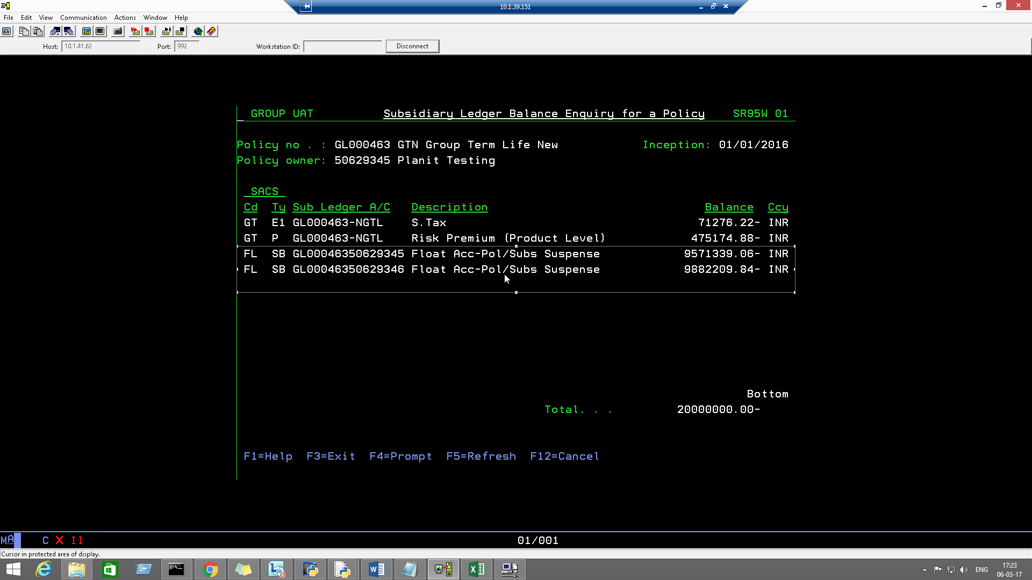

## Issue the Policy (Deletions, Additions, Revisions)

**Requirement:**

1. If float amount is sufficient for premium amount than Issue policy for Addition and Revision transactions. For Deletion we can directly issue the policy.

**Implementation:**

1. Navigate back to “**System Master Menu** “ screen and select the “**Gropu Policy Admin”** and click on enter



1. Select the Major Alterations in the “**Policy Administration contd**” screen and click on enter



1. Enter **Y** in the **Pre-validate (Y/N)** field and Option **F** – **Issue Policy** in the **Action** field in the “**Major Alterations –Sub Menu”** screen

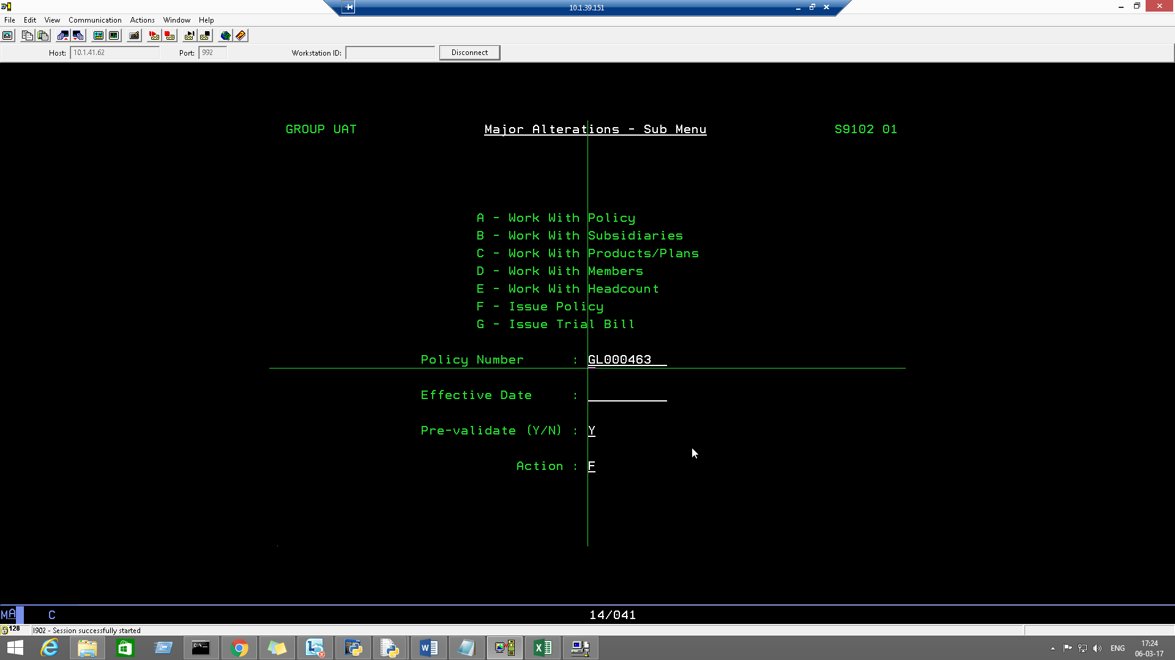

1. Click on enter in the **Pre-Issue Product Count** screen

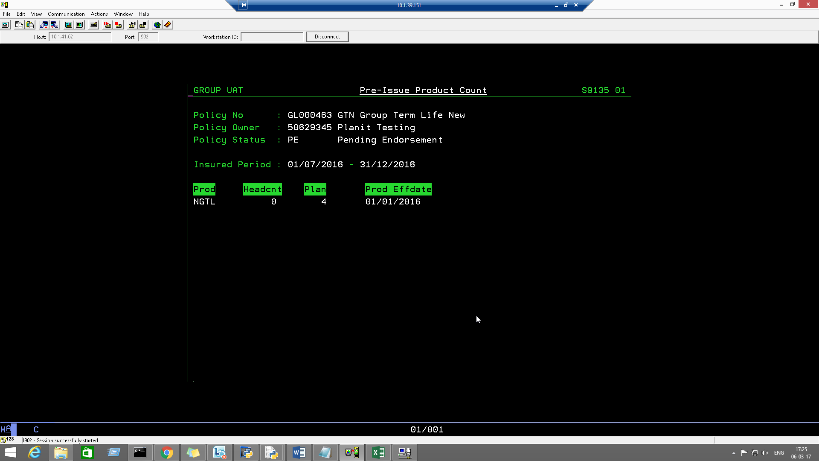

1. Click on enter in the “**Pre-issue Validation”** screen

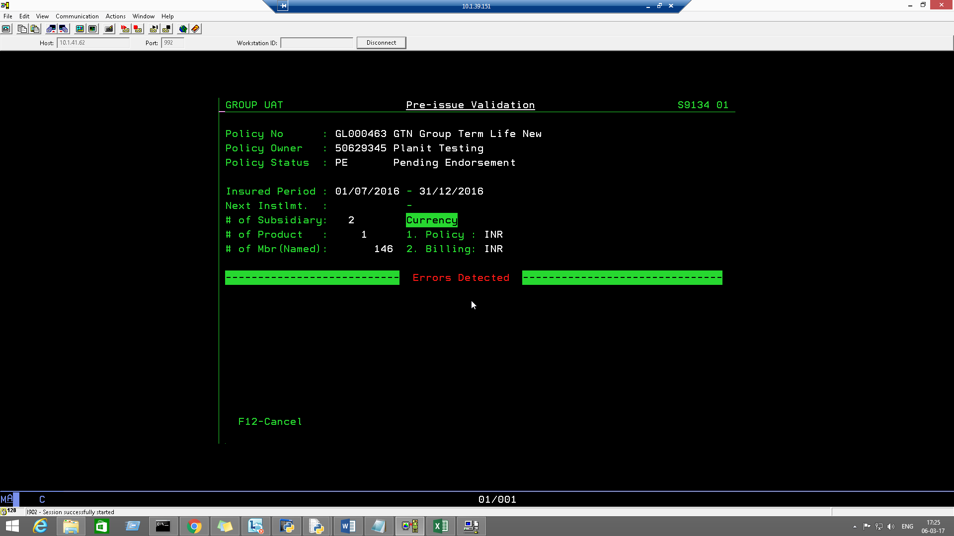

1. Click on enter in the “**Issue Confirmation”** Screen



1. Verify the **completed normally** message in the “**Display Messages”** screen

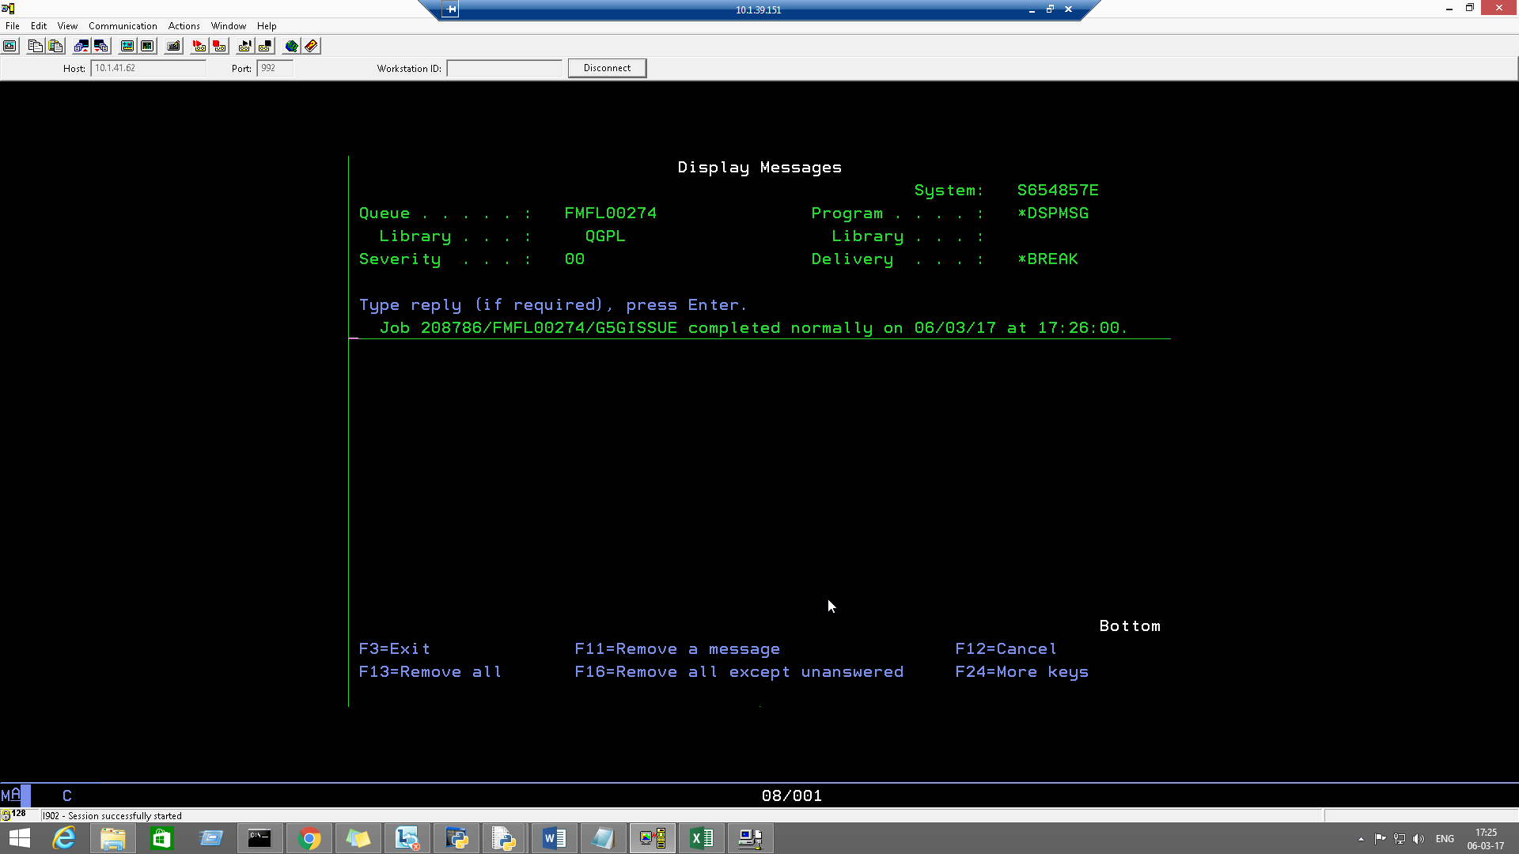

## Verify Policy Status (Deletions, Additions, Revisions)

**Requirement:**

1. Verify Policy Status for all Transaction (Deletions, Additions, Revisions)

**Implementation:**

1. Navigate to “**System Master Menu** ‘” screen and select sub menu as “**Group Policy Admin Enq”** and click on enter

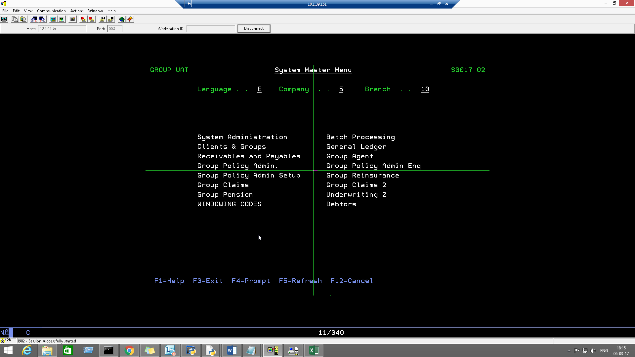

1. Select the “Policy Enquiry” sub menu in the “**Policy Administration Enquiry”** screen and click on enter

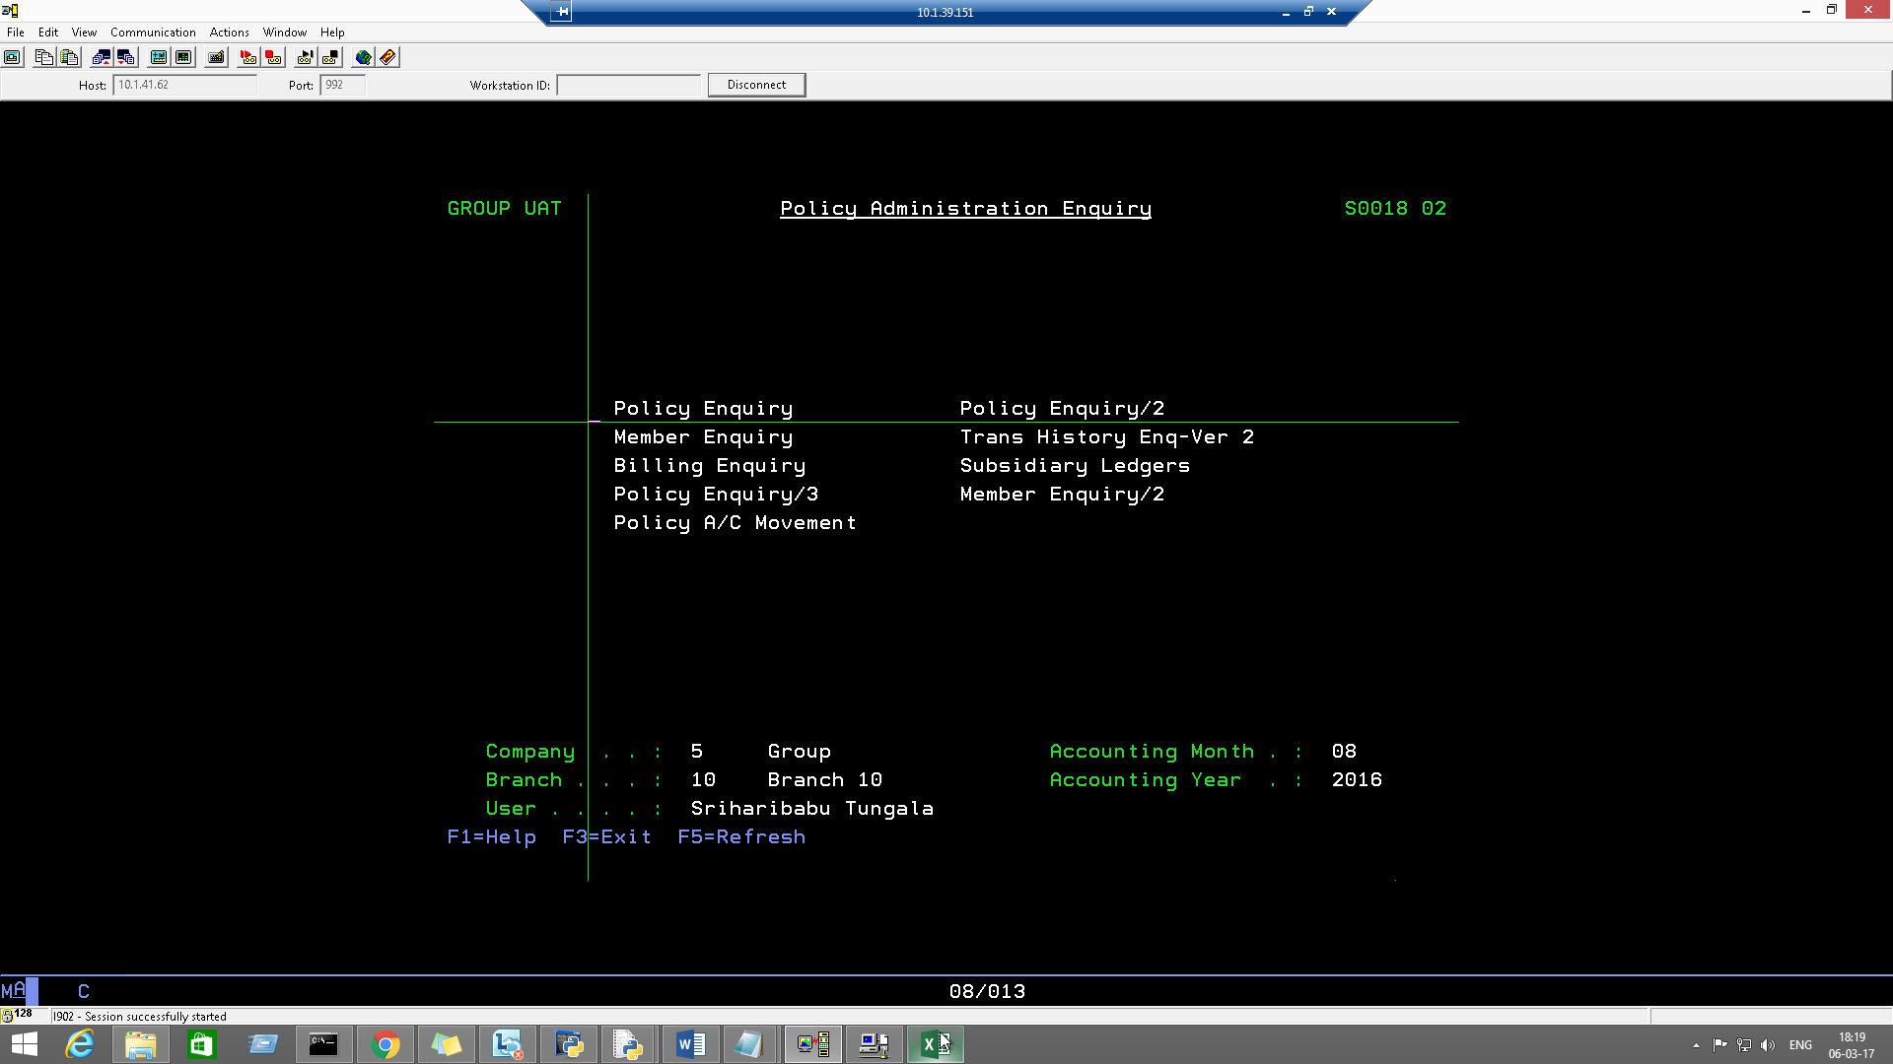

1. Click on enter in the “**Inquiry – Sub Menu”** screen

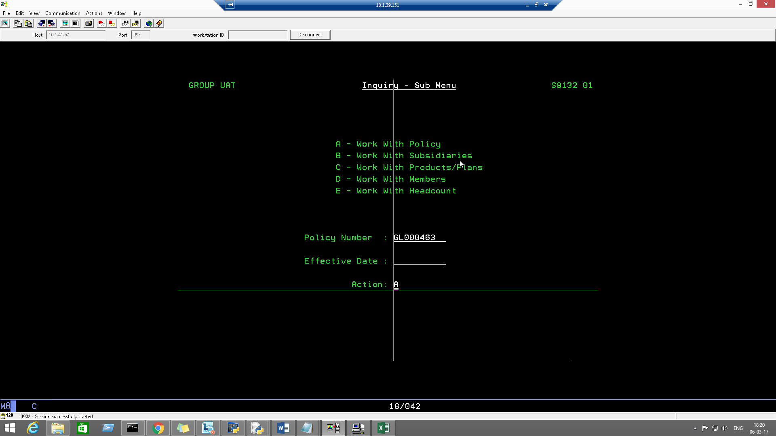

1. Verify the Policy Status in the “**Policy Header”** screen

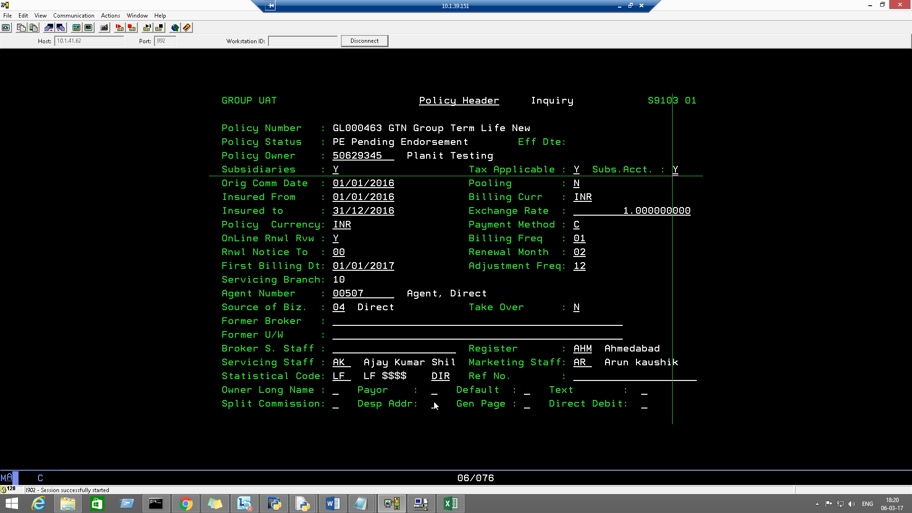

## Generate Bill Data from Bill Data dtf (Deletions, Additions, Revisions)

**Requirement:**

1. Bill Numbers are extracted by Bill data Transfer from IBM i (. dtf) file uploader

**Implementation:**

1. Lunch the “BillData.dft“ file downloader
2. Select IBM i Name as the 10.1.41.62 from the dropdown
3. Click on Data Option button

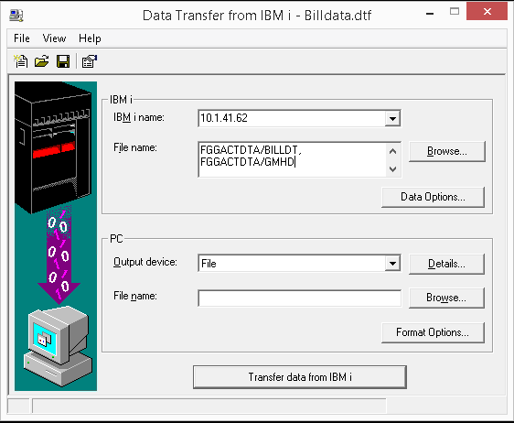

1. Enter the required **Date** in the “**Where”** field text box and click OK in the Change Data Options window

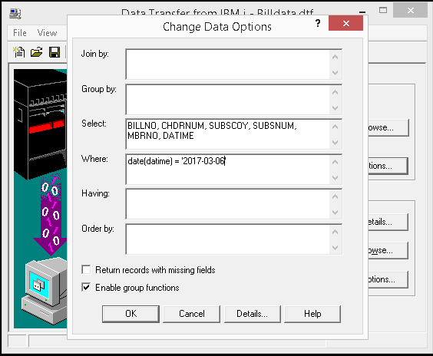

1. Click on Browse button and select the **file name** to save the **Billdata** with the extension.xls
2. Click on Transfer data from IBM i button

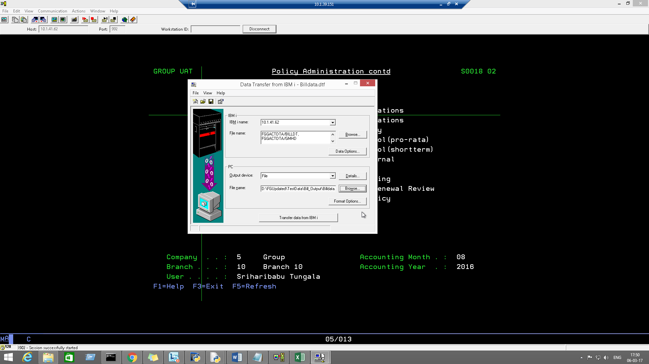

1. Click on “**Yes”** buttonin the **“IBM i Access Data Transfer** “ in pop up window

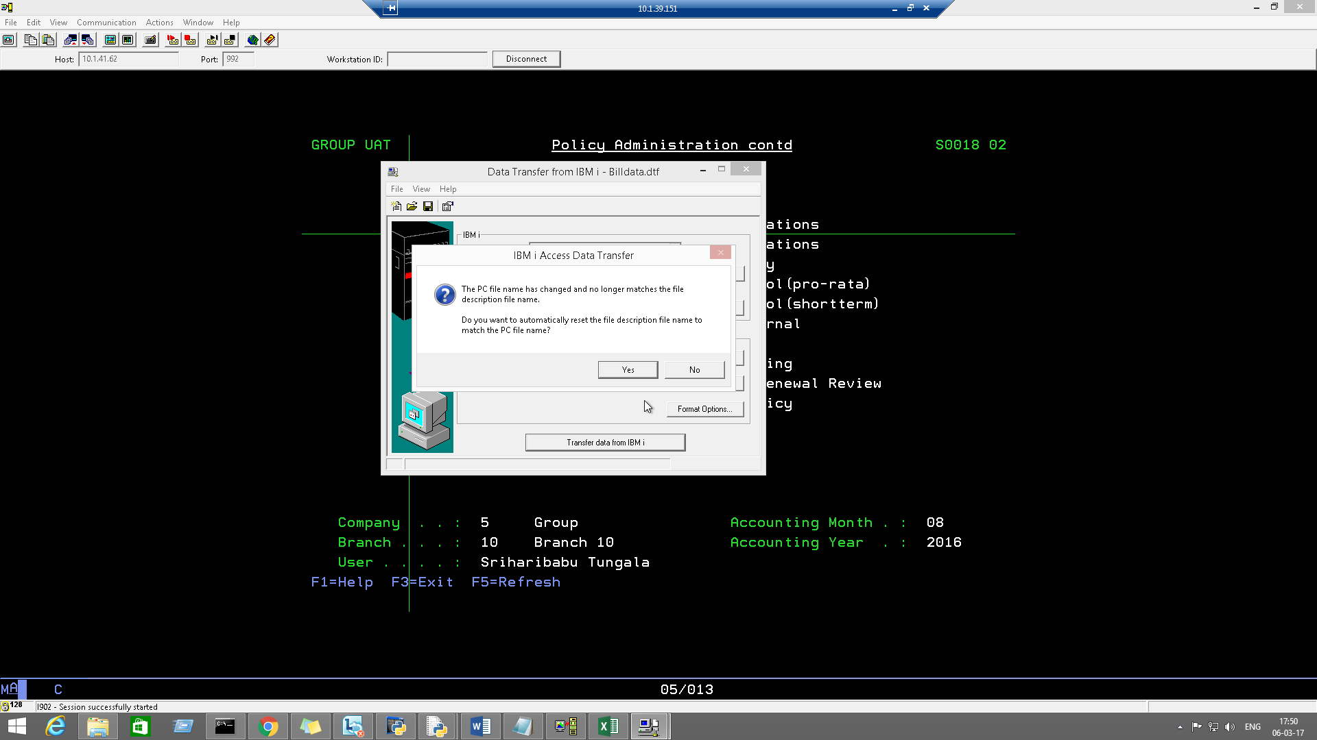

1. Enter the valid credentials in the” **IBM i signon”**  window

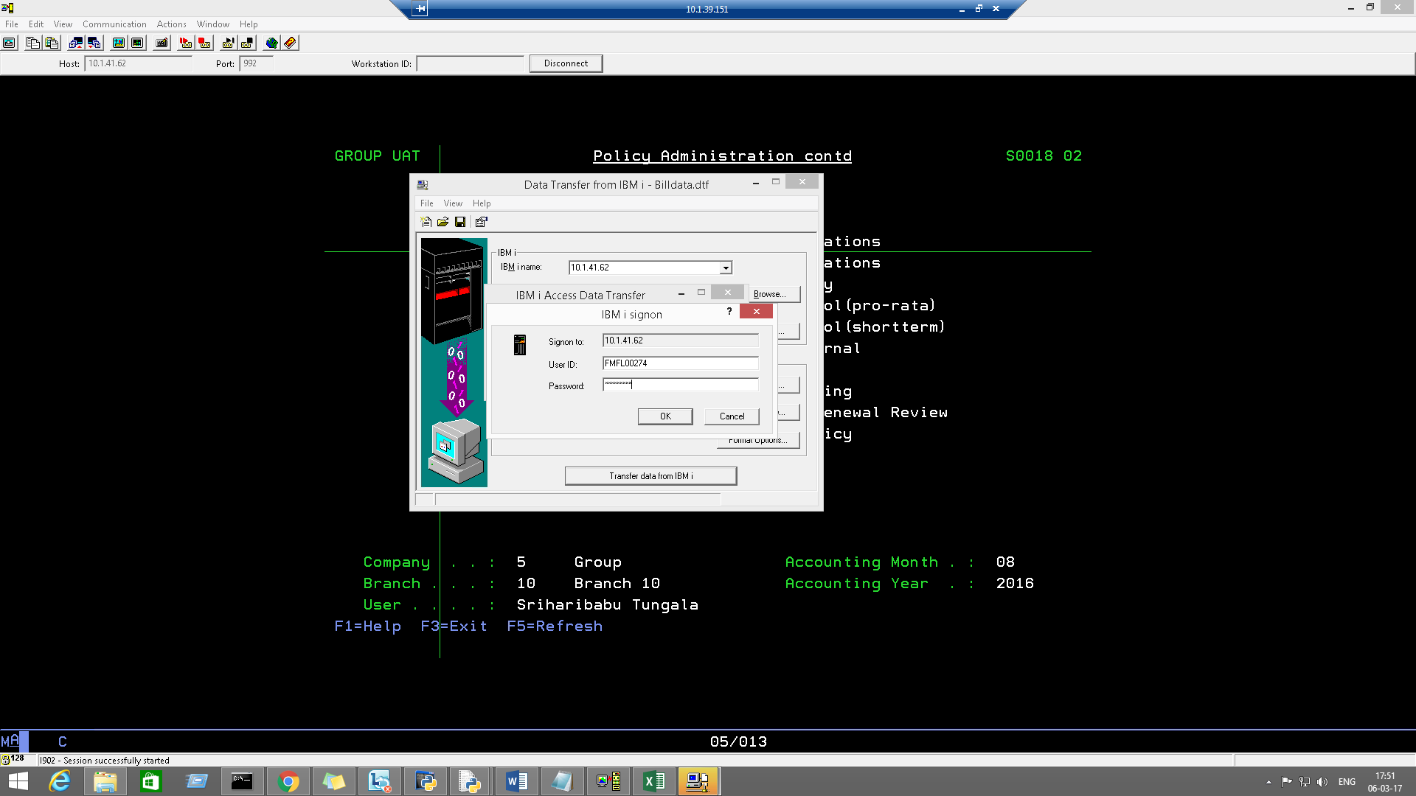

1. Click on **OK button** in the “**Transfer to File Complete”** in pop up window

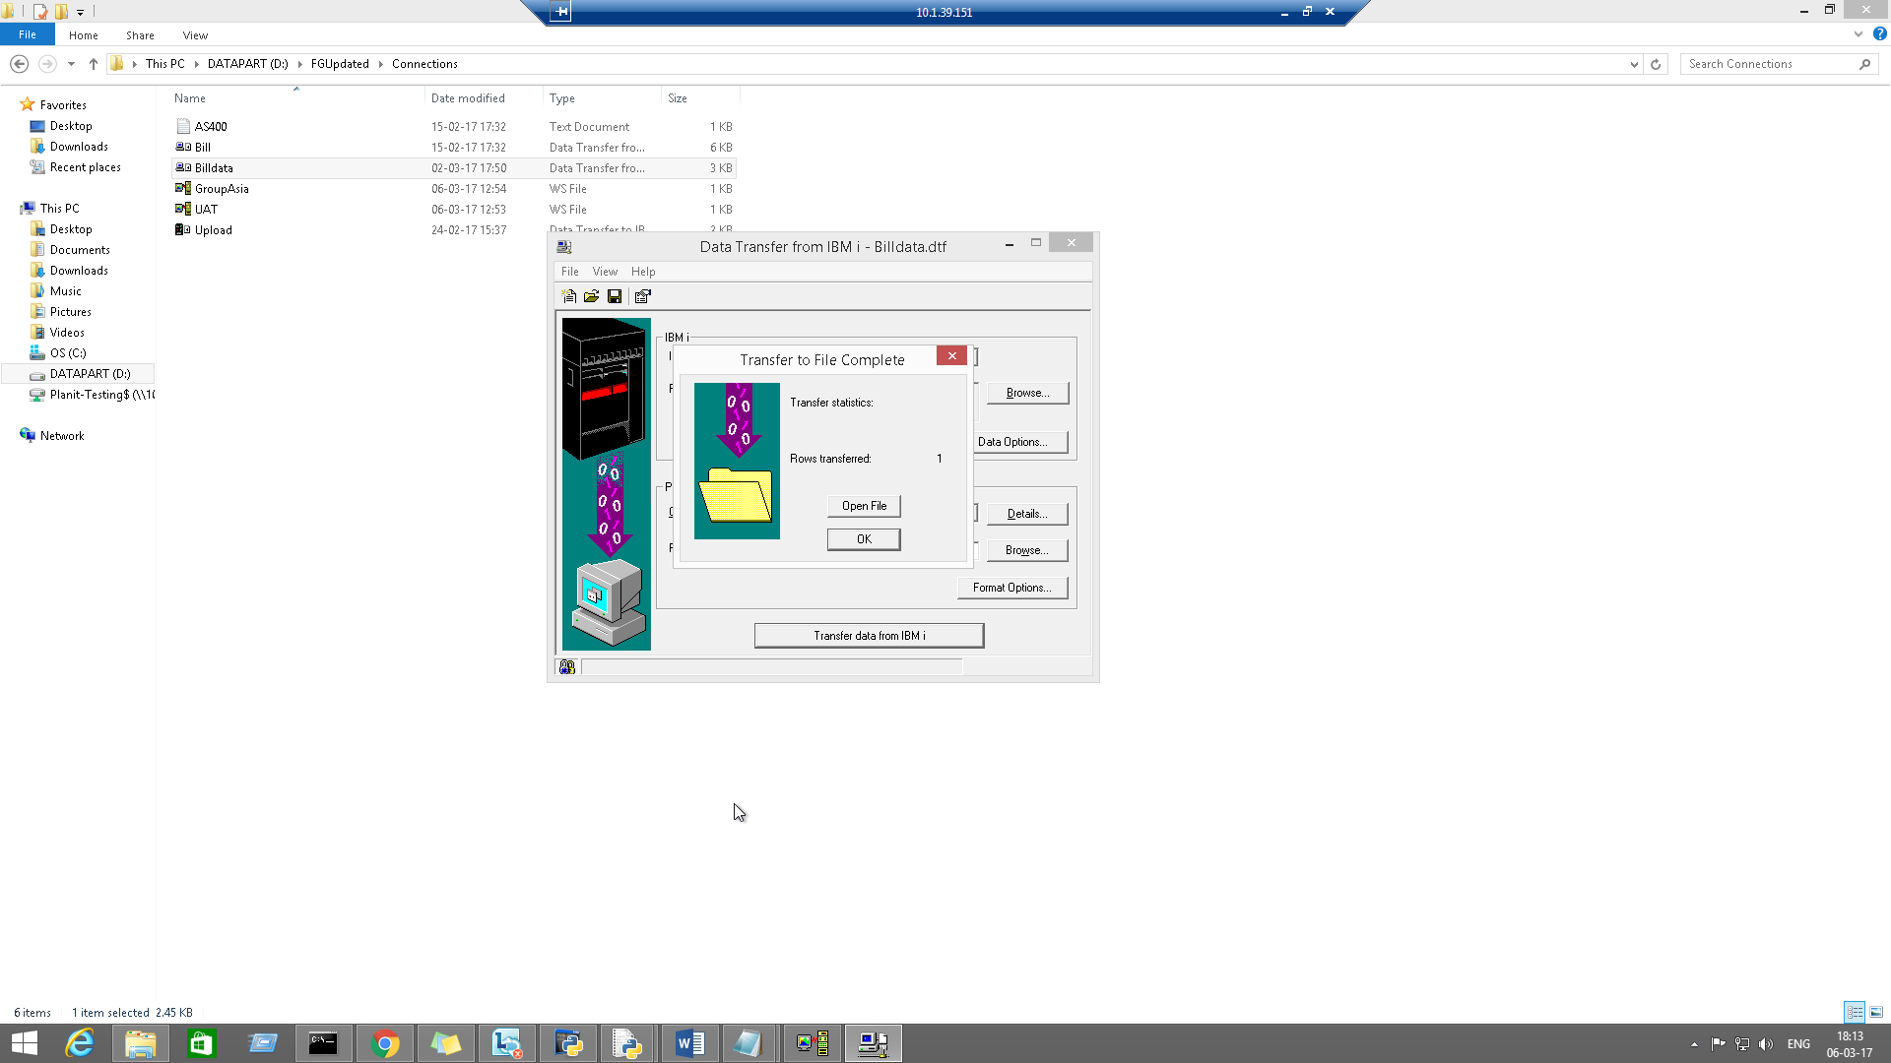

1. Verify the BillNo’s in the “**BillData.xls”** file

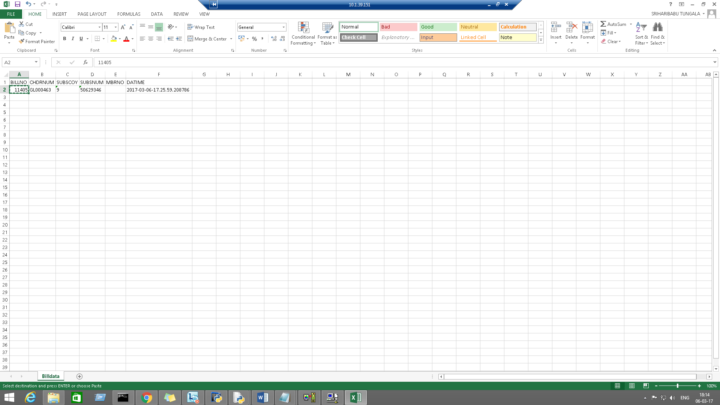

## Submitted Bill No Batch Processing (Deletions, Additions, Revisions)

**Requirement:**

1. Run bill batch job as batch name “G5GBILEXT’’ and export bill though dtf file downloader

**Implementation:**

1. Select the Batch Processing in the “**System Master Menu “**screen

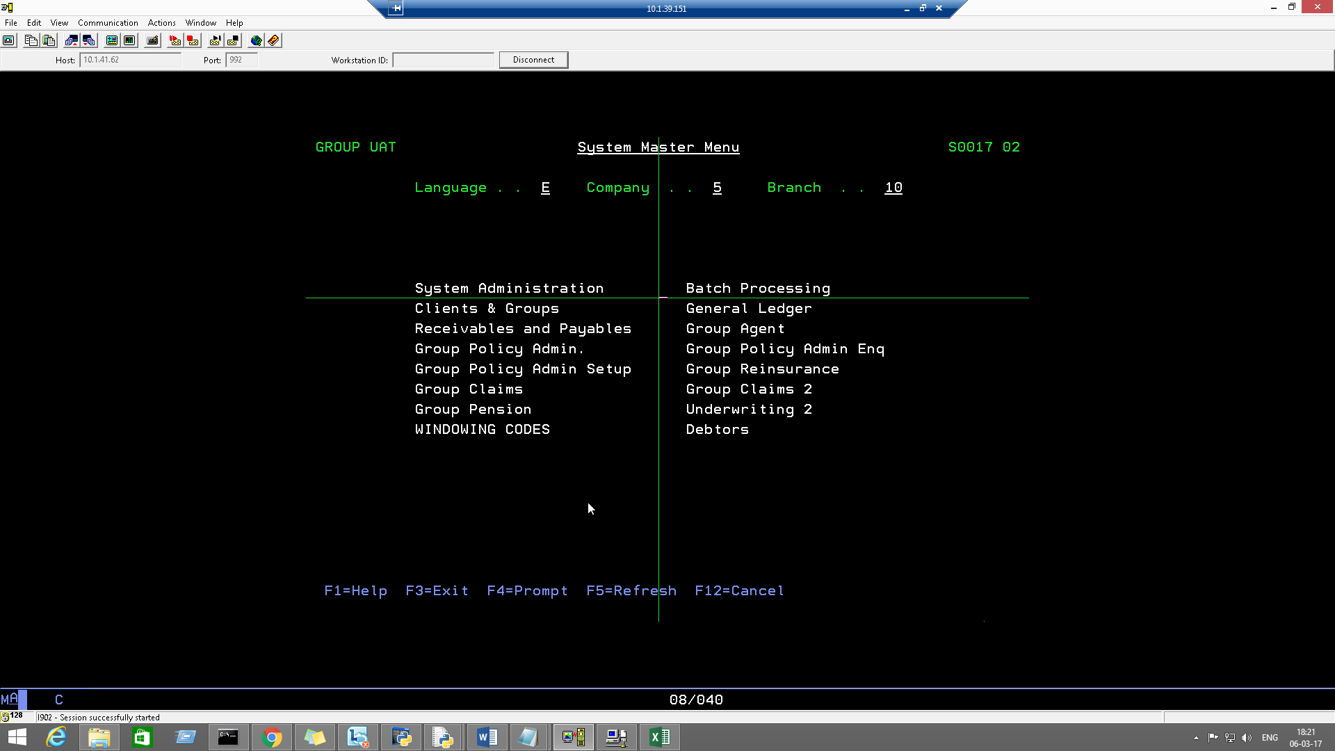

1. Select the Schedule Submission in the “**Batch Processing “**screen

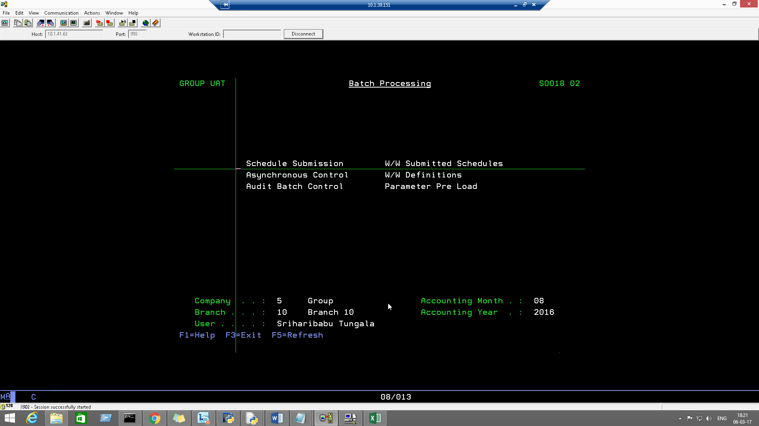

1. Enter batch job as “**G5GBILEXT**”in the select field under “**Schedule Submission Submenu”** screen and click on enter

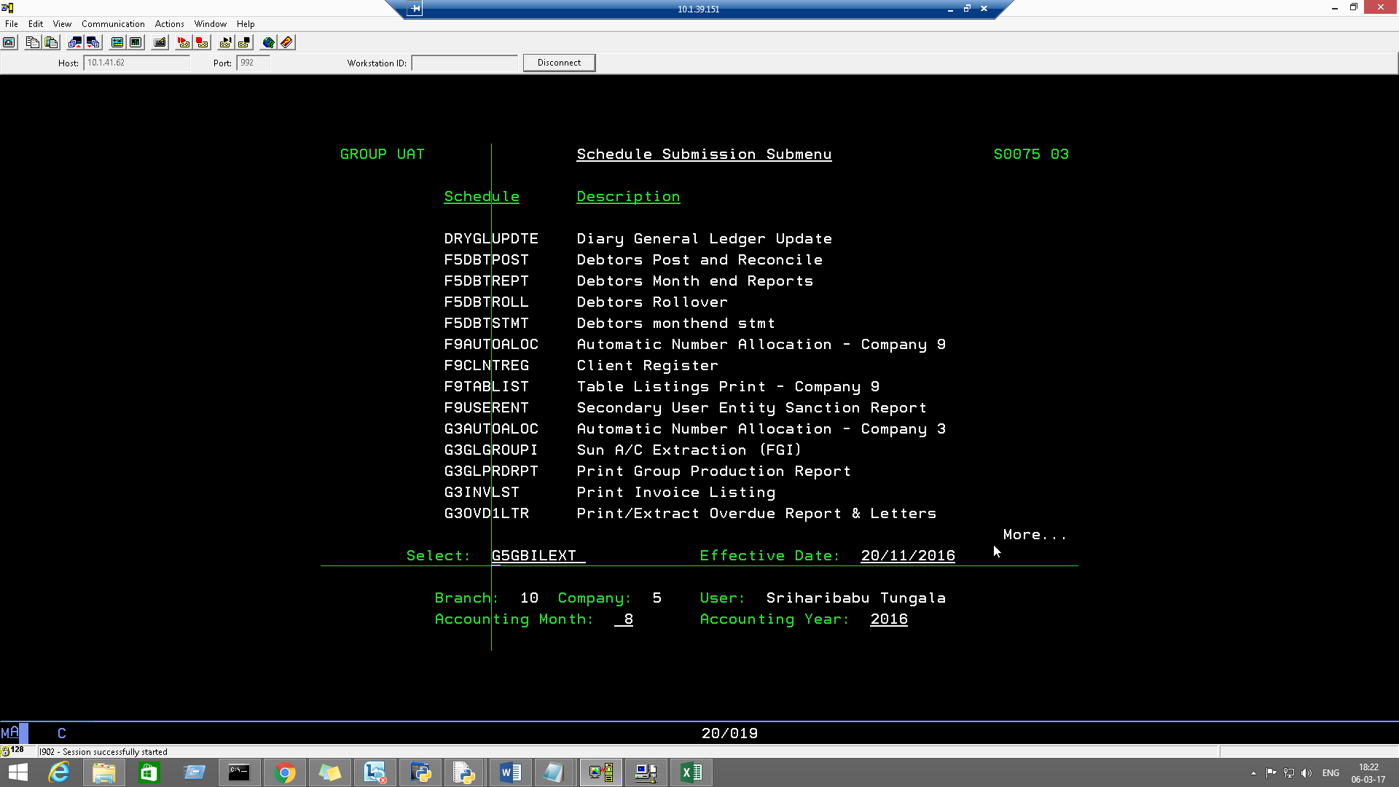

1. Enter the Bill No in the “**Bill No.”** field and click on enter

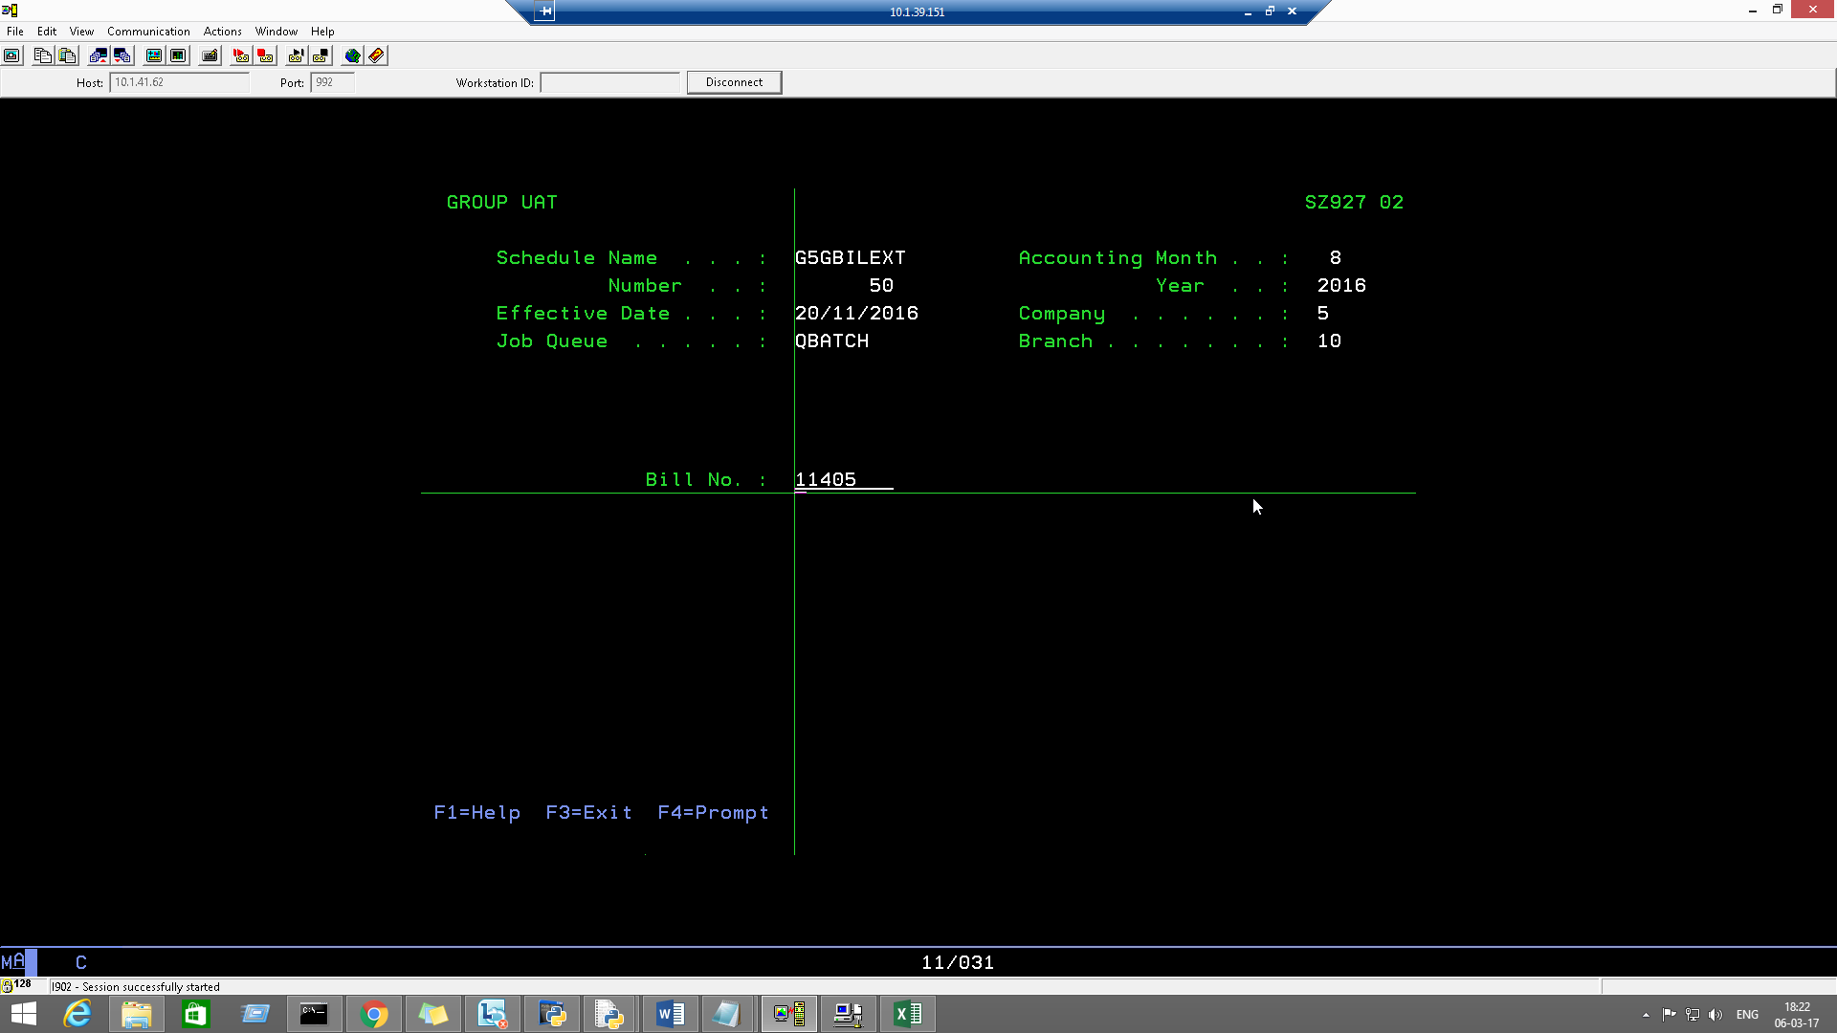

1. Verify the C**ompleted normally** message in the “**Display Messages”** screen

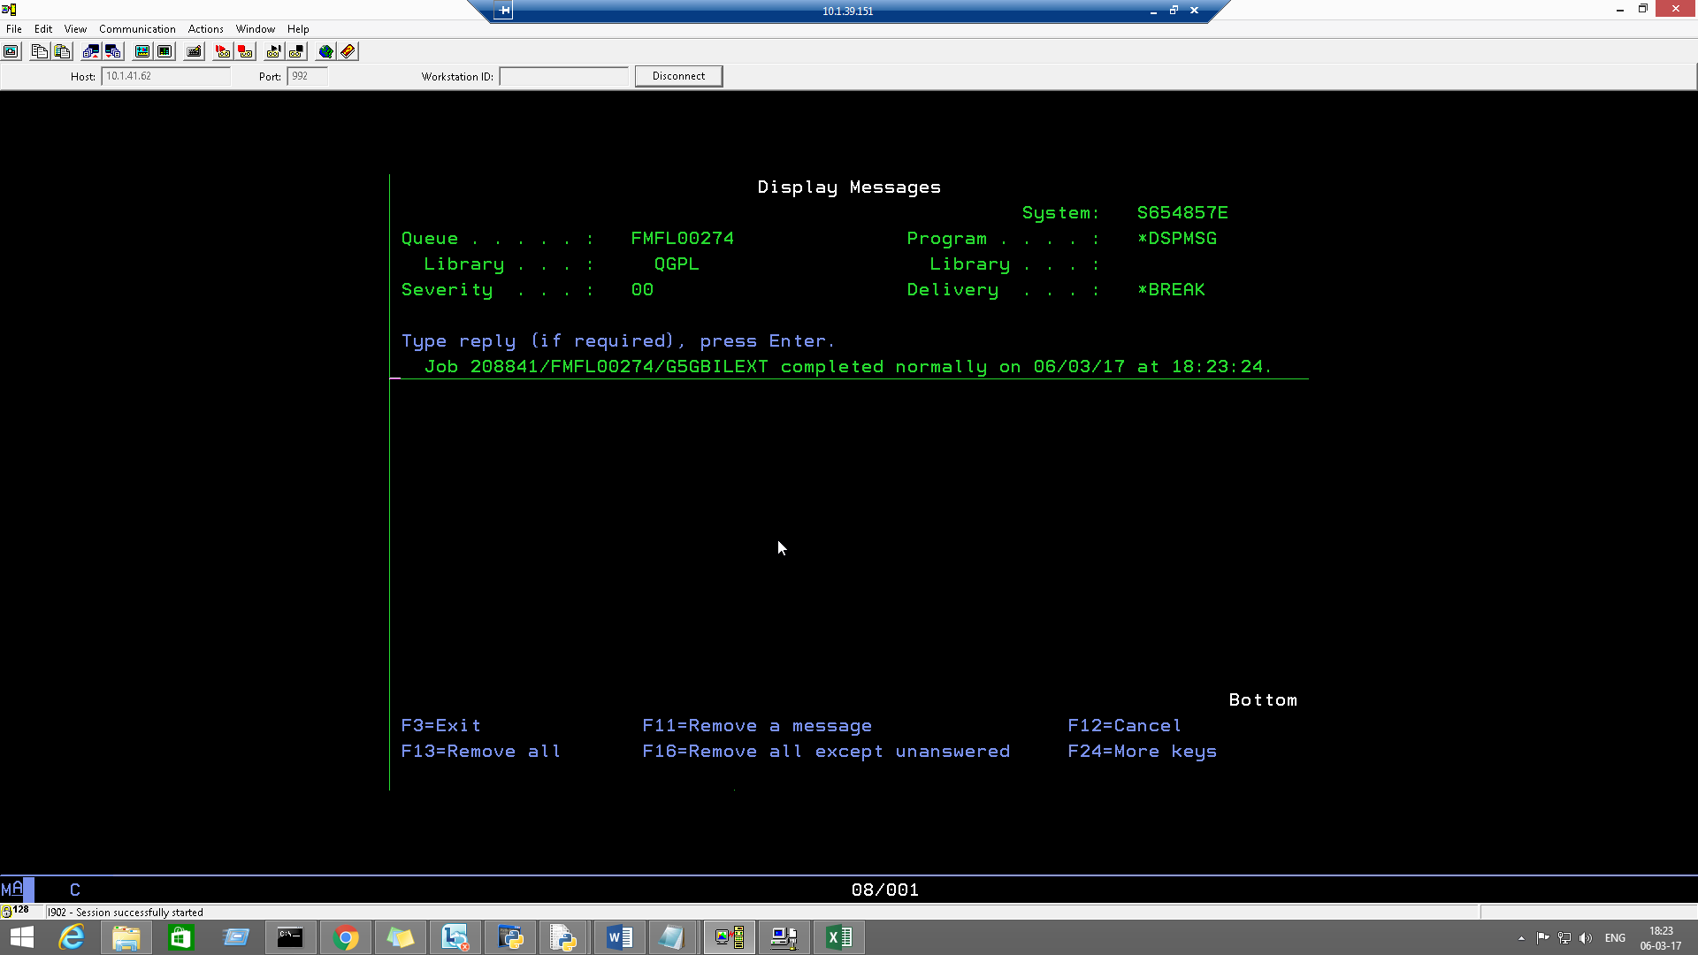

1. Verify the Schedule submitted message in the “**Schedule Submission” Submenu** screen

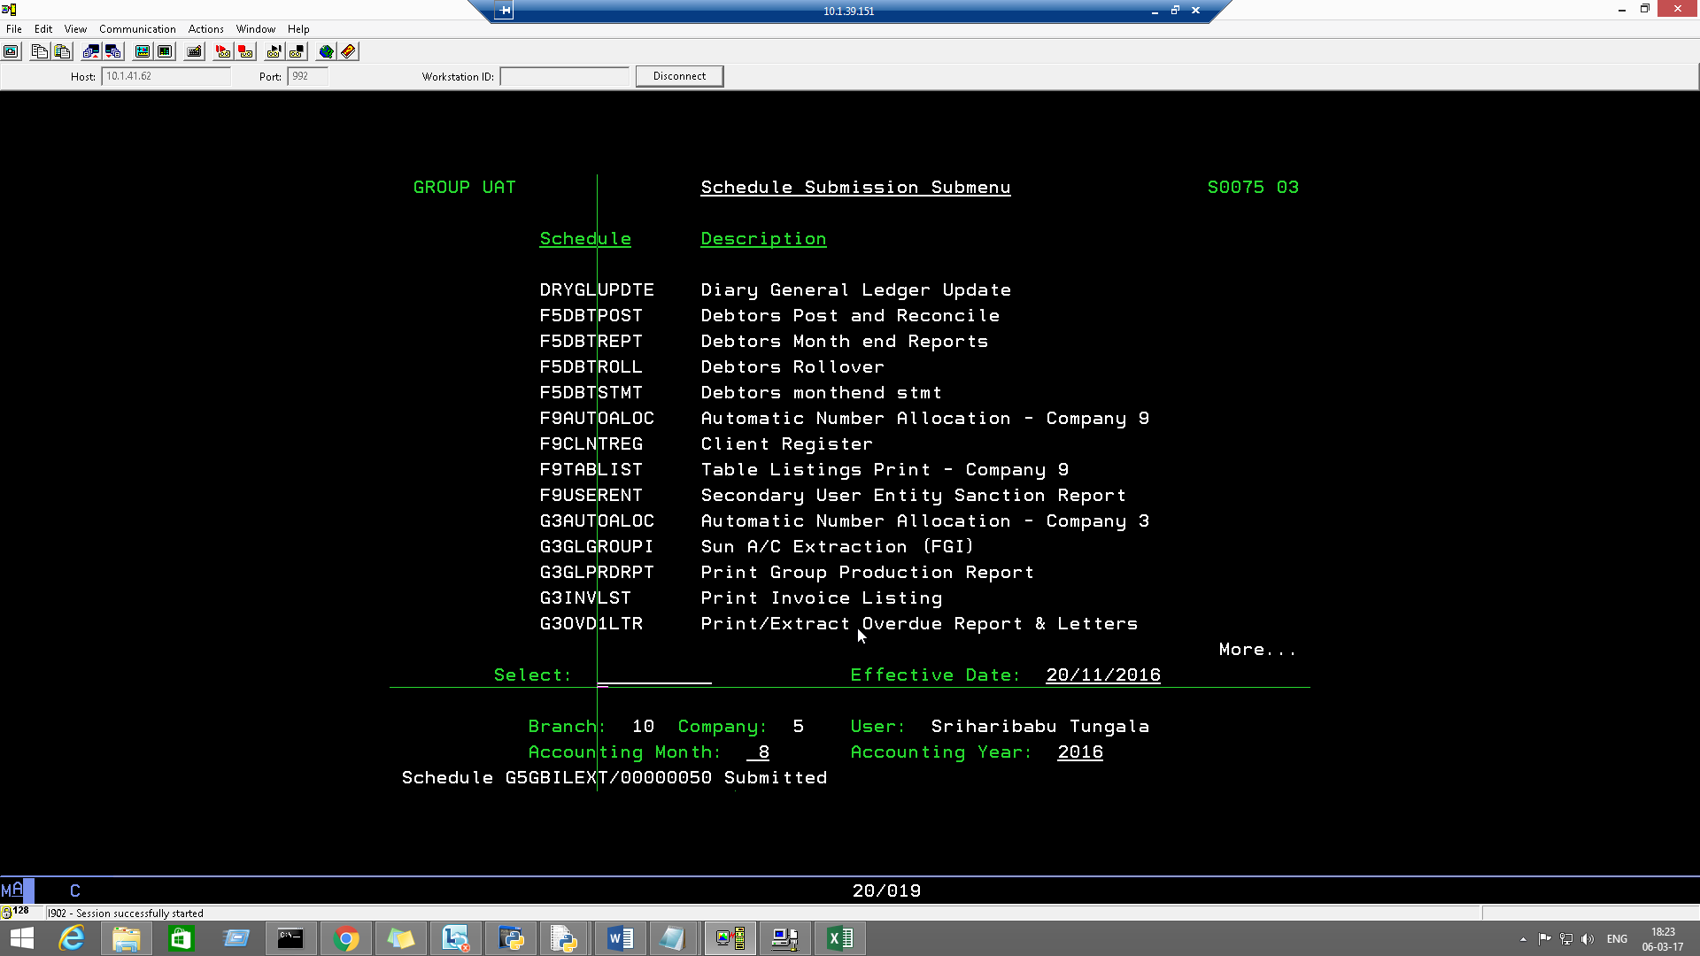

## Export bill though dtf file downloader (Deletions, Additions, Revisions)

1. Select “IBM i name” as 10.1.41.62
2. Enter the text “**FGACTDTA/BILLDT, FGGACTDTA/GMHD**” in File name field
3. Click on Browse button and Browse the “BillData.xls” file

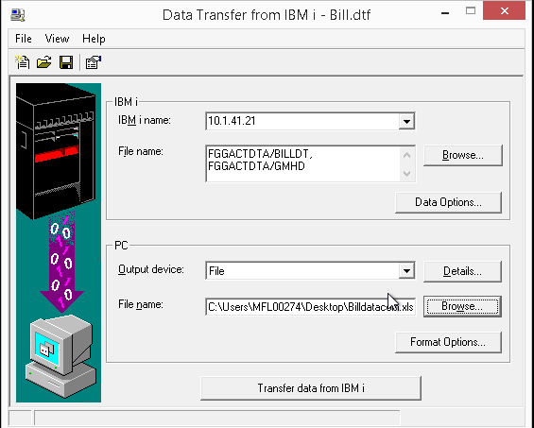

1. Click on Yes button in “**IBM I Access Data Transfer** “in pop up window

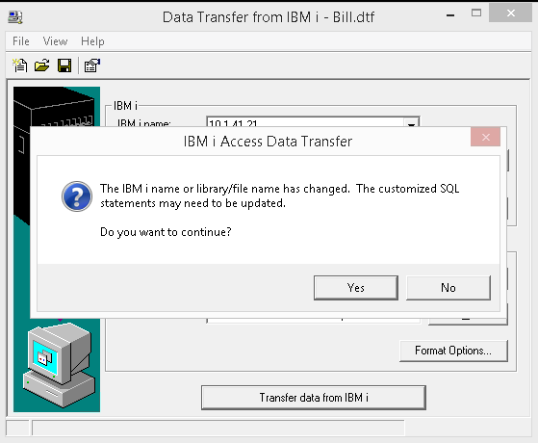

1. Enter valid credentilas in the “ **IBM i signon”** window and click on **Ok** button

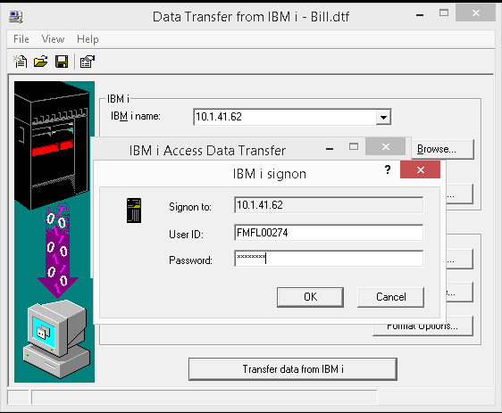

1. Click on Ok button in the “Transfer **to File Complete”** in pop up window

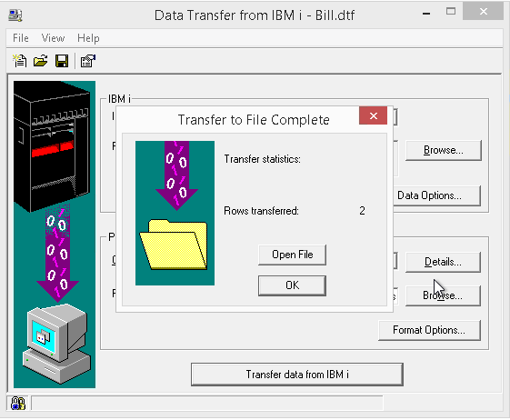

1. To check the extracted bill numbers, go to the “**Bill_Output**” folder in “**TestData**” folder.

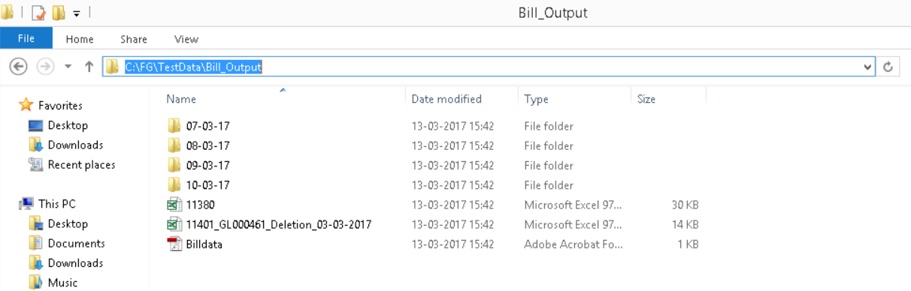

1. Extracted files with Policy numbers should be displayed in the current date folder in the “**Bill_Output**” folder

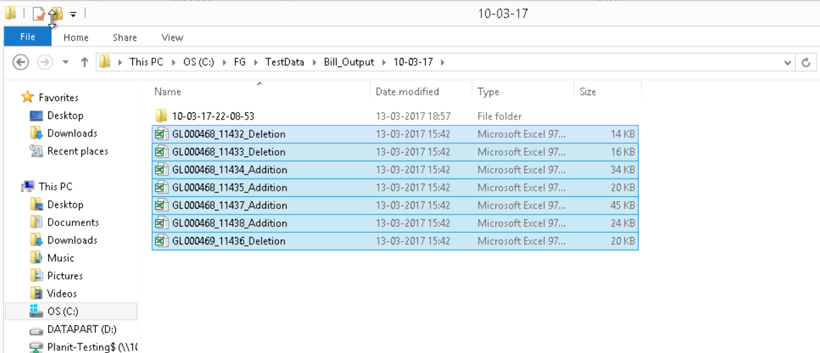

1. Get transaction name from extracted bill number file

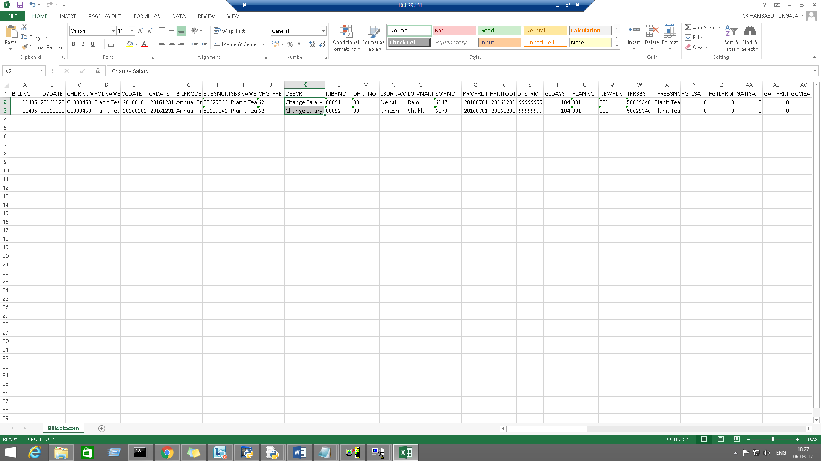

# Check List for Execution of the Utility

1. Client Data should be in the ‘..\FG\TestData\client_data’ folder. File name should be saved with the Policy Number
2. For every sheet in the client file one mapping sheet needs to be there in the configuration file in the path ‘..\FG\TestData\ConfigurationSheet.xlsx’
3. Below are the sheet names in configuration sheet file:



1. SheetNames:
   * In this sheet expected sheet names from the client file should be given in the ‘Expected Different Sheet Names’ column separated with comma (‘,’) and related default sheet name should provide in the next column ‘Default Sheet To Save’

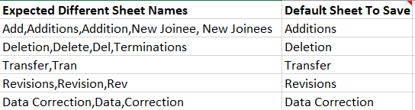

* + Expected column name to identify the row/Header of the client sheet should be provided in the ‘ColumnNameToGetRowNumber’ column separated with comma (‘,’)



* + Based on the name provided in the ‘ColumnNameToGetRowNumber’ header will be identified from the client file from the respective sheet and get the data below to that header
  + Sheet names provided in the ‘Default Sheet To Save’ column should be the sheet names for other transactions (ex: if ‘Additions’ is the sheet name in Default Sheet To Save column then sheet for Addition related transaction in client should also be ‘Additions’. This names should be case sensitive)

1. Additions: This sheet name should be same as the name provided in the ‘Default Sheet To Save’ column in the ‘SheetNames’ sheet
   * Expected columns from the client file in Additions related sheet should provide in the ‘Expected Different Column Names’ column separated with comma (‘,’) and related macro file column name should be provided in the ‘Default Column Name in Macro’

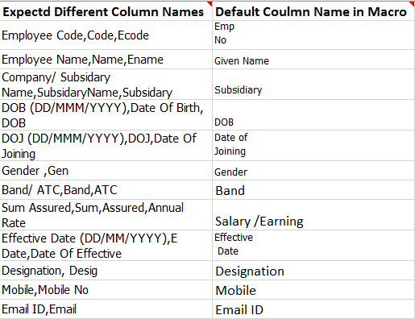

* + Band is not available in macro file but it is a required field to identify the ‘Plan’ and ‘Occp’ from the master data file in case of Graded policy
  + If no macro file column name is available for the client column, then provide the same name
  + Data in ‘Expected Different Column Names’ column is case-insensitive and space-insensitive

1. Revisions: Same as Addition sheet
2. Deletion:
   * Same as the Additions sheet but in case of Effective date we need to add +1 in the macro file, for that ‘Rule’ column is provided. Provide the number of days to add / remove from the effective date in the rule column. To decrease the date please provide the number with negative sign (ex: -2)

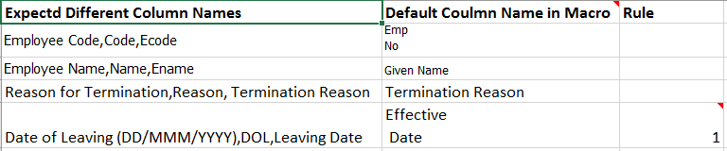

1. Static Data: In static data providing the static data related to all sheets and the differentiation is added in the code for which transaction what is the static data

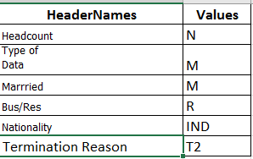

1. Master data file should be placed in ‘..\FG\TestData\Master DataFile.xlsx’. Format for the Master data should be in the below format

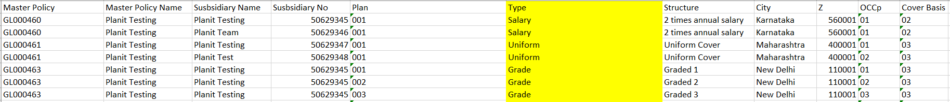

* + ‘Type’ column should be available in the Master data file to identify the Structure Type of the policy based on cover basis whether it is Uniform or Grade

1. Standard macro file should be placed in ‘..\FG\TestData\Standard_macro.xlsm’. Data in the client file written in the provided standard macro file to upload it to the application

**Test data folder for more details:**



# Execution Process

1. Open the RIDE from Command Prompt or shortcut icon from the desktop. Type ride.py in command prompt

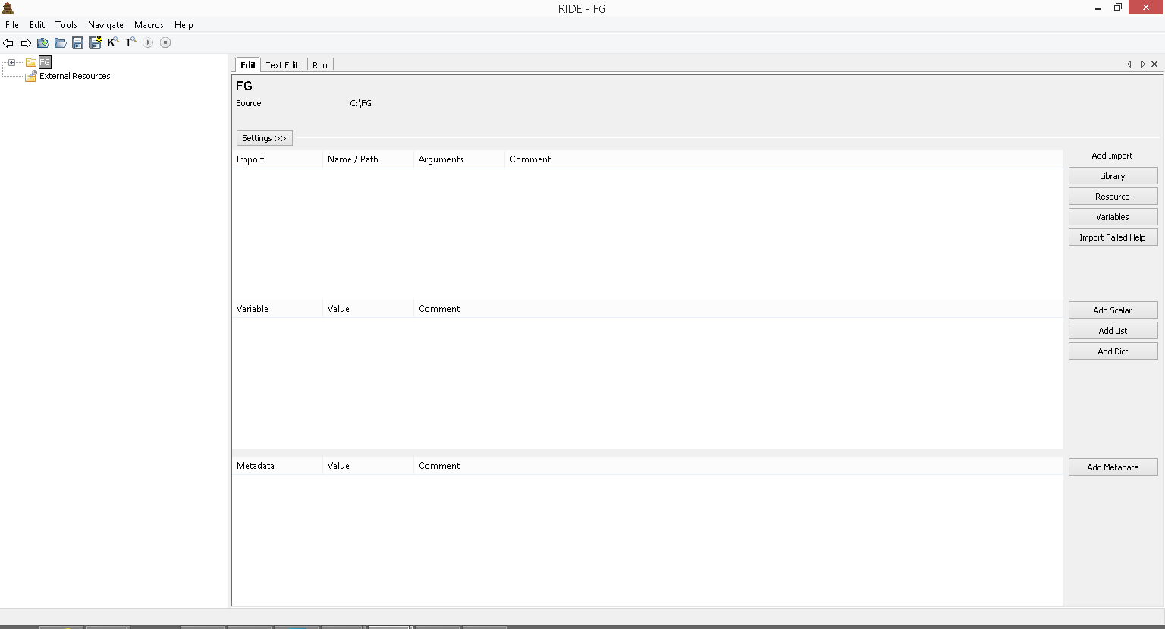

1. Click on the “open directory icon” on top left side corner. Select the FG project folder.

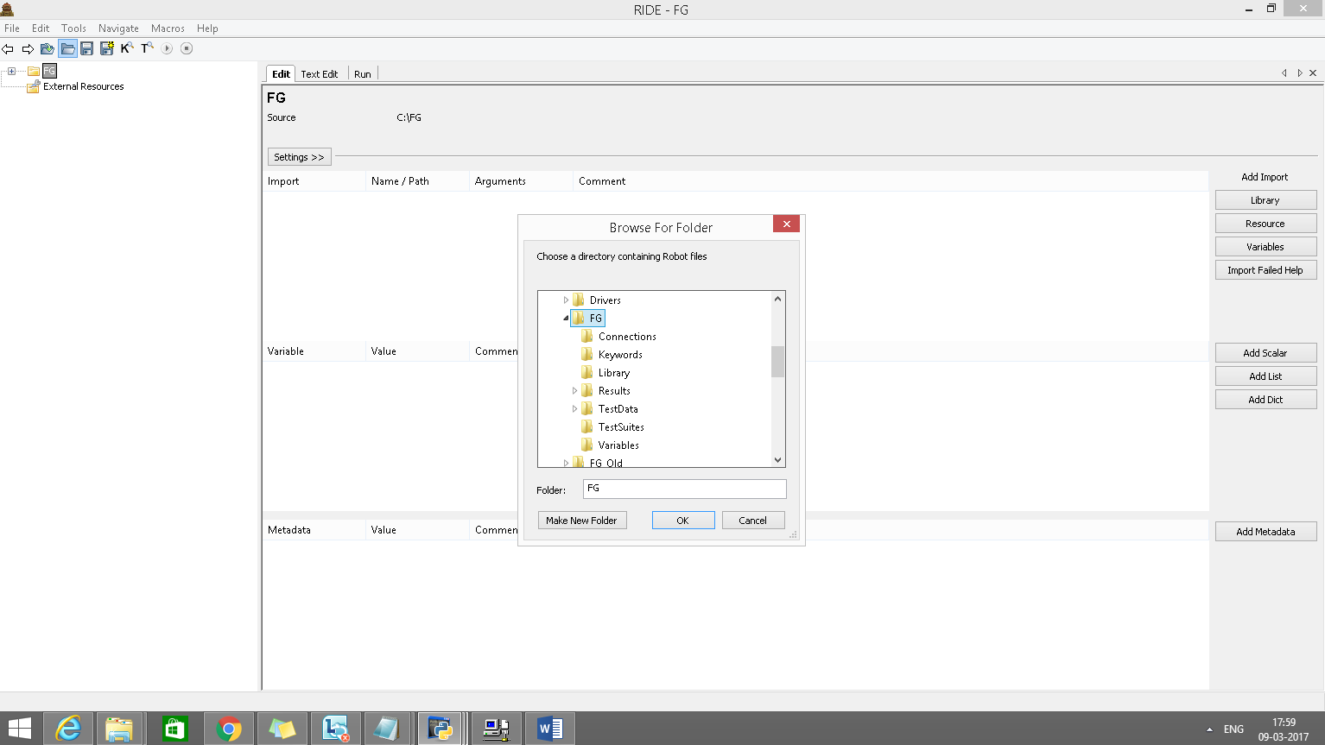

1. Click on ok button.

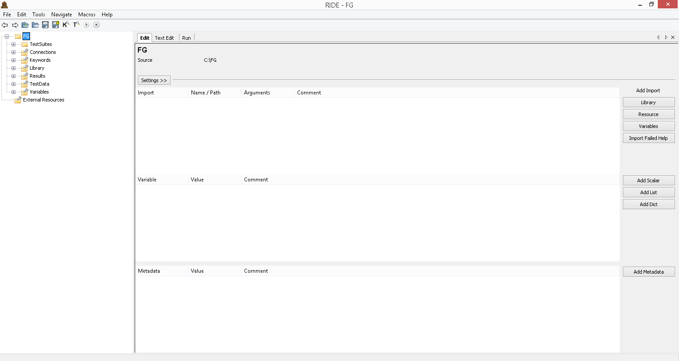

1. Expand the “**TestSuites**” folder and ‘FG Suite’ for the test case.

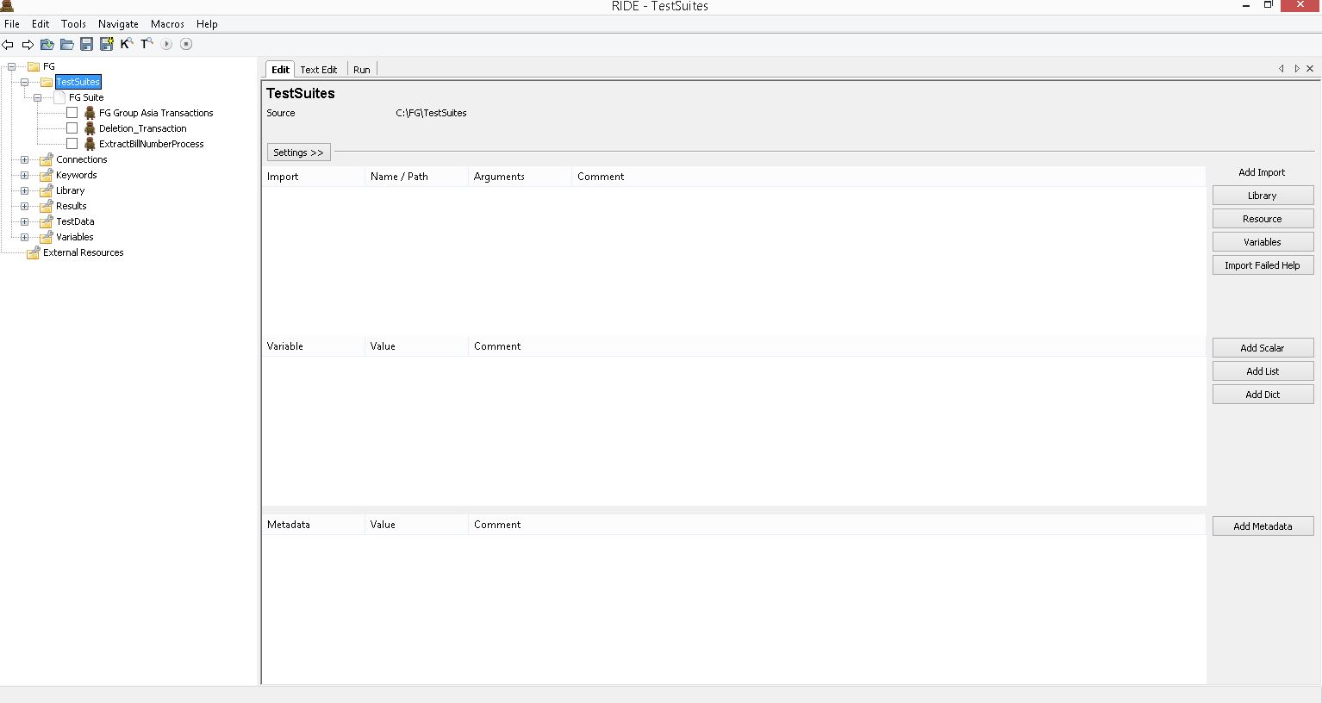

1. Select the “FG Group Asia Transactions” test script check box and we can able to see the test script.

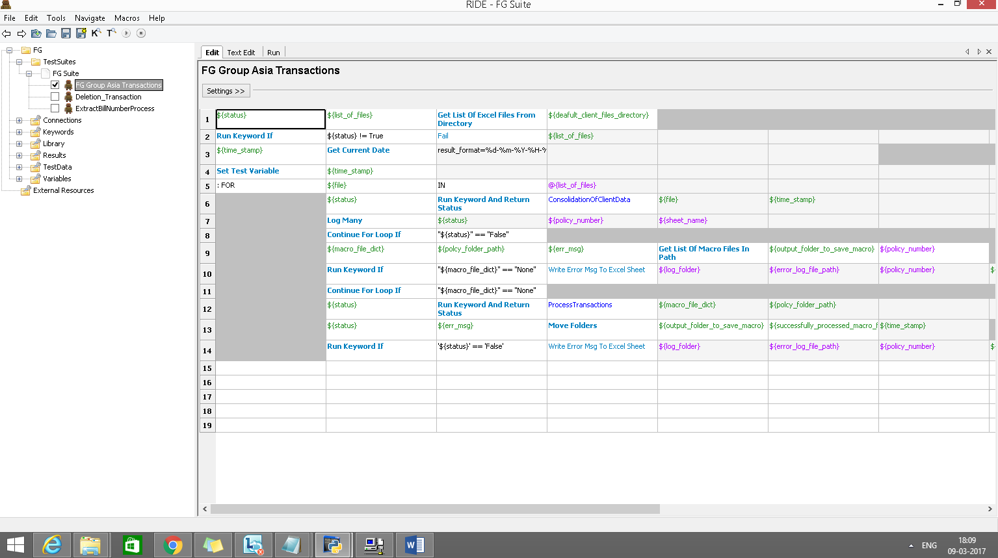

Note: Before starting the execution must be close all .xls, Upload.DTT, Group Asia and bill extract windows.

1. Click on the Run tab then click on Start button.

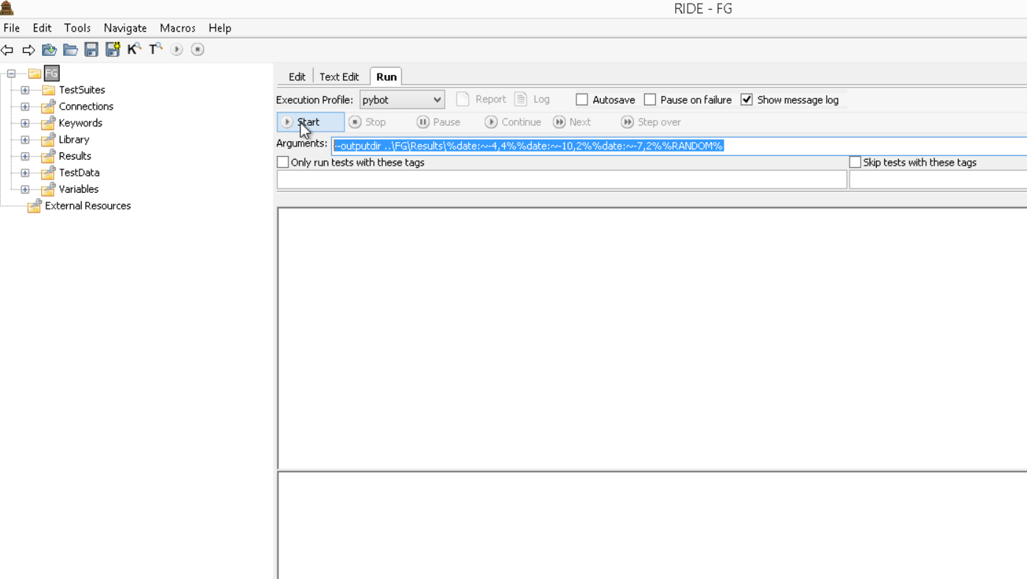

1. Select the “ExtractBillNumberProcess” test script for extracting the bill data files by EOD

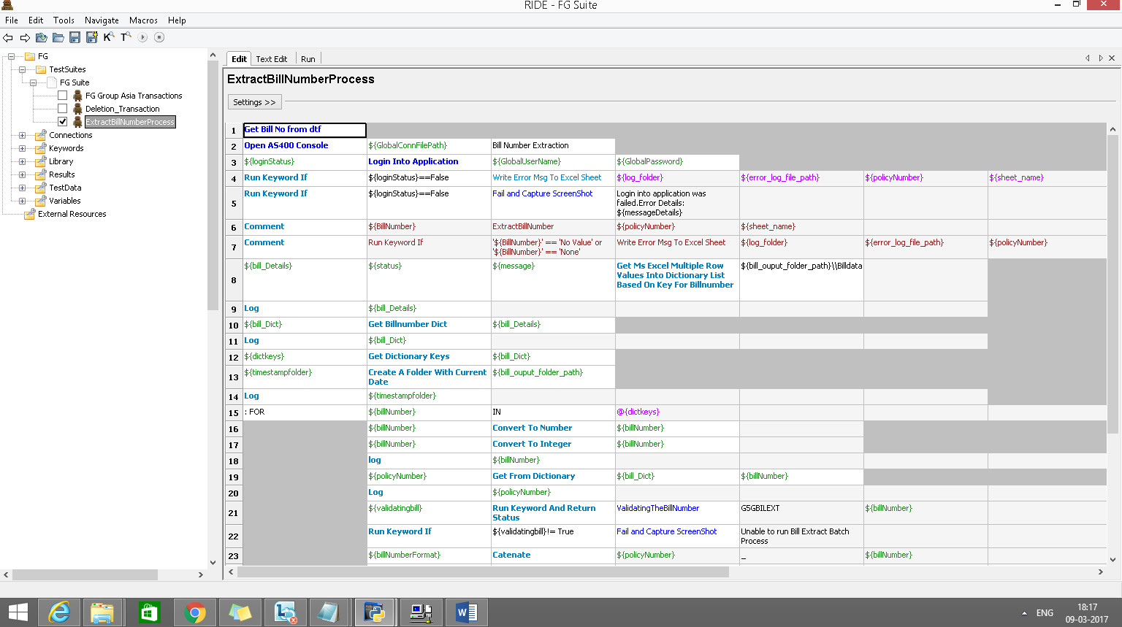

1. “Group Asia.WS”, “Upload.DTT” and “Bill” application icons are available in connections folder.

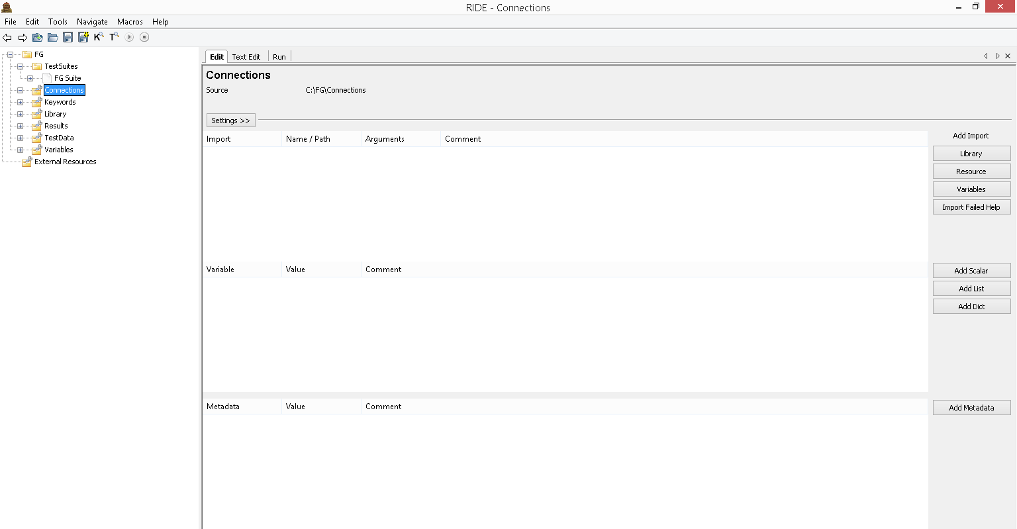

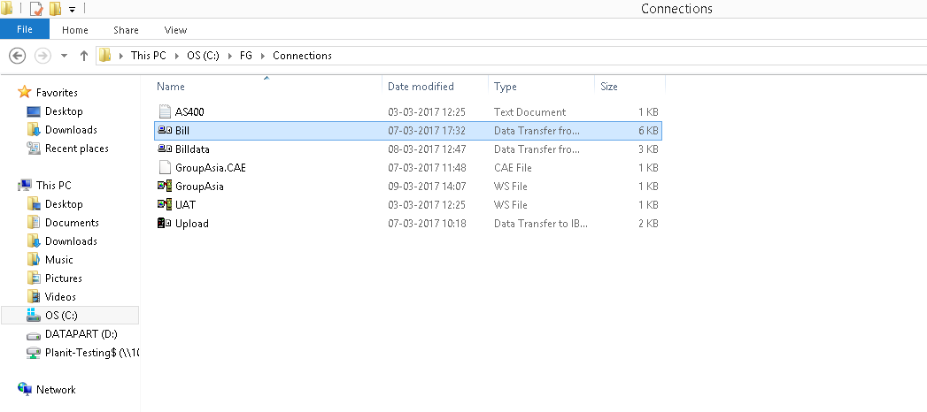

1. In “Keywords” folder we have different files like “batchprocessing.txt”,” common.txt” and “super.txt” files, Batch process related keywords all are in Batchprocessing.txt file, common keywords are available in common.txt file.
2. Global variables (ex: username, password details) are available in global.txt file in ‘Variables’ folder

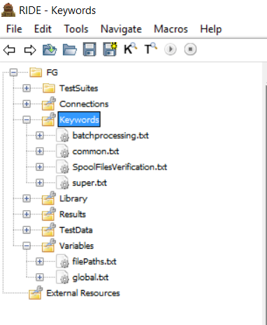

1. In Library folder we have the python files like ‘Insurance.py’ and ‘RobotExample.py’ files. These are all python customized keywords. In RobotExample.py file all consolidation related keywords are available and Group Asia related keywords are available in Insurance.py file

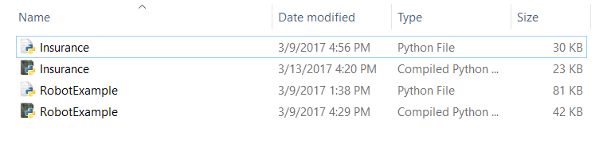

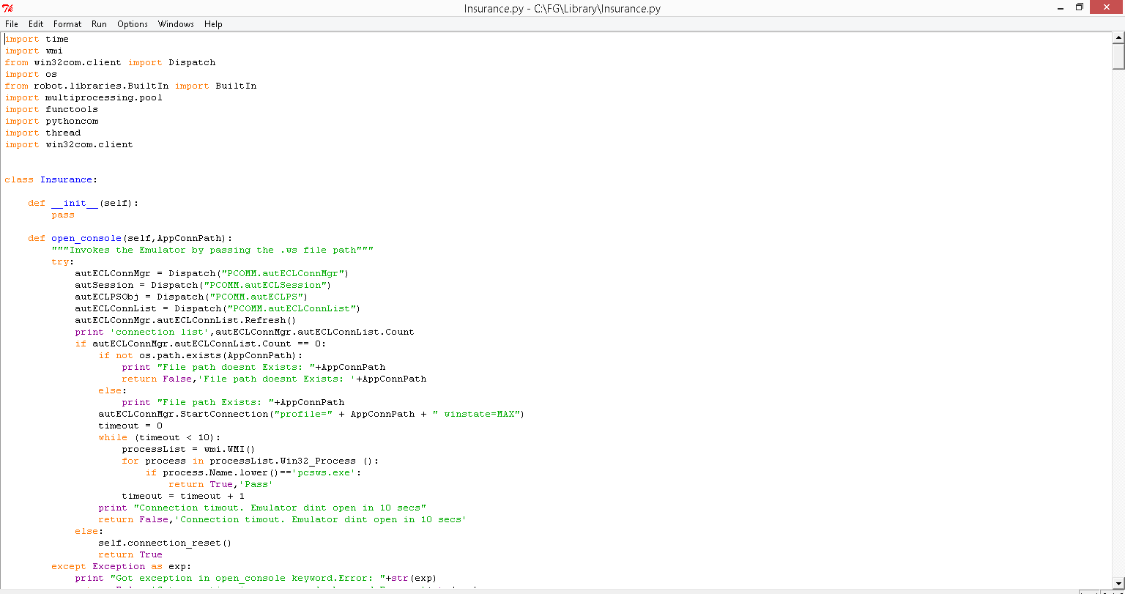

1. Test data folder contains different folders like ‘client_data’,’ Successfully_Processed_Macro_Files’, and ‘Successfully_Processed_Client_Files’, etc.

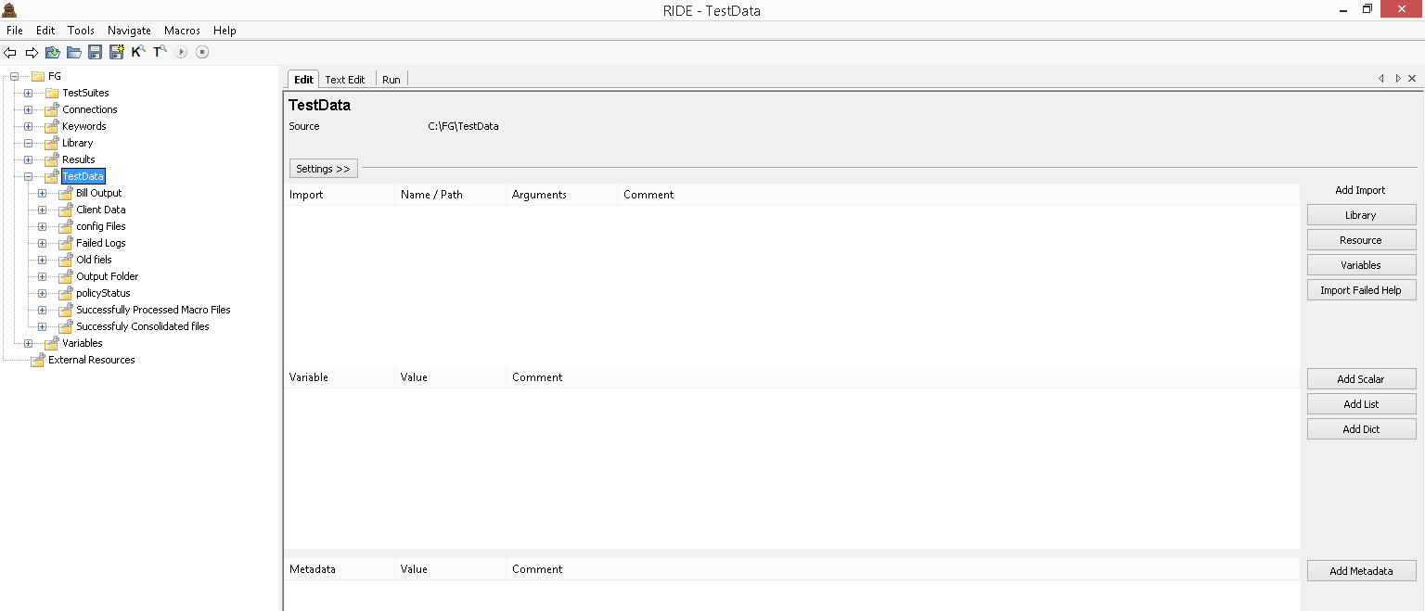

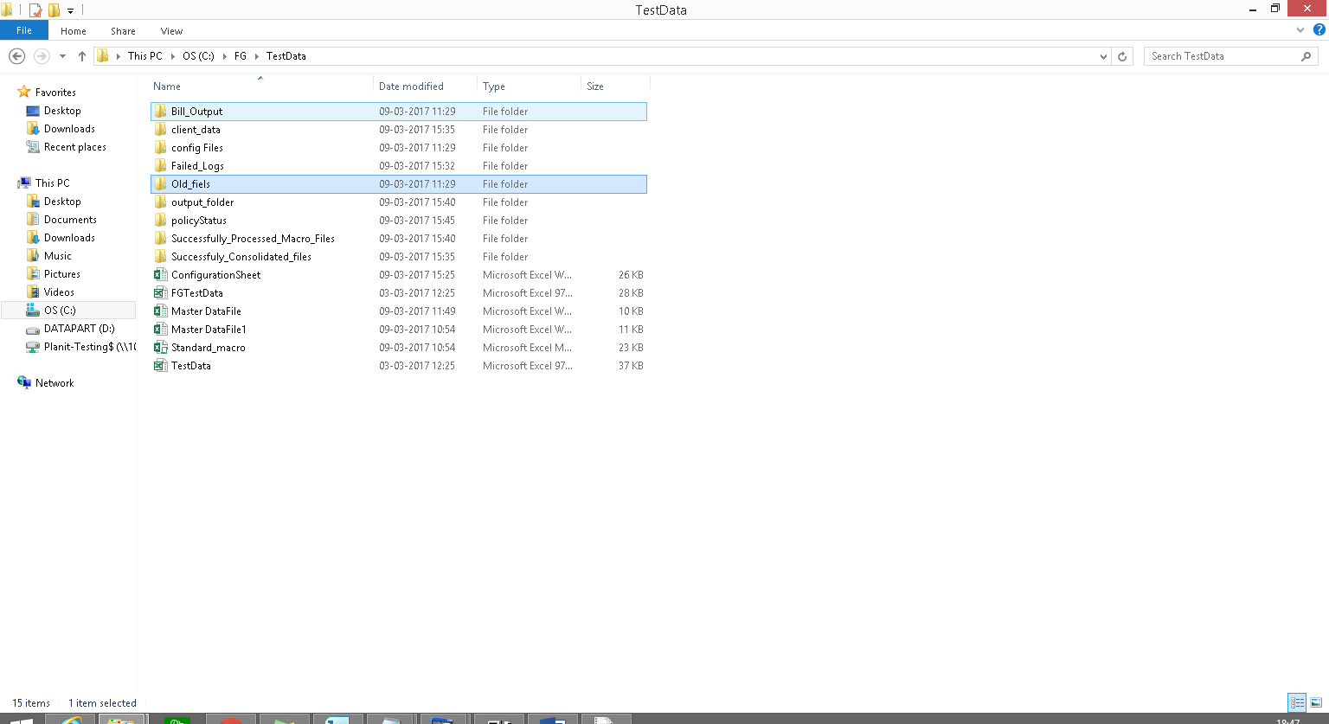

1. In Variables folder ‘global.txt’ and ‘filePaths.txt’ files are available, we can update the file path are any other variables from this files.

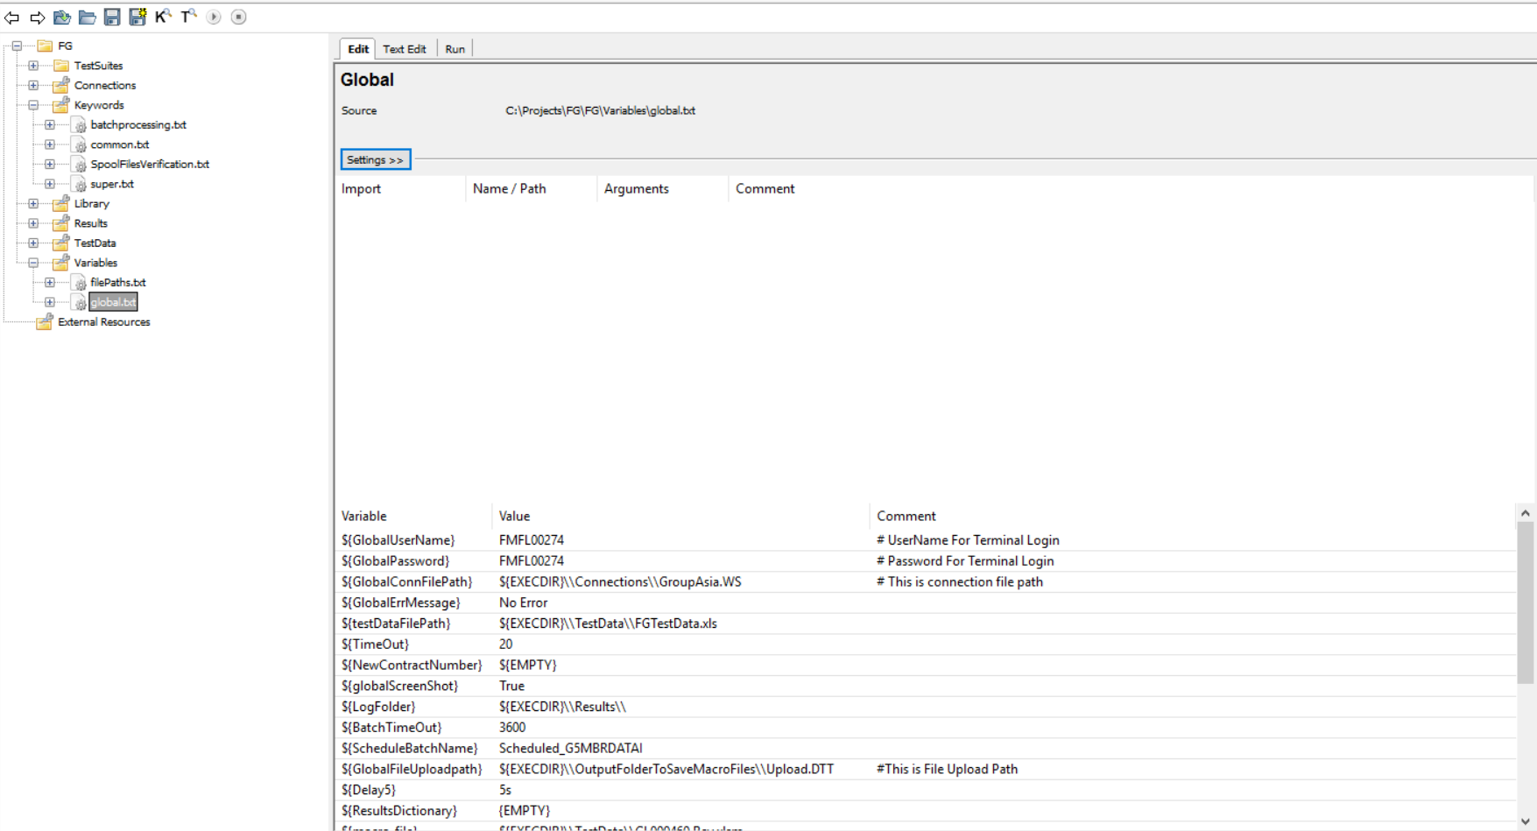

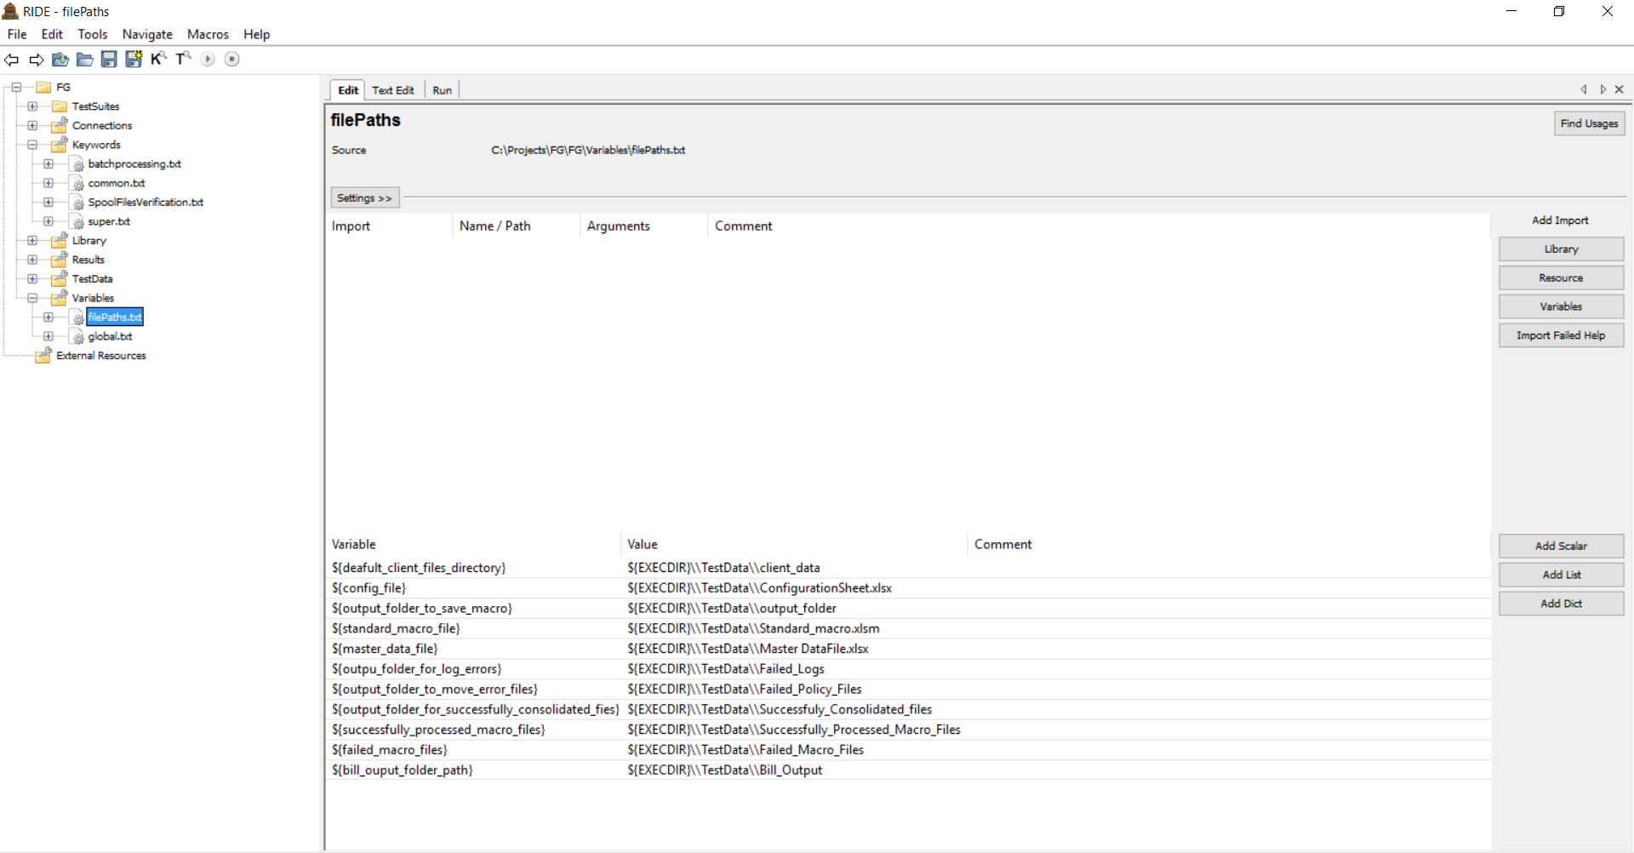

1. For test scripts execution check the check box, select the Run tab and click on ‘Start’ button.

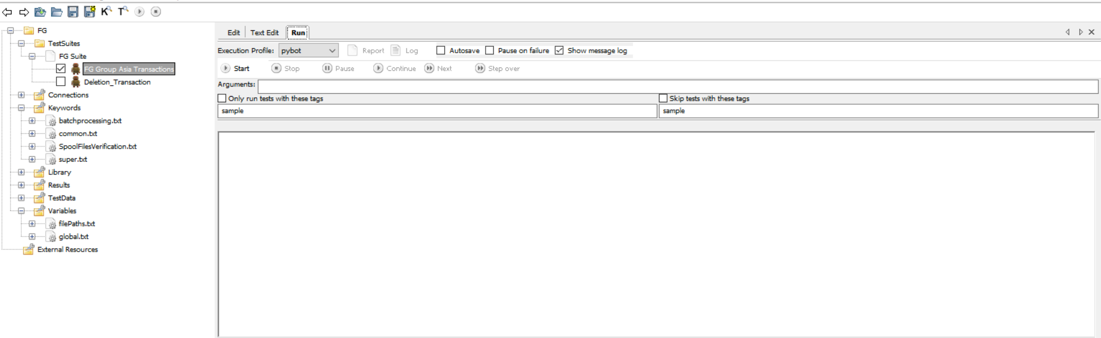

1. In Results folder we have the Log files with time stamp. These are all related results generated while executing the test scripts.

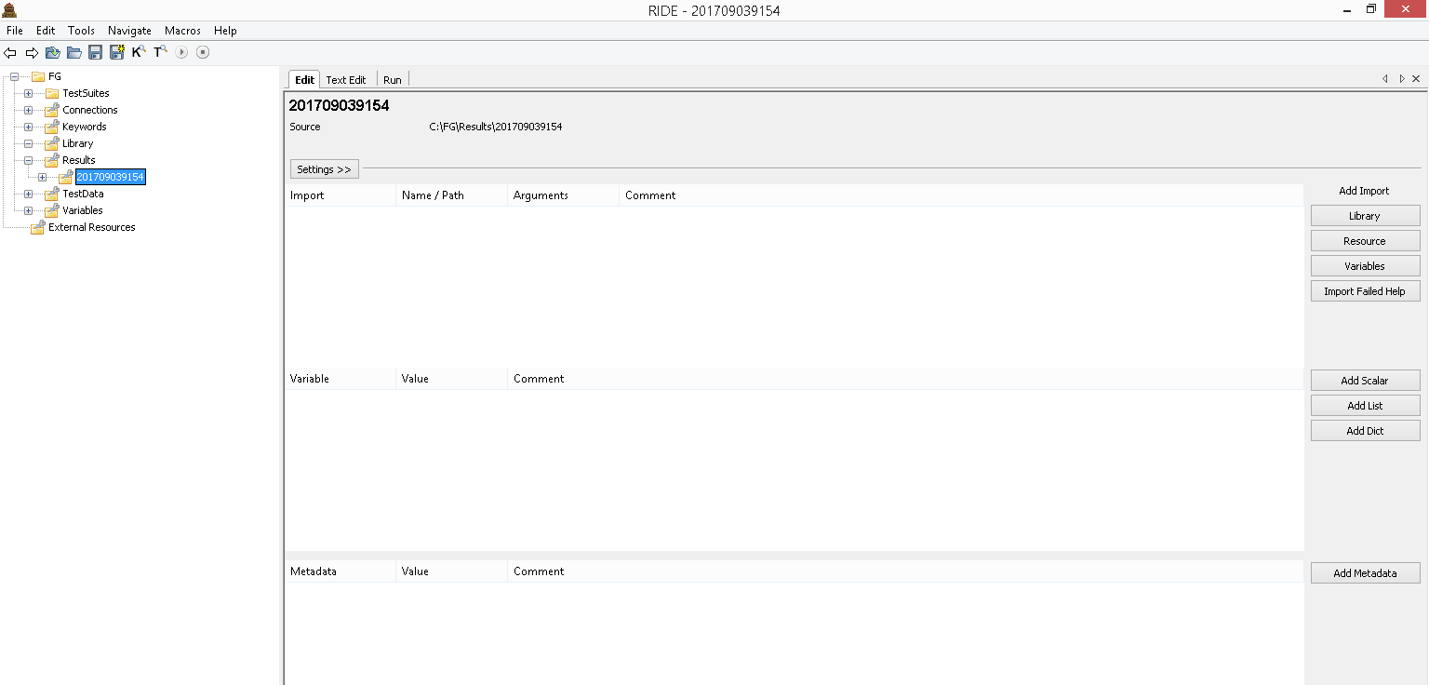

1. Log will show how many test scripts are executed, pass, fail and fail reasons with time taken for execution.

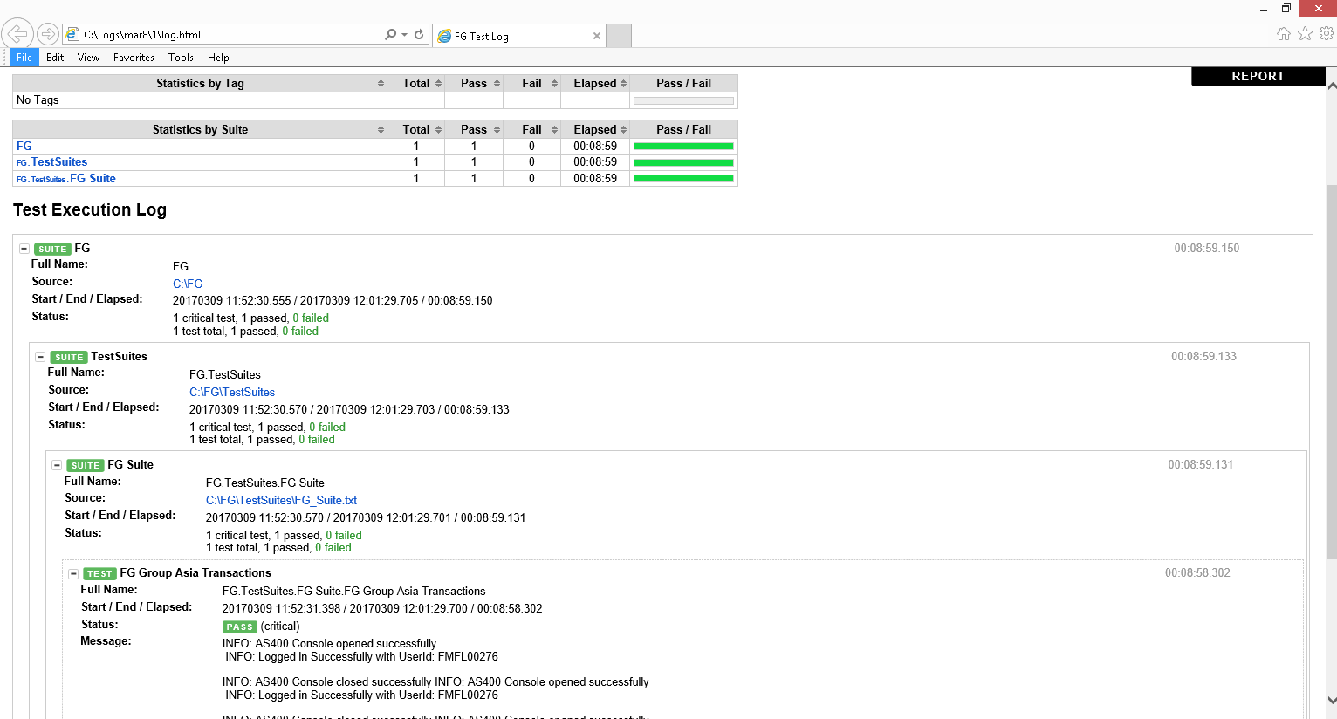

# To Verify the Log Reports After Execution

1. Click on the” **Failed_Logs** “folder available in “**TestData** “folder, verify the current date time folder then you can able to see the Error log with policy number (If any transaction failed)

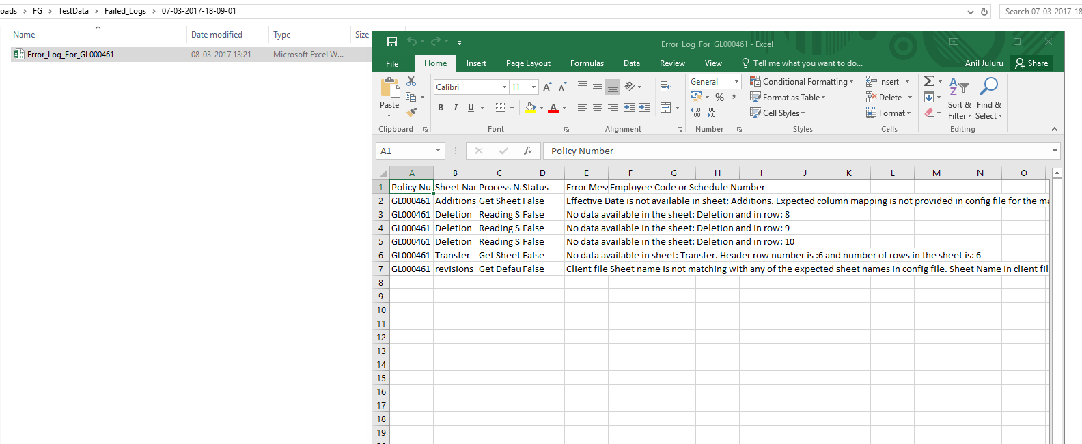

1. To check the “**Policy Status”** navigate to Test data folder and Policy Status folder you will see the current date excel file

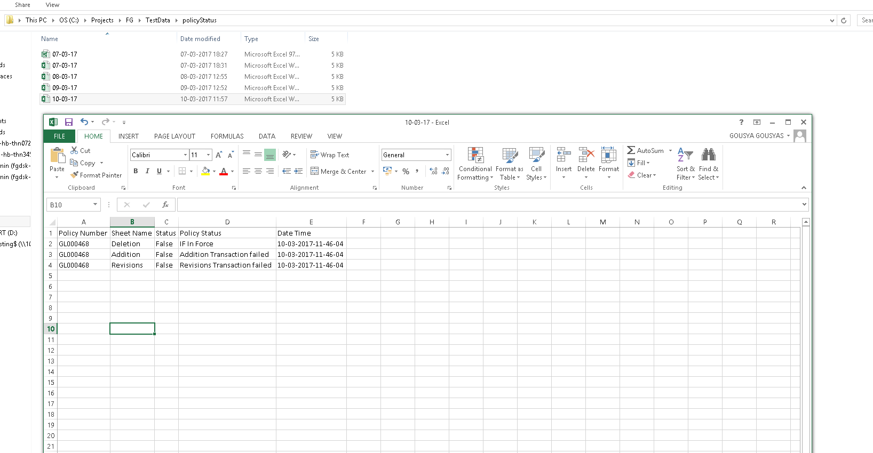

1. After completion of the processed macro files will be moved to “**Successfully_processed_Macro_Files”** folder



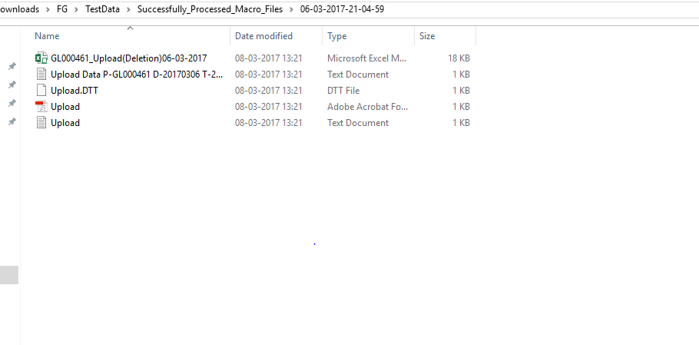

1. After completion of the processed client files will be moved to “**Successfully_Consolidated_files”** folder



1. Below is Test Data folder

